KIBOGORA POLYTECHNIC
FACULTY OF HEALTH SCIENCES
DEPARTMENT OF BIOMEDICAL LABORATORY SCIENCES
ANTIMICROBIAL ACTIVITY OF GARLIC EXTRACTS ON SELECTED HUMAN PATHOGENIC BACTERIA
Case study: Centre Hospitalier Universitaire de Butare (CHUB)
Undergraduate thesis presented in partial fulfillment of the requirements for the Bachelor’s degree with honor in Biomedical laboratory sciences.

PREPARED BY:
NYIRAMUGWERA Maida
REG. Nº 1900539
&
NYAMPINGA Evelyne
REG. Nº 2000658

SUPERVISED BY:
Mr. HITAYEZU Elysee (M.sc MBC)

Kibogora, August 2023

DECLARATION
Declaration by the Candidates
We, NYIRAMUGWERA Maida and NYAMPINGA Evelyne hereby declare that this is our own original work and not a duplication of any similar academic work. It has therefore not been previously or concurrently submitted for any other degree, diploma or other qualification to Kibogora Polytechnic or any other institution. All materials cited in this paper which are not our own have been duly acknowledged.

NYIRAMUGWERA Maida
Signed.......................................
Date..........................................

NYAMPINGA Evelyne
Signed.......................................
Date...........................................

Declaration by the Supervisor
I declare that this work has been submitted for examination with my approval as KP Supervisor

HITAYEZU Elysee
Signed………………………
Date…………………………

ABSTRACT
This research was conducted to found out the antimicrobial activity of garlic extracts on selected human pathogenic bacteria. Our main objective was to determine the antimicrobial activity of garlic extract against microorganisms. An experimental study design and both quantitative and qualitative study approach was used to determine the antimicrobial effect of garlic on microorganisms. Emerging multidrug resistance bacterial infections are burning public health concerns worldwide. There is urgent need to explore alternative antibacterial agents for effective management of bacterial infections. Garlic (Allium sativum) has been traditionally used for the treatment different diseases since ancient times. This study determined the phytochemical components and in vitro antibacterial activities of garlic on selective pathogenic bacterial isolates which are Staphylococcus aureus, Streptococcus pyogene, Streptococcus pneumonia, Pseudomonas aeruginosa, Klebsiella oxytoca, Escherchia coli and Proteus mirabilis by using well assay method. The phytochemical analysis was carried out using standard methods. The antibacterial activities of garlic chloroform, ethanol and distilled water extracts at concentration of 100mg/ml was determined against all test isolates using well assay. All extracts were found to contain important phytochemicals such like flavonoids, alkaloids, saponins, resins, phlobatannins, tannins, phenols, phytosterols while glycoside was not appeared. Both garlic plant extracts chloroform, methanol, ethanol and distilled water were observed to be more potent to test organisms with maximum inhibition zone against P. aeruginosa 22.5mm, 20.5mm P. mirabilis for chloroform at 100mg/ml. 21.5mm on S. aureus and P. mirabilis, 20.5 on E. coli and K. oxytoca for methanol at 100mg/ml. 21mm on K. oxytoca for ethanol at 100mg/ml. All test isolates and solvents used were statistically not significant, and significant where the P value obtained were 0.10>0.05, 0.014<0.05 respectively. As conclusion, this study has established that the extracts of Allium sativum have strong antibacterial activities against both gram positive and gram negative bacteria. This study recommends to the public health awareness to promote awareness of the potential benefits of garlic extracts in combating bacterial infections through educational programs and public health campaigns and promote awareness of the potential applications of garlic extracts among healthcare professionals, policymakers, and the public.

DEDICATION

This thesis is dedicated;
To Almighty God
Our beloved parents
Our sisters and brothers
Our friends
Evelyne and Maida

ACKNOWLEDGEMENTS
This work would not have been a success in its final from without the support and effort of numerous people.
First of all, we thank the lord who redeemed our life.
Honest thanks and gratitude go to our supervisor Mr. HITAYEZU Elysee who supervised us in all our research work. We gained a wonderful quantity of knowledge under their supervision.
We would like to pay special appreciations to the administration of KIBOGORA for its guidance during our academic’s studies. We also very thankful to all lectures, we additional express gratitude to our classmates in biomedical laboratory sciences department for the wonderful moments and learning experience we shared together.
And special thanks go to our lovely family
NYAMPINGA Evelyne and NYIRAMUGWERA Maida

TABLE OF CONTENTS

DECLARATION i
ABSTRACT ii
DEDICATION iii
ACKNOWLEDGEMENTS iv
TABLE OF CONTENTS i
LIST OF TABLES iv
LIST OF FIGURES v
LIST OF APPENDICES vi
LIST OF ABBREVIATION AND ACRONYMS vii
CHAPTER ONE: GENERAL INTRODUCTION 1
1.0 INTRODUCTION 1
1.1BACKGROUND OF THE STUDY 1
1.2PROBLEM STATEMENT 2
1.3PURPOSE OF THE STUDY 3
1.3.1 General objective 3
1.3.2 Specific objectives 3
1.4 RESEARCH QUESTIONS 3
1.5 SIGNIFICANCE OF THE STUDY 3
1.6 LIMITATIONS OF THE STUDY 4
1.7 SCOPE OF THE STUDY 4
1.7.1 Geographic scope 4
1.7.2 Content scope 4
1.7.3 Time scope 4
CHAPTER TWO: LITERATURE REVIEW 5
2.0 INTRODUCTION 5
2.1 DEFINITION OF KEY CONCEPTS/TERMS 5
2.2 BIO-ACTIVE COMPOUNDS THAT ARE PRESENT IN GARLIC EXTRACT 6
2.3 THE ANTIMICROBIAL EFFECT OF GARLIC ON SELECTED HUMAN PATHOGENIC BACTERIA 9
2.5 MEANING OF ANTIMICROBIAL ACTIVITY 13
2.5.1 Historical background 13
2.5.2 Mechanism of action of antimicrobial activity 13
2.5.3 Medicinal plant 14
2.5.4 Historical overview 14
2.5.5 Uses of medicinal plants 15
2.5.6 Garlic (Allium savitum) 16
2.5.7 Microorganism 17
2.5.7.1 Escherichia coli 17
2.5.7.2 Staphylococcus aureus 18
2.5.7.3 Streptococcus pneumoniae 18
2.5.7.4 Streptococcus pyogenes 19
2.5.7.5 Klebsiella oxytoca 19
2.6 Conceptual Framework 20
2.7 Research Gap 21
CHAPTER THREE: RESEARCH DESIGN AND METHODOLOGY 19
3.0 INTRODUCTION 19
3.1 RESEARCH DESIGN AND APPROACHES 19
3.1.1 RESEARCH DESIGN 19
3.3 GARLIC (Allium sativum) AND MICROORGANISM 19
3.4 COLLECTION AND PREPARATION OF GARLIC 19
3.5 SUB-CULTURING OF MICROORGANSISM 20
3.6 ANTIMICROBIAL ACTIVITY OF ALLIUM SAVITUM AGAINST SELECTED HUMAN PATHOGENIC BACTERIA 20
3.6.1 Disk diffusion method 20
3.7 Qualitative phytochemical screening of Allium sativum 20
3.8 REASERCH INSTRUMENT FOR DATA COLLECTION 21
3.9 ETHICAL CONSIDERATION 21
3.10 DATA ANALYSIS 21
CHAPTER FOUR: DATA PRESENTATION, ANALYSIS AND INTERPRETATION 23
4.0 INTRODUCTION 23
4.1 DATA PRESENTATION AND ANALYSIS 23
4.1.1 Phytochemicals constituents of garlic plant 23
4.1.2 Observation of controls 23
4.1.3 Antibacterial activities of garlic extracts 23
4.1.4 Comparison of plants extract and standards antibiotics 26
4.2 DISCUSSIONS OF FINDINGS 28
4.3 SUMMARY OF FINDINGS 30
CHAPTER FIVE: GENERAL CONCLUSION AND RECOMMENDATIONS 31
5.0 INTRODUCTION 31
5.1 CONCLUSION 31
5.2 RECOMMENDATIONS 31
5.3 SUGGESTION FOR FURTHER STUDY 32
REFERENCES 33

LIST OF TABLES
Table 1: Phytochemical profile of garlic 23
Table 2: Inhibition zones of garlic leaves extracts in diameter. 23
Table 3: Diameter in mm of zone of inhibitions of garlic bulbs 25
Table 4: T-test comparison of standards antibiotics and plant extracts…………………………26

LIST OF FIGURES
Figure 1: Mechanism action of antibiotics 14
Figure 2: Garlic (Allium savitum) 16
Figure 3: Mode of transmission of Escherichia coli infection 18
Figure 4: Conceptual Framework 21

LIST OF APPENDICES
APPENDICES 1: Dry garlic bulbs and leaves at room temperature 32
APPENDICES 2: Antibacterial susceptibility testing 33
APPENDICES 3: Letter requesting data collection to CHUB 34
APPENDICES 4: Research Letter 35

LIST OF ABBREVIATION AND ACRONYMS
AIDS: Acquired Immunodeficiency Syndrome
AMR: Antimicrobial Resistance
ANOVA: Analysis of Variance
BC: Before Christ
CDC: Center of Diseases Control
CHUB: Centre Hospitalier Universitaire de Butare
DNA: Deoxyribonucleic acid
FGE: Fresh garlic extract
HIV: Human Immunodeficiency Virus
KP: Kibogora Polytechnic
MHA: Muller Hinton Agar
MIC: Minimum Inhibitory Concentration
MRSA: Methicillin-resistant Staphylococcus aureus
NRL: National Reference Laboratory
RNA: Ribonucleic acid
UV: Utraviolet
WHO: World Health Organisation
CNS: Central Nervous system

CHAPTER ONE: GENERAL INTRODUCTION

1.0 INTRODUCTION
This chapter describes the background of the study, statement of the problem, objectives of the study including general objective and specific objectives, significance of the study and scope of the study.

1.1BACKGROUND OF THE STUDY
Traditional remedies for a variety of human ailments have included the use of medicinal plants. They are still utilized as the principal source of medication in rural areas of underdeveloped countries. Crushed garlic formulations have been demonstrated to be toxic to a wide variety of microorganisms, including bacteria, fungus, protozoa, and viruses. Garlic's antibacterial effects have been known for centuries, with many of its therapeutic characteristics originally referenced in an Egyptian recipe called Papirus ebers about 1500 BC. It is currently utilized in folk medicine to treat a variety of ailments. (Gurib, 2017).
Biologically active chemicals derived from natural sources have long piqued the curiosity of infectious disease researchers. These bioactive chemicals, also known as phytochemical compounds, are naturally occurring chemical compounds found in plants that give additional health benefits to humans than macronutrients and micronutrients. They protect plants from illness and damage and contribute to the color, aroma, and flavor of the plant. (Madan Mohan Gunda, 2018).
Generally speaking, phytochemicals are plant compounds that shield plant cells from environmental dangers such pollution, stress, dehydration, UV exposure, and pathogenic attack. Recent developments have made it abundantly evident that they play a part in safeguarding human health when dietary intake is significant. About 150 phytochemicals have undergone in-depth research out of the more than 4,000 that have been cataloged and categorized by their chemical, physical, and protective properties.l (Saxena, 2013).
Garlic, also known as Allium sativum, is a plant in the Liliaceae family and is a member of the onion family. It has received a lot of attention from modern medicine because it contains more than 200 chemical compounds and is frequently used to protect the human body from a variety of diseases due to widespread beliefs about its effectiveness in enhancing overall wellbeing. Allicin, also known as allyl 2-propenethiosulfinate or daily thiosulfate, is the primary bioactive substance that may be found in raw garlic that has been crushed or extracted in water. They function as anti-infective agents against fungus, parasites, and bacteria. It also has anticancer agents and other protective qualities for the liver. (Mohammed1, 2020).
One of the most difficult public health issues that various nations throughout the world are dealing with is the rising mortality rate of infectious diseases. This compromises and endangers people's health. The treatment of infectious diseases has always included the use of several synthetic antibiotics. (Gabriel, 2022) . Resistance has resulted through the widespread use of various antimicrobial agents in the medical field, the food business, the feed industry, and crop protection, which has decreased the potency of these antimicrobial agents. Antibiotic use has generated debate since it can result in residues and animal resistance, which would be harmful to consumers. (thria, 2011). Therefore, use of antibiotics also has an impact on bacterial resistance.

1.2PROBLEM STATEMENT
Gram-positive and gram-negative bacteria infections that are potentially fatal can result from the ongoing development of bacterial resistance to different antibiotics. Additionally, overusing antibiotics has been linked to altered gut flora and increased spread of dangerous pathogens like methicillin-resistant Staphylococcus aureus. (Mohammed1, 2020). Since the beginning of time, naturally occurring plants have been crucial in the search for new therapeutic medicines. Bacterial resistance is a challenge that almost all antibiotics face. (M. N. Palaksha, 2010).
For many years, especially in traditional medicine, the community has used medicinal plants to cure a variety of human maladies. Because they are affordable and have minimal side effects, they are regarded as the main source of novel, natural, and secure pharmaceuticals to be employed in illness management as an effective and safe alternative therapy. Medicinal plants have substantial significance and may be the best source of complementary and alternative natural medicines, according to a World Health Organization (WHO) research released in 2002 in Geneva. (Gabriel, 2022).
Due to its various advantages for human health and welfare, garlic, also known by its scientific name Allium sativum, is one of the oldest plants used as a food spice and medication. According to research, garlic can be used to treat a number of illnesses, including hyperglycemia and cardiovascular disease. Garlic has also been shown to increase immune function, fight inflammation, and defend against infectious diseases in addition to lowering the risk of cancer. (Gabriel, 2022) Therefore, this study will establish the effectiveness of using garlic extracts as a new source of antimicrobial agents that is effectively inhibit growth of bacteria with minimum side effects and compares their effect with the effect of some antibiotics (Mohammed1, 2020).

1.3PURPOSE OF THE STUDY

1.3.1 General objective
To determine the antimicrobial activity of garlic extracts on selected human pathogenic bacteria.

1.3.2 Specific objectives
- To determine bio-active compounds that are present in garlic extracts.
- To determine the antimicrobial effect of garlic on selected human pathogenic bacteria.
- To compare the antimicrobial effect of garlic with other antibiotics.

1.4 RESEARCH QUESTIONS
- What are bio-active compounds that are present in garlic extracts?
- What is the antimicrobial effect of garlic on selected human pathogenic bacteria?
- What are the differences in inhibition of selected bacteria between garlic and other antibiotics?

1.5 SIGNIFICANCE OF THE STUDY
This study will reveal a great importance in different three categories: Personal interest, Academic interest and social interest.
Personally, this study will help researcher to improve the knowledge about the antibacterial activity of garlic. This study will also be the great benefits for researcher to fulfill the requirement of the awards of a bachelor’s degree in Biomedical Laboratory Sciences.
This study will be useful academically for individuals who need to know about antimicrobials and will provide documentation for comparable field researchers. This research will also be beneficial for the local, inexpensive treatment of diseases caused by specific bacteria. A medicinal plant will be taken into consideration. Hence, the temptations to their elimination or their mishandling were no longer exist in the society.

1.6 LIMITATIONS OF THE STUDY
This study has some limitation due to the researchers’ limited time because we needed an adequate time in experimentation, data collection and analysis in order to get reliable result and due to the financial constraints because of the limited funding restrict our ability to carry out more comprehensive experiments or analyses.

1.7 SCOPE OF THE STUDY

1.7.1 Geographic scope
The study was carried out at University teaching hospital of Butare (CHUB) located in Huye District.

1.7.2 Content scope
The researchers hope to determine the antimicrobial activity of garlic extracts against the selected human pathogenic bacteria.

1.7.3 Time scope
This study was covered in the period of 5 months from March 2023 to August 2023.

CHAPTER TWO: LITERATURE REVIEW

2.0 INTRODUCTION
This chapter consist of definitions of key concepts, literature review related on the determination of the antimicrobial effect of garlic on selected human pathogenic bacteria, bioactive compound that are present in garlic and the comparison of the antimicrobial effect of garlic with other antibiotics

2.1 DEFINITION OF KEY CONCEPTS/TERMS
Antimicrobial activity: Antimicrobial activity is a catch-all word for all active compounds that impede bacterial growth, prevent the formation of microbial colonies, and may kill microorganisms. Several terminologies are used in the field of antimicrobial surfaces. Bactericidal, antibacterial, bacteriostatic, and fungicidal propertiesl (Balouiri & Moulay, 2016) According to Ahn (2017), antimicrobial action refers to a condition where an active agent has a negative effect on the strength of microorganisms.
Garlic: Garlic (Allium savitum L.) is a common spice with many health benefits, mainly due to its diverse bioactive compounds, such as organic sulfides, saponins, phenolic compounds and polysaccharides. In recent decades, numerous studies have demonstrated the remarkable biological functions of garlic, including antioxidant, cardiovascular protective, anticancer, anti-inflammatory, immunomodulatory, anti-diabetic, anti-obesity and antibacterial properties (Shang, 2019).
Extraction: Refers to the process of separating a specific substance or component from a mixture using solvents or other techniques. This is typically done when one wants to isolate or purify a particular compound of interest from a complex mixture (Ahn, 2017).
Pathogenic bacteria: Are microorganisms that can cause disease in humans, animals, or plants. They are a subset of bacteria that have evolved mechanisms to harm their hosts. These bacteria can produce toxins or directly damage host tissues, leading to various illness. Common examples of pathogenic bacteria include staphylococcus, streptococcus and Escherichia coli (Clessence, 2013).

2.2 BIO-ACTIVE COMPOUNDS THAT ARE PRESENT IN GARLIC EXTRACT
The liquid that is derived from garlic contains a variety of bioactive substances. Allicin is one of those compounds. Allicin is one of the active components in freshly crushed garlic and is reported to have a wide range of antibacterial activity. It is also well-researched for its antimicrobial, anti-inflammatory, and antioxidant effects. Allicin's antibacterial, antifungal, antiparasitic, and antiviral properties have all been demonstrated in its pure form against a variety of Gram-positive and Gram-negative bacteria, including multidrug-resistant enterotoxin-producing strains of Escherichia coli. Allicin's primary antibacterial effect results from a chemical interaction with (Ankri, 1999).
Garlic's antibacterial properties have been related to the thiosulfinates it contains, such as allicin, whose removal renders garlic wholly ineffective against microbes. Garlic cloves can be crushed or sliced to release allicin. The enzyme allinase (a cysteine sulfoxide lyase) breaks down the odorless amino acid alliin, which is present in garlic cloves, into allicin and other thiosulfinates, which in addition to having antibacterial properties, give garlic its distinctive odor. The fact that allicin completely prevents RNA production while only partially preventing DNA and protein synthesis suggests that RNA is the compound's main target. The structural variations between the bacterial strains may also affect how susceptible bacteria are to garlic.
S-Allyl-cysteine: S-Allyl-cysteine is a water-soluble compound found in aged garlic extracts, which has been shown to exhibit antihypertensive, anti-inflammatory, and antioxidant activities (Kodera, 2001).Diallyl disulfide is another sulfur-containing compound found in garlic extracts. It has been shown to possess cardioprotective, antimicrobial, and anticancer properties (Lee, 2014). Allicin in particular, which gives garlic its distinctive flavor and aroma, and sulfur-rich chemicals are responsible for the biological activity of garlic. Ajoene (4,5.9-trithiadodeca-1,6,11-triene-9-oxide) is a substance generated from garlic that can be synthesized more effectively than pure allicin and has the benefit of being chemically stable. superior to allicin. Ajoene has several biological properties, but its antithrombotic, anti-microbial, and cholesterol-lowering properties are the most well-known. (Lamm, 2003).
A variety of bioactive components, including polysaccharides, saponins, phenolic compounds, and organosulfur compounds, are found in garlic. Among the principal active components of garlic are its organosulfur compounds, which include S-allyl-cysteine (SAC), S-allyl-cysteine sulfoxide (alliin), diallyl thiosulfonate (allicin), diallyl sulfide (DAS), diallyl disulfide (DADS), diallyl trisulfide (DATS), and E/Z-ajoene. In general, the organosulfur components of raw garlic are easier to digest than those of cooked garlic. It was also demonstrated that saponins maintained a higher level of stability while cooking. Desgalactotigonin-rhamnose, proto-desgalactotigonin, proto-desgalactotigonin-rhamnose, voghieroside D1, sativoside B1-rhamnose, and sativoside R1 were among the saponins that were uniquely present in purple garlic. Purple garlic contained about 40 times more saponin than white garlic in general. Additionally, garlic had more than 20 phenolic chemicals. (Shang, 2019).
Garlic (Allium sativum L.), which has a significant amount of allicin and polyphenols, is used all over the world as a flavoring or medicinal plant. Garlic possesses anti-cancer, anti-pathogenic microorganism, and anti-cancer capabilities due to the presence of these bioactive components, according to epidemiological research. (Yabin Feng, 2020).
The natural color pigments that give fruits of plants their color are frequently used and go by the names phenols, phenolics, or polyphenolics (or polyphenol extracts). The enzyme phenylalanine ammonia lyase converts phenylalanine into the bulk of phenolic compounds found in plants. They are essential to plants and have a range of functions. They are employed in the treatment of human pathogenic disorders because their most important role may be in shielding plants from viruses and herbivore predators. They are separated into three categories: phenolic acids, non-flavonoid polyphenols, and flavonoid polyphenols (catechins, flavonones, and flavones). (Lattanzio V. L., 2015).
Volatile oils found in garlic include compounds rich in flavonoids such diallyl disulfide, di allyl trisulfide, and methyl allyl trisulfate. Some of the pharmacologic effects of the plant are assumed to be attributed to the amino acid allicin, which gives crushed garlic its extremely strong odor.According to scientific and clinical research, garlic can strengthen immunity, protect against infection and inflammation, and help lower the risk of cancer, heart disease, and dementia. There is evidence that regular garlic eating helps reduce cardiovascular disease risk factors. (Vandana Singh1, 2017).
The plant flora contains a significant group of polyphenols known as flavonoids. They are structurally formed of several benzene rings, and various studies back up their usage as antioxidants or free radical scavengers. (Kim & Chang, 2004). The substances are generated from flavan-class parent substances. It is estimated that there are around 4,000 flavonoids, some of which are pigments in higher plants. Common flavonoids including quercetin, kaempferol, and quercitrin are found in around 70% of plants. Anthocyanidins, dihydroflavons, flavans, flavonols, and flavones are among the other groups of flavonoids. (Omojate & Enwa, 2014).
The term tannin is widely applied to any large polyphenolic compound containing sufficient hydroxyls and other suitable groups (such as carboxyls) to form strong complexes with various macromolecules (Ashok & Upadhyaya, 2012). These are widely distributed in plant flora. They are phenolic compounds of high molecular weight. Tannins are soluble in water and alcohol and are found in the root, bark, stem and outer layers of plant tissue. Tannins have a characteristic feature to convert things into leather. They are acidic in reaction and the acidic reaction is attributed to the presence of phenolics or carboxylic group (Khoddami, 2013).
Tannins are divided into hydrolysable tannins and condensed tannins. Hydrolysable tannins, upon hydrolysis, produce gallic acid and ellagic acid and depending on the type of acid produced, the hydrolysable tannins are called gallotannins or egallitannins. On heating, they form pyrogallic acid. Tannins are used as antiseptic and this activity is due to presence of the phenolic group. Tannins as rich medicinal plants are used as healing agents in a number of diseases. In Ayurveda, formulations based on tannins plants have been used for the treatment of diseases like leucorrhoea, rhinnorhoea and diarrhea (Akindele & Fatunla, 2017).
These are the largest group of secondary chemical constituents made largely of ammonia compounds comprising of nitrogen bases synthesized from amino acid building blocks with various radicals replacing one or more of the hydrogen atoms in the peptide ring, most containing oxygen. The compounds have basic properties and are alkaline in reaction, turning red litmus paper blue. In fact, one or more nitrogen atoms that are present in an alkaloid, typically as 1, 2 or 3 amines, contribute to the basicity of the alkaloid. The degree of basicity varies considerably, depending on the structure of the molecule, and presence and location of the functional groups (Sarker & Nahar, 2007).
These nitrogenous compounds are involved in the defense of plants against herbivores and pathogens, and are widely exploited as pharmaceuticals, stimulants, narcotics, and poisons due to their potent biological activities. In nature, the alkaloids exist in large proportions in the seeds and roots of plants and often in combination with vegetable acids. Alkaloids have pharmacological applications as anesthetics and CNS stimulants. More than 12,000-alkaloids are known to exist in about 20% of plant species and only few have been exploited for medicinal purposes (Ziegler & Facchini, 2015).

2.3 THE ANTIMICROBIAL EFFECT OF GARLIC ON SELECTED HUMAN PATHOGENIC BACTERIA
One of the herbs utilized by traditional healers to prepare herbal medicines is garlic. Drug resistance is clearly on the rise and a global problem. looking for novel, all-natural, plant-based antibiotics. Alliaceae is the family that includes garlic. One of the active ingredients in freshly crushed garlic homogenates, allicin has a number of antibacterial properties. This study examined the antibacterial activity of garlic against typical isolates of S. aureus and E. coli that were graciously provided by ENHRI. The bioactive component from garlic was extracted using four different solvents with various polarities. By using the agar diffusion method, the antibacterial activity of the crude garlic extracts was assessed against Standard isolates of S. aurous and E. coli. The trial was completed in three copies. Three factors were employed in a factorial design. With the least significant difference (LSD) set at 5% (P=0.05) for the Student's t-test, the treatment means were compared. The data analysis was carried out using the mini tab statistical software program. In this experiment, the inhibition zone of the non-polar chloroform was higher. Water had the largest yield potential, followed by ethanol, chloroform, and petroleum ether, in that order. More sensitive to the extracts than S. aureus was E. coli. For human pathogenic bacteria, garlic may be an efficient antibacterial agent. (Kuma H, 2018).
Human skin infections, particularly those affecting the delicate mucosal surfaces and soft skin, are a severe issue, particularly in developing tropical and subtropical nations . The most common skin pathogens were identified as Methicillin-resistant S. aureus (MRSA), S. epidermidis, Escherichia coli (E. coli), Pseudomonas aeruginosa, and Candida albicans. Since MRSA is a common cause of infections acquired in hospitals, it has received a lot of attention in the last ten years. For their daily medical needs, the vast majority of people on this globe still rely on traditional medicine. It has taken a lot of work to identify new antibacterial components in various species of medicinal herbs. The screening of medicinal herbs, which are widely used in folk medicine and throughout the world, may lead to the discovery of brand-new, potent chemicals that can combat pathogenic germs. For the development of new antimicrobial medications, substances that can either stop the growth of human skin infections or kill them without harming host cells are considered prospects. In order to find a replacement for common antibiotics, it is imperative to conduct research on novel antimicrobial compounds with potential natural activity. Garlic has long been recognized for its therapeutic properties. It works well as an antibacterial agent against numerous bacterial species, including gram-positive bacteria like S. aureus and gram-negative bacteria like E.coli (Dadile M. Abdulrahman1*, 2017).
Finding novel antibacterial medicines has become necessary due to the emergence of bacterial resistance to currently existing antibiotics. The majority of post-operative wound infections, toxic shock syndrome, endocarditis, osteomyelitis, and food poisoning are caused by gram positive bacteria like Staphylococcus aureus.. In the human intestine, gram-negative bacteria like Escherichia coli can cause septicemia, coleocystis, or lower urinary tract infections. Multiple drug resistance has been observed in human pathogenic microorganisms evolved as a result of the widespread use of commercial antimicrobial medications for treating infectious infections. Antibacterial agent use, host features, environmental conditions, and the specific nature of the association between bacteria and antibiotics all play a role in the development of antibiotic resistance. Due to this circumstance, scientists have been driven to look for innovative antimicrobial chemotherapeutic agents from a variety of sources. However, the expense of producing synthetic medications is expensive. they produce adverse effects compared to plants derived drugs (Amenu, 2014).
Herbal drug use is on the rise. Garlic is one of these herbs that is most frequently and extensively used. Garlic has a long history of being used to treat infectious diseases by many different societies all over the world. Garlic is different from typical foods or food ingredients because it can be given as dietary supplements in the form of capsules and powders. The first person to describe the antibacterial properties of onion and garlic juices was Louis Pasteur. Allium vegetables, especially garlic (Allium sativum L.), have a range of properties that include: i) antibacterial activity against Gram-negative and Gram-positive bacteria, including multidrug-resistant enterotoxicogenic strains of Escherichia coli; ii) antifungal activity, particularly against Candida albicans; iii) antiparasitic activity, including some significant human intestinal protozoan parasites like Entamoeba histolytica and Giardia lamblia; and iv) antiviral activity. Besides other beneficial effects it also reduce the risk factors for cardiovascular diseases and cancer (Benmeziane, 2018).
2.4 THE COMPARISON OF GARLIC AND OTHER ANTIBIOTICS IN INHIBITION OF SELECTED HUMAN PATHOGENIC BACTERIA
Since synthetic antibiotics are often used in clinical settings, numerous microorganisms—in particular methicillin-resistant Staphylococcus aureus (MRSA), Pseudomonas aeruginosa, and Candida albicans have developed resistance to them over time. Numerous drug-resistant bacteria are now responsible for tens of thousands of fatalities annually. The risk of infection is higher for patients with open wounds, invasive devices, and immunodeficiency than it is for healthy people in hospitals and nursing homes, where some of these organisms can live harmlessly in humans and are carried in the nasal passage and on the skin. Additionally, resistance does make the infection more deadly and difficult to cure with conventional medicines. Consequently, the ongoing expansion of drug-resistant genotypes and the (Guoliang Li, 2005).
Numerous diseases have been shown to be prevented by garlic. Garlic has proven to have antibiotic effects in numerous contemporary research, and it is efficient against a variety of bacteria, fungi, and viruses. Additionally, the existence of several bioactive molecules is related to the antibacterial properties of garlic. Additionally, numerous studies have shown that garlic can be a more powerful broad-spectrum antibiotic than traditional antibiotics. Although little is known about the potential of fresh garlic extract (FGE) to increase the susceptibility of multi-drug resistant strains to conventional antibiotics, most prior studies have only focused on the antimicrobial activities of garlic and garlic-derived organ sulfur compounds or the distinction between garlic or garlic-derived organ sulfur compounds and standard antibiotics. (Guoliang Li, 2005).
The consumption of traditional plants, particularly garlic, has gradually increased in worldwide due to their greater efficiency, lower side effects and relatively lower cost. Scientific investigations have depicted that it contains 65% water, 30% carbohydrates, along with 5% of other bioactive moieties mainly sulphur- containing and nonsulphur – containing compounds. Among these organosulphur compounds, particularly cysteine sulphoxides and thisulphinates have greater importance. Antibiotics have been commonly using to treat bacterial infections such as Ampicillin and Ciprofloxacin. There is an increasing problem of antibiotic resistance to conventional drugs and a requirement for new solutions. Antibiotics have revolutionized medicine in many respects; their discovery was a turning point in medicinal history.
Regrettably, the use of these wonder drugs has been accompanied by the rapid appearance of resistant strains. The increasing reliance on drugs from natural sources has led to the extraction and development of several drugs and chemotherapeutic agents from traditional herbs, which are present in abundance in the tropics. Reviewing the effectiveness of plant based antimicrobial compounds, noted that a good proportion of such compounds are agents with weak or narrow spectrum of activities that act in synergy with intrinsically produced efflux inhibitors. However, bioactive compounds of plant origin when used together with antibiotics can increase the sensitivity of microbial cells to such antibiotics. Previous research shown that fresh garlic (Allium sativum) extracts combined with antibiotics have higher antibacterial sensitivity [10]. This can be of great help in the fight against diseases brought on by virulent strains of pathogenic and drug-resistant bacteria, which are currently posing serious public health risks in both developed and developing nations. As reported earlier on major UTI causes, bacterial isolates were identified as Escherichia coli, Pseudomonas aeruginosa, and Staphylococcus aureus [11]. Numerous studies have also linked these three bacteria to the leading causative agents of both community- and hospital-acquired infections. Recent studies from the scientific community have raised worries that the difficulties highlighted by the current rate of antibacterial medication development will not be sufficiently addressed adequately address the problems posed by antibiotic resistance among important bacterial pathogens leading to diseases (Rokhsana Mohamed Ismail, 2020).
For thousands of years, Allium sativum (garlic) has been farmed extensively on every continent. The species is among the first vegetables that humans have grown, valued not only for their distinct flavor and aroma but also for their medicinal properties. Garlic is a plant that can be used in alternative medicine because it contains a variety of biologically active compounds, notably in its subterranean bulb. In addition, the medicinal activity of the species is being researched and the new issues facing current medicine have led to more and more people are using plants as remedies. Additionally, compounds contained in garlic stimulate the human immune system by enhancement of macrophage activity; hence, they can be used as supportive therapy of such diseases as HIV/AIDS. Therefore, garlic is an excellent alternative to the antibiotics used currently (Tchórzewska, 2021).

2.5 MEANING OF ANTIMICROBIAL ACTIVITY
The term "antimicrobial activity" refers to all active substances that stop bacteria from growing, prevent microbial colonies from forming, and may even kill microorganisms. Several frequent terms are used in the context of antimicrobial surfaces. Including fungicidal, bactericidal, antibacterial, and bacteriostatic (Balouiri & Moulay, 2016).

2.5.1 Historical background
Although many antibiotics have been developed to treat bacterial infections, the problems of antibiotic resistance and toxicity have made the continual search for innovative treatments necessary. In this study, the antibacterial effects of Allium sativum and Allium cepa against Salmonella typhi, Staphylococcus aureus, Streptococcus pneumoniae, Klebsiella pneumoniae, and Escherichia coli were investigated. The evolution of bacterial resistance to already available antibiotics has necessitated the discovery of novel antibacterial drugs. Gram positive bacteria like Staphylococcus aureus are responsible for the majority of post-operative wounds brought on by the indiscriminate use of commercial antimicrobial drugs routinely prescribed for the treatment of infectious diseases. (Clessence, 2013).
The specific nature of the association between bacteria and antibiotics, the use of, and other factors, all have a role in the development of antibiotic resistance.

2.5.2 Mechanism of action of antimicrobial activity
Understanding how antimicrobials promote bacterial cell death can help you concentrate on the crucial cellular activity that is being blocked by the main drug-target interaction. Antimicrobials can be categorized according to the cellular system or component they influence as well as whether they actually cause cell death or just stop it from happening. However, the mechanism of action of an antimicrobial drug is divided into five categories: damage to the plasma membrane, blockage of the production of important metabolites, impairment of the function of DNA synthesis, inhibition of protein synthesis, and inhibition of cell wall synthesis. (Gabriel, 2022).
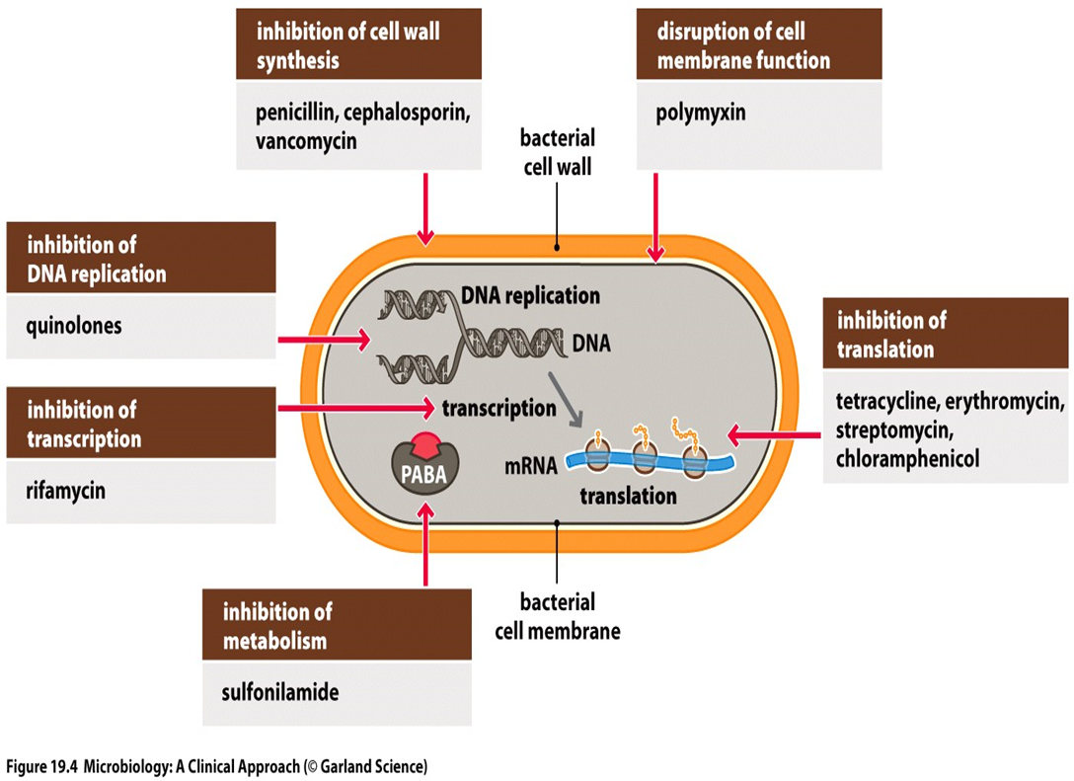
Figure 1: Mechanism action of antibiotics

2.5.3 Medicinal plant
Therapeutic plants, also referred to as medicinal herbs, have been discovered and used in conventional medical practices since prehistoric times. Plants produce hundreds of distinct chemical compounds for a range of uses, including defense and protection against insects, fungi, disease, and herbivorous mammals. Herbal medicine can take many different forms, including powders, liquids, mixes, ointment linings, and incision linings that can be boiled or rowed. In many poor countries, a sizable portion of the population relies on traditional healers and their collection of medicinal plants to meet their healthcare needs. (Hassan, 2012).

2.5.4 Historical overview
Traditionally, medicinal plants have been used by the community for a very long time to cure a wide range of human problems. Because they are inexpensive and have little side effects for people, they are regarded as the primary source of novel, natural, and safe medications to be used in managing diseases as an efficient and safe alternative medicine. The World Health Organization (WHO) in Geneva released a report in 2002 that stated that medicinal plants have great value and may be the best source of complementary and alternative natural medicines. (Hassan, 2012).

It's important to note that 80% of people worldwide use traditional or folk medicine, which relies on plant parts and extracts that are known to have medical or pharmaceutical potential. Modern science is working to further investigate these plants' capabilities and how to use them. A traditional medical practice that dates back centuries uses plant extracts for treatment of infections. Many plants have been employed as antimicrobial medicines since they are largely created during the secondary metabolism of the plants. Numerous phytochemicals found in medicinal plants, including flavonoids, alkaloids, tannins, and terpenoids, have antibacterial and antioxidant activities. Numerous studies have been conducted on certain plant species' antibacterial properties. For instance, the undiluted extracts of of cinnamon, garlic, basil, curry, ginger, sage, mustard, and other herbs exhibit antimicrobial properties against a wide range of Gram-positive and Gram-negative bacteria (Singh, 2016).

2.5.5 Uses of medicinal plants
It's crucial to remember that 80% of people employ traditional or folk medicine, which relies on plant parts and extracts with potential for use as drugs or in medicine. Further research into the capabilities and applications of these plants is being done by modern science. Plant extracts are used in an age-old, traditional medical procedure to cure infections. Since they are mostly produced during the secondary metabolism of the plants, many plants have been used as antibacterial medications. The antibacterial and antioxidant properties of several phytochemicals found in medicinal plants include flavonoids, alkaloids, tannins, and terpenoids. The antibacterial capabilities of specific plant species have been the subject of numerous investigations. For example, the pure extracts of (Hassan, 2012)
Essential oils found in the tissues or seeds of medicinal plants generally stop the growth of bacteria, mold, or other organisms. It has antibacterial qualities because of this property. Essential oils found in common herbs like peppermint, basil, oregano, thyme, and rosemary inhibit the growth of microorganisms. Making a tea from the leaves of oregano in particular has been used to help decrease the effects of bacterial infection. Spices and herbs have a significant role in medicine and are effective treatments for many pathogenic infections. The distinctive flavor and scent of the spices come from substances known as phytochemicals or secondary metabolites. The phytochemicals are antimicrobial molecules found in spices that can draw beneficial organisms and ward off dangerous ones. They also operate as photoprotectants and react to environmental factors. (Gurib, 2017).

2.5.6 Garlic (Allium savitum)
The onion sativum Linn, also known as garlic, is a member of the Liliaceae family and is classified with onions. It has drawn considerable interest from modern medicine due to its high chemical content—more than 200—and widespread use as a preventative measure against a variety of illnesses. Allicin, also known as allyl 2-propenethiosulfinate or diallyl thiosulfinate, is the primary bioactive component in garlic's aqueous extract and in raw garlic that has been crushed. It acts as an anti-infective agent against bacteria, parasites, and fungus. Additionally, it has anticancer and liver-protective effects.. (Kuma H, 2018)
Different studies' findings have demonstrated that garlic extracts can stop various pathogenic bacteria from growing. The presence of sulfur compounds, notably allicin, which is the substance formed by the enzyme alliin lyase after crushing or bruising a garlic bulb, has been related to their antibacterial action. Garlic extracts are effective against a wide range of medical germs, including both gram-positive and gram-negative strains, proving that garlic has a wide range of biological effects due to its chemical makeup. However, different extraction techniques affect the quantity and types of antimicrobial compounds recovered. (Ankri, 1999).

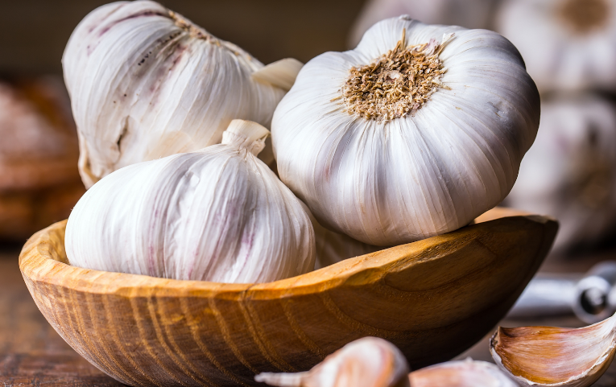
Figure 2: Garlic (Allium savitum)

2.5.7 Microorganism

2.5.7.1 Escherichia coli
In the lower intestine of warm-blooded creatures, Escherichia coli, also known as E. coli, is a Gram-negative, facultatively anaerobic, rod-shaped coliform bacterium of the genus Escherichia. Most E. coli strains are either innocuous or very briefly cause diarrhea. However, other strains, including E. coli O157:H7, can cause vomiting, severe stomach pains, and bloody diarrhea. The most frequent commensal occupant of the gastrointestinal tracts of people and warm-blooded animals as well as one of the most significant diseases is E. coli, a member of the bacterial family Enterobacteriaceae. It coexists with hosts in a mutually beneficial relationship as a commensal and rarely transmits illness. However, it is also among the most prevalent diseases that affect both humans and animals. (Nerino Allocati 1, 2013).
Mechanisms of Resistance
A significant and growing issue in world healthcare is antimicrobial resistance. Since the discovery of penicillin, many bacteria have developed the capacity to evolve and spread antimicrobial resistance to other species in response to the use of antibiotics. The use of antimicrobial drugs improperly and in greater quantities both contributed to the acceleration of this problem. Additionally, the acquisition and dissemination of multidrug resistant bacteria is significantly influenced by ongoing foreign travel for both leisure and business (Nerino Allocati 1, 2013).

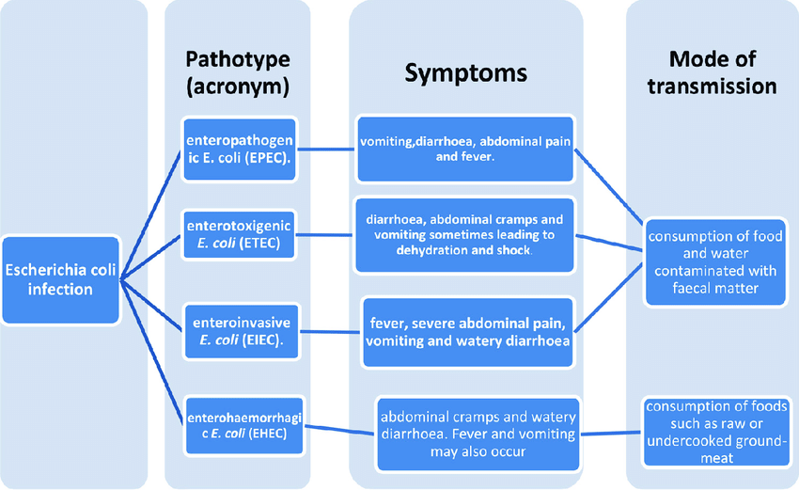
Figure 3: Mode of transmission of Escherichia coli infection

2.5.7.2 Staphylococcus aureus
Gram-positive, round (coccus), staphylo-like clusters of S. aureus bacteria are extremely harmful opportunistic colonies. In small populations, Staphylococcus aureus is a commensal bacterium that does neither good nor bad for the body. The germs can infect the skin, blood, lungs, heart valves, brain, and bones as colonies proliferate. Common antibiotics are ineffective against a lot of types. One of the most notorious and common bacterial pathogens is Staphylococcus aureus, which annually causes hundreds of thousands to millions of more serious, invasive infections and an uncountable number of simple skin infections. It is a major factor in the development of nosocomial bacteremia, surgical site, prosthetic joint, and cardiovascular infections, as well as pneumonia and other respiratory tract infections.. (Gordon Y. C. Cheung, 2021)

2.5.7.3 Streptococcus pneumoniae
S. pneumoniae is a Gram-positive, spherical bacteria that can either be alpha- or beta-hemolytic depending on the environment. Over 1.2 million people die each year from pneumonia, sepsis, and meningitis due to S. pneumonia. S. pneumoniae is the most frequently recovered isolate of pneumonia, which is the main infectious cause of mortality in both children and adults around the world. (Almas & Kaug, 2015). One method of containing and treating this infection utilizing medicinal herbs like Salvadora persica has been discussed in the study. On solid media, all of the plant's extracts were demonstrated to eliminate pneumococci lawns. Fruit extract, however, significantly decreased the number of pneumococcal colony forming units (CFU) in liquid culture. (Singh et al., 2018).

2.5.7.4 Streptococcus pyogenes
A significant human-specific bacterial pathogen called Streptococcus pyogenes causes a wide range of symptoms, from minor localized infections to potentially fatal invasive infections. Acute rheumatic fever and post-streptococcal glomerulonephritis are post-infectious sequelae of ineffective S. pyogenes infection treatment. Additionally, it leads to invasive infections including toxic shock syndrome and necrotizing fasciitis, which are linked to significant morbidity and mortality.
Gram-positive, catalase-negative, coagulase-negative, and found in pairs or chains are streptococci. According to the type of hemolysis that occurred on blood agar, they are separated into three groups: beta-hemolytic (full lysis of red cells), a hemolytic (green hemolysis), and gamma-hemolytic (no hemolysis). Group A streptococci (Streptococcus pyogenes) and group B streptococci (Streptococcus agalactiae) are two types of beta-hemolytic streptococci. (Kanwal S 1, 2020)

2.5.7.5 Klebsiella oxytoca
The Gram-negative, rod-shaped K. oxytoca is closely related to the Gram-positive K. pneumoniae, but differs from the latter by being indole-positive (Maiyo et al., 2018). It can develop antibiotic resistance just like other enterobacteria, and isolates have been found to produce extended-spectrum beta-lactamases (Hoenigl et al., 2017). Nursing homes and intensive care units are two hospital situations where K. oxytoca is frequently transmitted. K. oxytoca can lead to life-threatening infections. Urinary tract infections, wound infections, and symptoms resembling pneumonia are all brought on by one type of infection. Studies have revealed that several extracts from edible plants are also antibacterial against K. oxytoca. (Bass & Washington, 2015)

2.6 Conceptual Framework
An analytical tool used to develop a comprehensive understanding of a certain occurrence is a conceptual framework. It is used in a variety of professional fields and is frequently used to visually explain the key ideas or variables and the relationships between them that call for further exploration.

Independent variables
- Concentration of Garlic Extract
- Types of Garlic
- Bacterial species
- Exposure time

Dependent variables
- Bacterial growth inhibition
- Zone of inhibition
- Minimum inhibition concentration
- Minimum bactericidal concentration

Intermediate variables
- Extraction Solvents
- Chemical composition analysis
- Bacterial resistance mechanisms
- pH of the medium
- Garlic processing
Figure 4: Conceptual Framework

2.7 Research Gap
The research gap in this study lies in the need for comprehensive investigation into the potential variation in antimicrobial efficacy across different strains of human pathogenic bacterial. While existing studies have demonstrated garlic antimicrobial properties, there is a lack of in-depth exploration into whether its effectiveness remains consistent against a diverse array of bacterial strains, including those that are antibiotics resistant. Addressing this gap through systematic experimentation could enhance our understanding of garlic’s broader applicability as a natural antimicrobial agent and its potential to combat a wider spectrum of human pathogenic bacteria, contributing to both scientific knowledge and potential therapeutic applications.

CHAPTER THREE: RESEARCH DESIGN AND METHODOLOGY

3.0 INTRODUCTION
This chapter introduces the research topic and details the study’s methodology. It describes the precise instruments that was used and how they were put to use to gather data for the study. Additionally, it was cover the types and distribution of the data used for the study, sampling procedures, and data used in it.

3.1 RESEARCH DESIGN AND APPROACHES

3.1.1 RESEARCH DESIGN
This study was an experimental research design in vitro extraction of garlic and it was used in against the selected human pathogenic bacteria.
3.1.2 RESEARCH APPEOACH
In investigating the Antimicrobial activity of garlic extracts against human pathogenic bacteria, our research approach adopts a laboratory-based experimental design. This approach allows us to systematically evaluation the potential inhibitory effects of garlic extracts on a selection of pathogenic bacteria. We employ standardized extraction methods to obtain garlic extracts and carefully cultivate pathogenic bacteria strains in controlled laboratory conditions. Following this, we introduce the garlic extracts into the bacterial cultures and monitor their growth over time.
This quantitative approach enables us to collect numerical data such as colony-forming units, to assess the antimicrobial activity. This research approach aims to provide empirical evidence regarding the effectiveness of garlic extracts as a potential antimicrobial agent against a range of human pathogenic bacteria, contributing to our understanding of natural remedies in combating microbial infections.

3.3 GARLIC (Allium sativum) AND MICROORGANISM
The garlic was purchased in the market located at Huye District and microorganisms was obtained in clinical isolation from University teaching hospital of Butare( CHUB).

3.4 COLLECTION AND PREPARATION OF GARLIC
Healthy plants of garlic was collected in the laboratory of University teaching hospital of Butare after being dried it was peeled and washed thoroughly with tap water then sliced into small pieces and after period of time it was smashed in a mortar. Then the washed and prepared garlic was treated with solvents. The three 100mg/ml were treated with those solvents which are ethanol, methanol, chloroform and distilled water. After that the extract was filtrated through Whatman No 1 filter paper and then evaporated using heidolph rotary evaporator to obtain concentrated extracts. (Gabriel et al., 2022)
2ml of this extract was put on Muller Hinton broth, and incubated at 37°C for 24 hours for Sterility proofing. The concentrated garlic extracts was then stored at 4 ºC for further use.

3.5 SUB-CULTURING OF MICROORGANSISM
Bacteria strains was cultured and sub-cultured again for purity on specific media for each selected bacteria. Colony morphology, Gram staining as well as biochemical test was carried out to confirm the identity of working strains.

3.6 ANTIMICROBIAL ACTIVITY OF ALLIUM SAVITUM AGAINST SELECTED HUMAN PATHOGENIC BACTERIA

3.6.1 Disk diffusion method
A solution of plant extracts was taken. Then different concentration was used for overnight impregnation of sterilized 6 mm blank discs and placed on Mueller Hinton agar plates seeded with the test bacterium previously suspended in 4mL of normal saline (McFarland standard 0.5) into a test tube, mix with vortex to make a homogenous mixture. The plates were incubated at 37 º c for 24 hours, after 24 hours the zone of inhibition around each disc was measured and the diameter was recorded. Concentration with low inhibition zone was considered as MIC. Standard antibiotic was used as the reference. A negative control was prepared using only the solvent used for extraction and kept for comparison. The tests was repeated 2 times to ensure reliability of the result.

3.7 Qualitative phytochemical screening of Allium sativum
The presence of resins, phenols, glycosides, saponins, tannins, flavonoids and alkaloids in the crude extract were determined based on CHUB SoPs
Resins
0.5 g of leaves was added in 5 ml of 95% ethyl alcohol. The mixture remained in a water bath for 2 min. After, 10 ml of distilled water acidified hydrochloric acid concentrated was added. Formation of turbidity was observed.
Tannins
2.5 ml of distilled water was poured in the glass containing 0.5 g of leaves extract. Mixture was mixed well and filtered. Filtrate was divided into two parts. 1% lead acetate solution was added in the 1st part to give white sediment as positive test. 1% ferric chloride solution was added in the 2nd part to give bluish green color as positive test.
Phenols
0.06 ml of 1% ferric chloride solution was added into 0.1 ml of the leaves extract. Solution was mixed well. The formation of bluish green color was observed.
Alkaloids
5 drops of Wagner reagent were added into 1.00 ml of an aqueous extracts. Mixture was mixed well. The appearance of brown precipitate was observed. Brown precipitate was confirmed by addition of few drops of Wagner’s reagent to 2 ml of the filtrate along the side of the tube.
Glycosides
10 ml of 50% H₂SO₄ was added into 1 ml of the leave extracts. Mixture was mixed well. The mixture was allowed in boiling water for 15 min. After that, 10 ml of Fehling’s solution was added in the mixture boiled. A brick-red precipitate was observed.

3.8 REASERCH INSTRUMENT FOR DATA COLLECTION
In our research we use many instruments which are: Rotary evaporator, Cutter mill mixer , Agitator, Microwave, Culture media, Wire loop, Incubator, Petri dish and Tubes.

3.9 ETHICAL CONSIDERATION
This study was conducted after getting an ethical approval from KP committee. Also, the authorization was requested from research office before conducting this research. There were no expected risks that can harm the lives of people because it was conducted under the rules of laboratory.

3.10 DATA ANALYSIS
All the values of inhibition zone was analyzed by conducting statistical test to determine the significance of the results and assess the reliability of the findings. This could include test such as ANOVA to compare the effects of different concentrations of garlic extract on bacterial growth. Differences between groups were considered significant at P<0.05 levels.

3.10 RELIABILITY AND VALIDITY MEASURES
The process of gathering information was taken place over a span of five months, specifically from April to august 2023. An inquiry document was utilized to determine the antimicrobial activity of garlic extracts on selected human pathogenic bacteria.

CHAPTER FOUR: DATA PRESENTATION, ANALYSIS AND INTERPRETATION

4.0 INTRODUCTION
The analysis and interpretation of the data collected during experiments or studies on this subject will be done in this chapter. The data collected may include information about the concentration of garlic extract used, the types of bacteria tested, and the effects of the garlic extract on the bacteria, such as growth inhibition or bacterial death. (Hanieh et al., 2015).

4.1 DATA PRESENTATION AND ANALYSIS

4.1.1 Phytochemicals constituents of garlic plant
Table 1: Phytochemical profile of garlic
 | Bulbs | Leaves
Tannins | P | A
Phenols | P | A
Saponins | P | P
Alkaloid | A | A
Flavonoid | P | A
Glycoside | A | A
Steroids | P | A
P= Present, A=Absent
The phytochemical screening of garlic indicated the presence of important phytochemicals where the test has been performed using different techniques in order to confirm the presence or absence of phytochemical substance as shown in previous table.

4.1.2 Observation of controls
The prepared controls for different solvents used in current study such like chloroform, methanol, ethanol and distilled water showed no inhibition zone against all test organisms.

4.1.3 Antibacterial activities of garlic extracts
Table 2: Inhibition zones of garlic leaves extracts in diameter.
 | Chloroform leaves | Methanol leaves | Ethanol leaves | D.water leaves
Bacteria | 50µl | 50µl | 50µl | 50µl
E. coli 25922 | 0 | 20.5 | 14 | 10.5
K. oxytoca 700524 | 16.5 | 20.5 | 21.5 | 11.5
S. aureus 43300 | 18.5 | 21.5 | 16.5 | 9.5
S. pyogene 12344 | 0 | 11.5 | 13 | 12
P. aeruginosa 27583 | 22.5 | 19.5 | 19 | 0
S. pneumonia49619 | 10.5 | 11.5 | 14 | 0

This study has been performed duplicate by in vitro and the table above is interpreting the antibacterial activity of garlic leaves extracts against test bacteria and the results are expressed in means. Chloroform extract showed higher inhibition zone of 22.5mm on P. aeruginosa than other solvents. Distilled water was the least to show inhibition on different test isolates where P. aeruginosa and S, pneumonia resisted to this solvent.
Table 2.1 Data for the first objective
 | Chloroform leaves |  |  | Methanol leaves |  |  | Ethanol leaves |  |  | D. water leaves
 | 50µl |  |  | 50µl |  |  | 50µl |  |  | 50µl
Bacteria | X1 | X2 | Mean | X1 | X2 | Mean | X1 | X2 | Mean | X1 | X2 | Mean
E. coli25922 | 0 | 0 | 0 | 20 | 21 | 20.5 | 13 | 15 | 14 | 10 | 11 | 10.5
K. oxytoca 700524 | 16 | 17 | 16.5 | 21 | 20 | 20.5 | 22 | 21 | 21.5 | 11 | 12 | 11.5
S.aureus 43300 | 18 | 19 | 18.5 | 22 | 21 | 21.5 | 16 | 17 | 16.5 | 9 | 10 | 9.5
S.pyogene 12344 | 0 | 0 | 0 | 11 | 12 | 11.5 | 12 | 14 | 13 | 12 | 12 | 12
P. mirabilis 126 | 21 | 20 | 20.5 | 21 | 22 | 21.5 | 17 | 17 | 17 | 13 | 14 | 13.5
P.aeruginosa 27853 | 23 | 22 | 22.5 | 20 | 19 | 19.5 | 18 | 20 | 19 | 0 | 0 | 0
S.pneumonia 49619 | 10 | 11 | 10.5 | 11 | 12 | 11.5 | 13 | 15 | 14 | 0 | 0 | 0
Previous table 2.1present all data used to analyze antimicrobial activity of garlic leaves with its performed mean, where X1= First step or first test, X2= Second step or second test, Mean or average
Table 3: Diameter in mm of zone of inhibitions of garlic bulbs
 | Chloroform bulbs | Methanol bulbs | ethanol bulbs | D.water  bulbs
Bacteria | 50µl | 50µl | 50µl | 50µl
E. coli 25922 | 0 | 15.5 | 12 | 10
K. oxytoca 700524 | 13.5 | 12.5 | 11.5 | 10.5
S. aureus 43300 | 0 | 0 | 13 | 11.5
S. pyogene 12344 | 14.5 | 11.5 | 11 | 0
P. mirabilis P126 | 14 | 11.5 | 13 | 8.5
P. aeruginosa 27583 | 12.5 | 10 | 15.5 | 0
S. pneumonia49619 | 0 | 0 | 0 | 0
The table above is interpreting the antibacterial activity of garlic bulbs extracts against test organisms where ethanol extract showed higher inhibition zone of 15.5mm in diameter on P. aeruginosa. S. pneumonia resisted to all extracts of garlic bulbs.

Table 3.1 Data for the second objective
 | Chloroform bulbs |  |  | Methanol bulbs |  |  | Ethanol bulbs |  |  |  | D. water bulbs
 | 50µl |  |  | 50µl |  |  | 50µl |  |  |  | 50µl
Bacteria | X1 | X2 | Mean | X1 | X2 | Mean | X1 | X2 | Mean | X1 |  | X2 | Mean
E. coli25922 | 0 | 0 | 0 | 15 | 16 | 15.5 | 11 | 13 | 12 | 9 |  | 11 | 10
K.oxytoca 700524 | 13 | 14 | 13.5 | 12 | 13 | 12.5 | 11 | 12 | 11.5 | 10 |  | 11 | 10.5
S.aureus 43300 | 0 | 0 | 0 | 0 | 0 | 0 | 12 | 14 | 13 | 11 |  | 12 | 11.5
S. pyogene 12344 | 14 | 15 | 14.5 | 11 | 12 | 11.5 | 10 | 12 | 11 | 0 |  | 0 | 0
P. mirabilis P 126 | 14 | 14 | 14 | 12 | 11 | 11.5 | 12 | 14 | 13 | 8 |  | 9 | 8.5
P. aeruginosa 27853 | 13 | 12 | 12.5 | 10 | 10 | 10 | 16 | 15 | 15.5 | 0 |  | 0 | 0
S. pneumonia 49619 | 0 | 0 | 0 | 0 | 0 | 0 | 0 | 0 | 0 | 0 |  | 0 | 0

Previous table 3.1present all data used to analyze antimicrobial activity of garlic bulbs with its performed mean, where X1= First step or first test, X2= Second step or second test, Mean or average

4.1.4 Comparison of plants extract and standards antibiotics

Table 4: T-test comparison of standards antibiotics and plant extracts
Antibiotics | Solvents | P-value | T-cal | T-tab | Observations
CIP/5 | D.water | 0.115 | 1.72 | 2.2281 | not significant
 | Methanol | 0.041 | 2.33 | 2.2281 | significant
 | Ethanol | 0.035 | 2.52 | 2.2281 | significant
 | Chloro | 0.002 | 4.05 | 2.2281 | significant
AM/5 | D.water | 0.688 | 0.41 | 2.2281 | significant
 | Methanol | 0.916 | 0.1 | 2.2281 | not significant
 | Ethanol | 0.96 | 0.05 | 2.2281 | not significant
 | Chloro | 0.586 | 0.56 | 2.2281 | not significant
S/5 | D.water | 0.142 | 1.59 | 2.2281 | not significant
 | Methanol | 0.305 | 1.08 | 2.2281 | not significant
 | Ethanol | 0.326 | 1.031 | 2.2281 | not significant
 | Chloro | 0.581 | 0.56 | 2.2281 | not significant
LE/5 | D.water | 0.054 | 2.18 | 2.2281 | not significant
 | Methanol | 0.011 | 3.11 | 2.2281 | significant
 | Ethanol | 0.005 | 3.48 | 2.2281 | significant
 | Chloro | 0.00003 | 7.048 | 2.2281 | significant
CIP: Ciproflaxin, AM: Amoxicillin, S: Streptomycin, LE: Levoflaxin, T-cal: T-calculated, T-tab: T-tabulated.

The partnership between susceptibility of bacterial strains against standard antibiotics applied. All bacteria were susceptible to all standard antibiotics except K. oxytoca and P. aeruginosa which resisted to AM. When the activities of Allium sativum was compared with these standard antibiotics, its distilled water active crude extract have showed better antibacterial activity against almost all bacteria strain than S except S. pneumonia, but least activity than LE and CIP. Methanol, ethanol and Chloroform active crude extracts were showed lower antibacterial activity against almost all bacteria strain than all standard antibiotics
Methanol, distilled water, ethanol and Chloroform revealed statistically significant when compared with CIP and LE using Student’s t-test with P- value of 0.041, 0.035, and 0.002 respectively. Similarly, methanol, ethanol and Chloroform were exhibited non-statistically significant compared with AM and S.

4.2 DISCUSSIONS OF FINDINGS
The qualitative phytochemical examination of the extracts revealed that all of the garlic plant's extracts contained the key phytochemical substances saponins, alkaloids, phlobatannins, resins, phenols, phytosterols, and tannins. This was consistent with the work carried out by (Jadon & Dixit, 2014). (Lekshmi et al., 2015a). Who reported similar findings that these substances were found in Allium species and have been found to have considerable therapeutic benefits against human pathogens such as bacteria, fungus, and virus.There are known antibacterial properties in the phytochemical components.
Tannins from Allium sativum have been reported to inhibit growth of pathogenic microorganisms including bacteria while alkaloids indicate that the plant can be used as antibacterial agents (Dalhat et al., 2018). The presence of saponins and flavonoids in Allium sativum have been reported to possess both bacteriostatic and bactericidal effects on some strains of bacteria (Gazuwa et al., 2013). Allium sativum has been known to exhibit antibacterial activities against both Gram positive and Gram negative bacterial pathogens.
Negative controls used in the current study which are solvents there was no effect provided by these controls on test organisms. So the antibacterial outcome against test bacteria arose from the garlic plant extracts which were essential oils originated from garlic plant extracts not solvents. Actually garlic plant contains chemical compounds like allicin which stops the growth of bacteria by inhibiting DNA replication and protein synthesis. The antibacterial activity of garlic or other medicinal plants work in the same way as mode of action of antibiotics, see figure 2.
The antibacterial activity of garlic extracts has been linked to the presence of some bioactive compounds. These secondary metabolites also serve to protect the garlic plant itself against bacterial, fungal and viral infections (El-Mahmood & Amey, 2007). These bioactive compounds are known to work synergistically to produce various effects on the human and animal subjects (Amagase, 2006). The large sizes of growth inhibition produced by the garlic extracts against the test organisms indicated the potency of the active principle in them.
Allium sativum leaves extracts showed maximum antibacterial activities against Pseudomona aeruginosa, Klebsiella oxytoca, Staphylococcus aureus, Proteus mirabilis and Escherchia coli at 100mg/ml while moderate activities were observed against Streptococcus pyogene and Streptococcus pneumonia except chloroform leaves extract which showed no inhibition zone on Escherchia coli and Streptococcus pyogene at 100mg/ml. Also distilled water leaves extract showed no inhibition zone on Pseudomonas aeruginosa and Streptococcus pneumonia at 100mg/ml.
Garlic bulbs extracts showed moderate activity against test strains like chloroform on all tested bacterial isolates except Escherchia coli and Streptococcus pneumonia which showed no inhibition zone at 100mg/ml. Methanol bulbs extract showed moderate activity against all tested organisms except Streptococcus pneumonia and Staphylococcus aureus which showed no inhibition zone at 100mg/ml. Also ethanol bulbs extract showed moderate effect against all test isolates except Streptococcus pneumonia which resisted to all garlic bulbs extracts. Distilled water bulbs was the least extract to show antibacterial effect against all test bacteria and even there were some bacteria which resisted to this extract like S. pyogene, P. aeruginosa and S. pneumonia.
The antibacterial sensitivity test of garlic extracts against test organisms in terms of inhibition zones were so different. This could be that the penetration and extraction capacity of solvents used were different due to their polarity. For instance, the nonpolar chloroform extract was the most to show high inhibition zone compared among all the solvents used in the present study at only Pseudomonas aeruginosa of 22.5mm in diameter while for polar methanol extract was observed with high potency against many of test isolates in the result interpreted it the table 3.
Antibacterial activities of Allium sativum extracts obtained in present study agree with those carried out by (Zakaria & Astal, 2003), who reported the antibacterial effects on garlic extracts on certain gram positive and gram negative bacteria. Chloroform and methanol leaves extracts were the most extracts which showed maximum inhibition zones than rest extracts. A study by (Shobana et al., 2009) revealed that alcohol extract of Allium sativum has the highest inhibitory activity against all test bacteria, while (Zakaria & Astal) also reported the inhibition of the growth of S aureus, S. typhi and E. coli by fresh garlic extract.
In present study garlic leaves extracts showed higher consequence on the test organisms, gram positive and gram negative bacteria. S. aureus was the most gram positive bacteria which was inhibited by this garlic extracts where methanolic, chloroform and ethanolic have an appreciable potency with inhibition zones at 100mg/ml of 21.5, 18.5 and 16.5mm in diameter respectively. P. aeruginosa was the most gram negative bacteria which has been inhibited by garlic extracts where at 100mg/ml chloroform, methanol and ethanol the zones of inhibition were 22.5, 19.5 and 19mm in diameter respectively.
Two-way analysis of variance without replication used to analyze data in the current study determined that the statistical significance obtained in antibacterial activity of garlic leaves against test strains was in solvents while in test strains there was not.
Comparison of plant extract and antibiotics are helpful in estimating the potential of antimicrobial activity quantitatively compared to standards antibiotics .The plant extracts have shown higher activity against almost all tested bacteria strains in CIP and S which means that the extracts are having good activity compared to those standard antibiotics, which is an indication of more promising therapeutic activity of Allium sativum.

4.3 SUMMARY OF FINDINGS
This study addresses the urgent need for effective antibacterial agents due to rising multidrug-resistant bacterial infections. The research investigates the antibacterial potential of garlic (Allium sativum) extracts against pathogenic bacteria like Staphylococcus aureus, Streptococcus pyogenes, Pseudomonas aeruginosa, and more. Using concentrations of 100mg/ml, chloroform, ethanol, and distilled water extracts were tested. Phytochemical analysis identified key compounds including flavonoids, alkaloids, saponins, and others. Notably, all extracts displayed substantial antibacterial activity, with the chloroform extract exhibiting maximum inhibition zones of 22.5mm against P. aeruginosa. Statistical analysis confirmed the significance of the results. This study underscores Allium sativum potential as a potent natural antibacterial agent against a range of bacteria, this also was confirmed during comparison of it with standard antibiotics.

CHAPTER FIVE: GENERAL CONCLUSION AND RECOMMENDATIONS

5.0 INTRODUCTION
Garlic (Allium sativum) stands out for its historical medicinal use and potential antimicrobial properties. This study delves into garlic's efficacy against various pathogens, analyzing its bioactive components and mechanisms of action. The ensuing sections detail overarching recommendations based on our findings, followed by a succinct conclusion highlighting garlic's promise in addressing antimicrobial challenges.

5.1 CONCLUSION
In conclusion, the study on the antimicrobial activity of garlic extracts against human pathogenic bacteria has yielded valuable insights into the potential of garlic as a natural antimicrobial agent. Through a series of comprehensive experiments and analyses, this research has demonstrated that garlic extracts exhibit notable inhibitory effects against a range of pathogenic bacteria strains. The findings suggest that the antimicrobial properties of garlic extracts are attributed to specific compounds present in garlic, which disrupt bacterial growth and survival.
The study’s results hold promising implications for healthcare and medicine, as garlic extracts could offer an alternative or complementary approach to combat bacterial infections. The broad-spectrum activity observed across various bacterial strains indicates the potential for garlic extracts to address a wide array of human pathogenic threats. Additionally, the identification of effective concentrations and mechanisms of action provides a foundation for optimizing treatments involving garlic extracts.

5.2 RECOMMENDATIONS
This research is mainly focus on the antibacterial activity of garlic on selective bacterial pathogenic isolates and screening of its phytochemical constituents. After conducting this study, it is evident that several recommendations have been made for those are following:
5.2.1 To a Researchers:
Encourage collaboration between research teams and institutions to pool resources, share expertise, and ensure a more comprehensive study. Advocate for replication studies by different research groups to validate and collaborate findings, enhancing the credibility of the research. Encourage in depth mechanistic studies to elucidate how garlic extracts interact with bacterial cells and disrupt their growth.
5.2.2 To the institute leaders:
This study recommends to our institute leaders to allocate sufficient resources, including funding, laboratory space, and equipment, to support a comprehensive and rigorous study in this field. Encourage collaboration between departments and researchers from diverse fields, such as microbiology, biochemistry, and pharmacology, to bring complementary expertise to the study.
5.2.3 To Public Health Awareness:
Promote awareness of the potential benefits of garlic extracts in combating bacterial infections through educational programs and public health campaigns. Promote awareness of the potential applications of garlic extracts among healthcare professionals, policymakers, and the public.

5.3 SUGGESTION FOR FURTHER STUDY
Here are some suggestions for further research on the antimicrobial activity of garlic extracts on selected human pathogenic bacteria:
- Public Health Strategies: Explore the potential of garlic extracts as components of public health strategies for preventing and managing bacterial outbreaks in healthcare settings and communities.
- Genetic Studies: Explore the genetic factors influencing bacterial susceptibility to garlic extracts, providing insights into potential target genes for drug development.
- Epidemiological Studies: Conduct epidemiological studies to assess the impact of garlic consumption on bacterial infection rates in populations with varying dietary habits.
- Bioavailability and Formulation: Study the bioavailability of active compounds in garlic extracts and develop improved formulations that enhance their absorption and effectiveness in the human body.

REFERENCES

1, M. E.-D. (2017). Antimicrobial activity of garlic and Pomegranate Peel extracts against some pathogenic bacteria. International Journal of Biology, 12. doi:10.1088/1755-1315/722/1/012017
Aburjai, T., & Darwish, M. (2011). Screening of antibiotic resistance inhibitors from local plant materials against two different strains of Pseudomonas aeruginosa. Journal of Ethnopharmacology, 4(79), 39-44.
Aburjai, T., & Darwish, M. (2017). Screening of antibiotic resistance inhibitors from local plant materials against two different strains of Pseudomonas aeruginosa. Journal of Ethnopharmacology, 4(79), 39-44.
Adnan, M., Bibi, R., Mussarat, S., Tariq, A., & Shinwari, Z. K. (2014). Ethnomedicinal and phytochemical review of Pakistani medicinal plants used as antibacterial agents against Escherichia coli. Annals of Clinical Microbiology and Antimicrobials, 13(1), 40-42.
Ahn, K. (2017). The worldwide trend of using botanical drugs and strategies for developing global drugs. BMB Reports, 50(3), 111–116.
Ajayi, A. M., Naluwuge, A., Buyinza, P., & Luswata, I. (2017). Comparative physicochemical, phytochemical and acute toxicity studies of two Ocimum species in Western Uganda. Journal of Medicinal Plants Research, 11(1), 1-10.
Akindele, P., & Fatunla, O. (2017). Antibacterial and phytochemical screening of Calotropis procera leaf extracts against vancomycin and methicillin resistant bacteria isolated from wound samples in hospital patients. Journal of Complementary and alternative Medical Research, 8(2), 10-14.
Alamgir, A. (2017). Origin, definition, scope and area, subject matter, importance, and history of development of pharmacognosy. . Therapeutic Use of Medicinal Plants and Their Extracts, 2(7), 40-60.
Alanis, A. J. (2005). Resistance to antibiotics: are we in the post-antibiotic era? Archives of Medical Research, 36(6), 697-705.
Alanis, A. J. (2015). Resistance to antibiotics: are we in the post-antibiotic era? Archives of Medical Research, 36(6), 697-705.
Almas, K., & Kaug, S. (2015). An in vitro Antimicrobial comparison of miswak extract with commercially available non-alcohol mouthrinses. Int J Dent Hyg, 3(1), 18-24.
Alonsa, P., & Fernandez, J. (2009). Screening of Uruguayan medicinal plants for antimicrobial activity. Journal of Ethno pharmacology, 3(40), 67-70.
Alonsa, P., & Fernandez, J. (2016). Screening of Uruguayan medicinal plants for antimicrobial activity. Journal of Ethno pharmacology, 3(40), 67-70.
Amenu, D. (2014). Antimicrobial Activity of Medicinal Plant Extracts and Their Synergistic Effect on Some selected pathogens. American journal of ethnomedecine, 29.
Ankri, S. &. (1999). Antimicrobial properties of allicin from garlic. Microbes and infection, 125-129.
Ashok, P. K., & Upadhyaya, K. (2012). Tannins are astringent. Journal of pharmacognosy and phytochemistry, 1(3), 45-50.
Ayodelea, O. D., & Oyegbadeb, O. (2015). Phytochemical analysis and antioxidant activities of dry and fresh leaves of Petivera alliacea and Ocimum gratissimum. Int J of Sci: Basic Appl Res, 24(5), 10-13.
Azwanida, N. (2015). A Review on the Extraction Methods Use in Medicinal Plants, Principle, Strength and Limitation. Med Aromat Plants, 4(196), 2167-0412. doi:10.4172/2167-0412.1000196
Bahman, K., Milad, I., Vahid, S., & Bibi, S. (2019). Review on plant antimicrobials: a mechanistic viewpoint. Antimicrobial Resistance and Infection Control, 118(8), 23-26.
Balouiri, M., & Moulay, S. (2016). Methods for in vitro evaluating antimicrobial activity a riview. Journal of pharmaceutical analysis, 2(6), 71-79.
Bass, L. H., & Washington, C. M. (2015). Infection control in radiation oncology facilities. Principles and Practice of Radiation Therapy, 4(3), 178-218.
Bekele, A. J., Obeng‐Ofori, D., & Hassanali, A. (2014). Evaluation of Ocimum suave (Willd) as a source of repellents, toxicants and protectants in storage against three stored product insect pests. International Journal of Pest Management, 42(2), 139-142.
Benayache, F., & Benyahia, S. (2001). Leaf Oils of some Eucalyptus Species Growing in Algeria. J. Essent. Oil Res, 13(1), 210-213.
Benayache, F., & Benyahia, S. (2014). Leaf Oils of some Eucalyptus Species Growing in Algeria. J. Essent. Oil Res, 13(1), 210-213.
Benmeziane, F. 2.-A. (2018). Evaluation of antibacterial activity of aqueous extract and essential oil from garlic against some pathogenic bacteria. International food research, 568.
Bhattacharjee, I., & Ghosh, A. (2005). Antimicrobial activity of the essential oil of Cestrum diurnum (L.)(Solanales: Solanaceae). African Journal of Biotechnology, 4(4), 371-374.
Bhattacharjee, I., & Ghosh, A. (2015). Antimicrobial activity of the essential oil of Cestrum diurnum (L.)(Solanales: Solanaceae). African Journal of Biotechnology, 4(4), 371-374.
Bosch, F., & Rosich, L. (2015). The contributions of Paul Ehrlich to pharmacology: a tribute on the occasion of the centenary of his Nobel Prize. Pharmacology, 82(14), 171-179.
Cabello, F. C. (2016). Heavy use of prophylactic antibiotics in aquaculture: a growing problem for human and animal health and for the environment. Environ Microbiol, 8, 1137-1144.
Cachia, P. J., & Hodges, R. S. (2003). Synthetic peptide vaccine and antibody therapeutic development: prevention and treatment of Pseudomonas aeruginosa. Peptide Science, 71(2), 141-168.
Cachia, P. J., & Hodges, R. S. (2017). Synthetic peptide vaccine and antibody therapeutic development: prevention and treatment of Pseudomonas aeruginosa. Peptide Science, 71(2), 141-168.
Chancey, S., & Zähner, D. (2012). Acquired inducible antimicrobial resistance in Gram positive bacteria. Future Microbiol, 4(7), 959 978.
Chogo, J. B., & Crank, G. (1981). Chemical composition and biological activity of the Tanzanian plant Ocimum suave. Journal of Natural Products, 44(3), 308-311.
Clessence, I. (2013). Evaluation of antimicrobial activity of Ocimum suave (Umwenya) crude extracts on E. coli and Serratia marcescens. Unpublished memoire.INES-Ruhengeri. Musanze.
Cox, G., & Wright, G. (2013). Intrinsic antibiotic resistance: mechanisms, origins, challenges and solutions. Int J Med Microbiol, 303(34), 287-292.
Dadile M. Abdulrahman1*, A. M. (2017). Antibacterial potency of garlic extract against certain skin pathogenic bacterial. Noval Research in microbiology journal, 13.
Euzéby, J. (1997). List of Bacterial Names with Standing in Nomenclature: a Folder Available on the Internet. International Journal of Systematic Bacteriology, 47(3), 590-592. doi: 10.1099/00207713-47-2-590
feng, Y. (2020). Role of drying techniques on physical, rehydration, flavor, bioactive compounds and antioxidant characteristics of garlic. food chemistry, 342.
feng, Y. (2020). Role of drying techniques on physical, rehydration, flavor, bioactive compounds and antioxidant characteristics of garlic. food chemistry, 343.
Frean, J. (2012). External quality assessment of national public health laboratories in Africa. Bulletinof the World Health Organization, 3(90), 191-199.
Frean, J. (2015). External quality assessment of national public health laboratories in Africa. Bulletinof the World Health Organization, 3(90), 191-199.
Gabriel, T. (2022). Antibacterial Activity of Nanoparticles of Garlic. 1-5. doi:https://doi.org/10.3390/app12073491
Gopalakrishnan, A., & Kong, A. N. (2015). Anticarcinogenesis by dietary phytochemicals: cytoprotection by Nrf2 in normal cells and cytotoxicity by modulation of transcription factors NF-κB and AP-1 in abnormal cancer cells. Food and Chemical Toxicology, 46(4), 1257-1270.
Gordon Y. C. Cheung, J. S. (2021). Pathogenicity and virulence of Staphylococcus aureus. virulence, 283. doi:https://doi.org/10.1080/21505594.2021.1878688
Griffith, M., & Postelnick, M. (2014). Antimicrobial stewardship programs: methods of operation and suggested outcomes. Expert Rev Anti Infe, 10(5), 63 73.
Guoliang Li, 1. X. (2005). Fresh Garlic Extract Enhances the Antimicrobial Activities of Antibiotics on Resistant Strains in Vitro. jundishapur journal of microbiology, 151.
Gupta, C., & Prakash, D. (2015). Studies on the antimicrobial activity of Tamarind (Tamarindus indica) and its potential as food bio-preservative. International Food Research Journal, 21(1), 23-24.
Gurib, F. (2017). Medicinal plants: traditions of yesterday and drugs of tomorrow. Molecular aspects of Medicine, 27(1), 89-93.
Handa, S. (2008). An overview of extraction techniques for medicinal and aromatic plants. Extraction technologies for medicinal and aromatic plants.
Harborne, J. B. (1984). Phytochemical method. London: Hall ltd.
Hassan, B. (2012). Medicinal Plants (Importance and Uses). Pharmaceutica Analytica Acta, 1-3. doi:10.4172/2153-2435.1000e139
Hoenigl, M., Valentin, T., Zarfel, G., Wuerstl, B., Leitner, E., Salzer, H. J., . . . Grisold, A. J. (2017). Nosocomial Outbreak of Klebsiella pneumoniae Carbapenemase-Producing Klebsiella oxytoca in Austria. Antimicrobial Agents and Chemotherapy, 56(4), 2158–2161. doi:10.1128/AAC.05440-11
Hook, M., & Schafer, W. (2013). the growing threat of multidrug-resistant gonorrhea. MMWR Morb. Mortal. Wkly Rep, 62(5), 103–106.
Jack, I., & Okorosaye, O. K. (2008). Phytochemical analysis and antimicrobial activity of the extract of leaves of fleabane (Conyza sumatrensis. Journal of Applied Sciences and Environmental Management, 4(12), 37-49.
Jack, I., & Okorosaye, O. K. (2017). Phytochemical analysis and antimicrobial activity of the extract of leaves of fleabane (Conyza sumatrensis. Journal of Applied Sciences and Environmental Management, 4(12), 37-49.
Jaworski, B. (2003). Control Combinations in Marketing: Conceptual Framework and Empirical Evidence. Journal of Marketing, 57(1), 57-69.
Jayaraman, S., & Manoharan, M. S. (2015). In-vitro antimicrobial and antitumor activities of Stevia rebaudiana (Asteraceae) leaf extracts. Tropical Journal of Pharmaceutical Research, 2(4), 1143-1149.
Johnson, L., & Lewis, D. (2008). The effect of genital tract infections on HIV-1 shedding in the genital tract: a systematic review and meta-analysis. Sex. Transm. Dis, 35(3), 946–959.
Jose, M. M., & Cesar, A. (2016). Mechanisms of Antibiotic Resistance. Microbiol Spectr, 4(2), 8-10. doi:10.1128/microbiolspec.VMBF-0016-2015
Kanwal S 1, K. (2020). Streptococcus Pyogenes.
Khoddami, A. W. (2013). Techniques for analysis of plant phenolic compounds. Molecules, 18(2), 2328-2375.
Kim, D., & Chang, Y. (2004). Comprehensive study on vitamin C equivalent antioxidant capacity (VCEAC) of various polyphenolics in scavenging a free radical and its structural relationship . Critical reviews in food science and nutrition, 44(4).
Kiraithe, M. N., Nguta, J. M., Mbaria, J. M., & Kiama, S. G. (2016). Evaluation of the use of Ocimum suave Willd.(Lamiaceae), Plectranthus barbatus Andrews (Lamiaceae) and Zanthoxylum chalybeum Engl.(Rutaceae) as antimalarial remedies in Kenyan folk medicine. Journal of Ethnopharmacology, 178(3), 266-271.
Kodera, Y. S. (2001). Aged garlic extract increases nitric oxide production in human endothelial cells in vitro. Journal of Nutrition, 131(3), 963S-967S.
Kohanski, M., & Collins, J. J. (2010). How antibiotics kill bacteria: from targets to networks. Nature Reviews Microbiology, 8(6), 423–435. doi:10.1038/nrmicro2333
Kuma H, T. K. (2018). Anti-Bacterial Activity of Garlic Extract against Human Pathogenic Bacteria. J Pharmacovigil, 2329-6887.
Lambert, P. (2017). Cellular impermeability and uptake of biocides and antibiotics in gram. J Appl Microbiol, 92(9), 46-54.
Lamm, D. (2003). Ajoene (natural garlic compound): a new anti-leukaemia agent for AML therapy. 667-671.
Lattanzio, V. L. (2015). Role of phenolics in the resistance mechanisms of plants agaisnt fungal pathogens and insects.
Lattanzio, V., & Lattanzio, V. (2015). Role of phenolics in the resistance mechanisms of plants against fungal pathogens and insects. Phytochemistry: Advances in research, 661(2), 23-67.
Lee, H. J. (2014). Anticancer activity of sulfur-containing compounds from garlic. Journal of microbiology and biotechnology, 24(8),, 1186-1191.
Little, J. (2006). Gonorrhea: update. Oral Surg. Oral Med., Oral Pathol., Oral Radiol., Endodont, 101(2), 137-143.
M. N. Palaksha. (2010). Antibacterial activity of garlic extract on streptomycin-resistant Staphylococcus aureusand Escherichia coli solely and in synergism with streptomycin. Aditya Institute of Pharmaceutical Sciences and Research, 15. doi:10.4103/0976-9668.71666
Madan Mohan Gunda, R. P. (2018). International Journal of Current Advanced Research, 1-3. doi:DOI: http://dx.doi.org/10.24327/ijcar.
Maiyo, Z. C., Ngure, R. M., Matasyoh, J. C., & Chepkorir. (2018). Phytochemical constituents and antimicrobial activity of leaf extracts of three Amaranthus plant species. African Journal of Biotechnology, 9(21), 3178-3182.
Martinez, J. ,. (2014). General principles of antibiotic resistance in bacteria. Drug Discov Today, 115, 33-39.
Masi, A., & Eisenstein, B. (2002). Disseminated gonococcal infection (DGI) and gonococcal arthritis (GCA): II. Clinical manifestations, diagnosis, complications, treatment, and prevention. Semin. Arthritis Rheum, 10(2), 173–197.
Mohammed1, M. F. (2020). Antibacterial Activities of Allium Sativum (Garlic) Extracts Against Staphylococcus Aureus and Escherichia Coli. European Journal of Molecular & Clinical Medicine, 534.
Mohan, M. (2018, february). STUDIES ON ANTIMICROBIAL ACTIVITY OF GARLIC EXTRACT AGAINST. International Journal of Current Advanced Research. doi:10.24327/ijcar.2018.9171.1504
Molyneux, R., & Lee, T. (2015). Phytochemicals: the good, the bad and the ugly? Phytochemistry, 68 (25), 2973–2985.
Monte, J., & Abreu, A. (2015). Antimicrobial activity of selected phytochemicals against Escherichia coli and Staphylococcus aureus and their biofilms. Pathogens, 3(2), 473-498.
Mounyr Balouiri n, M. S. (2015). methods for in vitro evaluating antimicrobial activity. journal of pharmaceutical of analysis, 77.
Nerino Allocati 1, *. M. (2013). Escherichia coli in Europe. international journal of environmental research and public health, 6253.
Ningthoujam, S., & Talukdar, M. (2012). Challenges in developing medicinal plant databases for sharing ethnopharmacological knowledge. Journal of ethnopharmacology, 1(141).
Nizami, G., & Sayyed, R. Z. (2018). Phytochemicals with Anticancer Potential: Methods of Extraction, Basic Structure, and Chemotherapeutic Action. In Anticancer plants: Properties and Application, 20(9), 431-453.
Omojate, G., & Enwa, F. (2014). Mechanisms of antimicrobial actions of phytochemicals against enteric pathogens. a review. J Pharm Chem Biol Sci, 2, 77-85.
Oskay, M., & Sarı, D. (2014). Antimicrobial screening of some Turkish medicinal plants. Pharmaceutical Biology, 45(3), 176-181.
Panchanan, P., & Somenath, R. (2012). A review on emergence of antibiotic resistant Staphylococcus aureus and role of. international journal of life science and pharma research, 2(1), 6-8.
Pauline, D. (2016). Comparative study of the antibacterial activity of crude extracts of Ocimum suave and Tetradenia riparia leaves on Ralstonia solanacearum. Unpublished memoire.INES-Ruhengeri. Musanze.
Pitout, J. (2016). Extraintestinal pathogenic Escherichia coli: a combination of virulence with antibiotic resistance. Frontiers In Microbiology, 2(1), 3-9.
Prabhu, K. S., & Lobo, R. (2016). Ocimum gratissimum: A review of its chemical, pharmacological and ethnomedicinal properties. The Open Complementary Medicine Journal, 2(1), 20-23.
Rahman, L. H., El-Khatib, R. M., Nassr, L. A., Abu-Dief, A. M., Ismael, M., & Seleem, A. A. (2014). Metal based pharmacologically active agents: synthesis, structural characterization, molecular modeling, CT-DNA binding studies and in vitro antimicrobial screening of iron (II) bromosalicylidene amino acid chelates. Spectrochimica Acta Part A: Molecular and Biomolecular Spectroscopy, 117(9), 366-378.
Raissa, U. (2013). Comparative study on the evaluation of antibacterial effect of Ocimum suave (Umwenya) crude extracts on Salmonella typhii and Staphylococcus aureus. Unpublished memoire.INES-Ruhengeri. Musanze.
Rathi, B., & Bodhankar, S. .. (2006). Evaluation of aqueous leaves extract of Moringa oleifera Linn for wound healing in albino rats. Indian J Exp Biol, 44(6), 898-901.
Reygaert, W. (2018). An overview of the antimicrobial resistance mechanisms of bacteria. AIMS Microbiology, 4(3), 482-501. doi:10.3934/microbiol.2018.3.482
Rokhsana Mohamed Ismail, A. H. (2020). GC-MS analysis and antibacterial activity of. Medecinal plants studies, 30.
Samsam, S. (2002). Effective materials extraction of plants and its identification methods. American journal of microbiology, 23(34), 60-63.
Samsam, S. (2016). Effective materials extraction of plants and its identification methods. American journal of microbiology, 23(34), 60-63.
Saravanasingh, k., & Ramamurthy, M. (2016). Bioactivity studies of extracts from Ocimum suave. International Journal of Current Research in Chemistry and Pharmaceutical Sciences, 13(32), 40-49.
Saravanasingh, k., & Ramamurthy, M. (2017). Bioactivity studies of extracts from Ocimum suave. International Journal of Current Research in Chemistry and Pharmaceutical Sciences, 13(32), 40-49.
Sarker, S., & Nahar, L. (2007). Chemistry for Pharmacy Students General, Organic and Natural Product Chemistry. England: John Wiley and Sons.
Saxena. (2013). Phytochemistry of Medicinal Plants. Journal of Pharmacognosy and Phytochemistry, 182.
Seema Yadav, N. A. (2015). Antimicrobial activity of fresh garlic juice: An in vitro study. Pharmacological Study, 207. doi: 10.4103/0974-8520.175548
Shang, A. (2019). Bioactive Compounds and Biological Functions of Garlic (Allium sativum L.). department of nutrition, 246.
Sheng-Ji, P. (2012). Ethnobotanical approaches of traditional medicine studies: some experiences from Asia. Pharmaceutical biology, 39(1), 74-79.
Singh, R. (2016). Medicinal Plants. Journal of Plant Sciences, 3(1), 50-55.
Smith-Hall, C., & Larsen, H. O. (2016). People, plants and health: a conceptual framework for assessing changes in medicinal plant consumption. Journal of Ethnobiology and Ethnomedicine, 8(1), 1-11.
Stevens, D. L. (2018). Treatments for skin and soft-tissue and surgical site infections due to MDR Gram-positive bacteria. Journal of Infection, 32(39), 59-61.
TA, T. (2017). Staphylococcus Aureus.
Tallury, P., & Malhotra. (2016). Nanobioimaging and Sensing of Infectious Diseases. Advanced Drug Delivery Reviews, 62(5), 424-437.
Tan, P. V., Mezui, C., Enow-Orock, G. E., & Agbor, G. (2013). Antioxidant capacity, cytoprotection, and healing actions of the leaf aqueous extract of Ocimum suave in rats subjected to chronic and cold-restraint stress ulcers. Ulcers, 2013, 2-8.
Tchórzewska, A. M. (2021). Antibacterial properties of Allium sativum L. against the most emerging multidrug-resistant bacteria and its synergy with antibiotics. Archives of Microbiology, 203.
thria, M. S. (2011, december). Antibacterial Activity of Garlic Extract Against some Pathogenic Animal Bacteria. 155. doi:10.5398/medpet.2011.34.3.155
Thulin, S. (2011). Antibiotic susceptibility and characteristics. Antimicrobial Agents and Chemotherapy, 3(11), 61-66.
Thulin, S. (2017). Antibiotic susceptibility and characteristics. Antimicrobial Agents and Chemotherapy, 3(11), 61-66.
Tibyangye, J., & Muk, B. H. (2013). Antimicrobial activity of ocimum suave (willd) essential oils against Uropathogens isolated from patients in selected hospitals in Bushenyi District, Uganda. Kampala: Kampala International University.
Udupa, A., & Kulkarni, D. (2014). A comparative study on the effect of some indigenous drugs on normal and steroid depressed wound healing. Fitoterapia, 69(8), 507-510.
Ukoroije, R. B., & Bobmanuel, R. (2019). Insecticidal Activity Of Leaf Powder And Ethanolic Extracts Of Azadirachta Indica, Ocimum Gratissimum And Dracaena Arborea Against Nymphs Of The Domestic Pest Periplaneta Americana (Dictyoptera: Blatellidae). Noble International Journal of Scientific Research, 3(12), 117-135.
Vandana Singh1, R. K. (2017). study of phytochemical analysis and antioxidant activity of allium savitum of bundekhand region. head of department of biochemistry, 1458.
Walag, J., & Stodula, J. (2009). Drug plants, culture methods, removal and description of illustrated in color 256 plants. american journal of microbiolgy, 98(32), 48-56.
Walag, J., & Stodula, J. (2017). Drug plants, culture methods, removal and description of illustrated in color 256 plants. american journal of microbiolgy, 98(32), 48-56.
Walsh, C. (2014). Antibiotics: actions, origins, resistance. American Society for Microbiology, 12(4), 95-98.
Wanda, C. (2018). An overview of the antimicrobial resistance mechanisms of bacteria. AIMS Microbiology, 4(3), 482–501.
WHO. (2006). The world health report . Working Together for Health.
Wolde T1*, K. H. (2018, january). Anti-Bacterial Activity of Garlic Extract against Human Pathogenic Bacteria. Journal of Pharmacovigilance, 5. doi:10.4172/2329-6887.1000253
Wolde T1*, K. H. (2018). Anti-Bacterial Activity of Garlic Extract against Human Pathogenic Bacteria. Journal of Pharmacovigilance 6.1, 2329-6887.
Wright, G. (2016). Antibiotic resistance in the environment: a link to the clinic? Curr. Opin. Microbiol., 13(4), 589–594.
Yabin Feng, B. X. (2020). Role of drying techniques on physical, rehydration, flavor, bioactive compounds and antioxidant characteristics of garlic. food chemistry, 343.
Yalavarthi, C. (2014). A review on identification strategy of phyto constituents present in herbal plants. International journal of research in pharmaceutical sciences, 4(2), 123-140.
Ziegler, J., & Facchini, P. (2015). Alkaloid biosynthesis: metabolism and trafficking. Annu. Rev. Plant Biol, 59(8), 735-769.
Zignol, M. (2010). Surveillance of anti-tuberculosis drug:resistance in the world: an updated analysis. Bulletin of the World Health Organization, 24(90), 111–119.
Zignol, M. (2018). Surveillance of anti-tuberculosis drug:resistance in the world: an updated analysis. Bulletin of the World Health Organization, 24(90), 111–119.

APPENDICES

APPENDICES 1: Dry garlic bulbs and leaves at room temperature
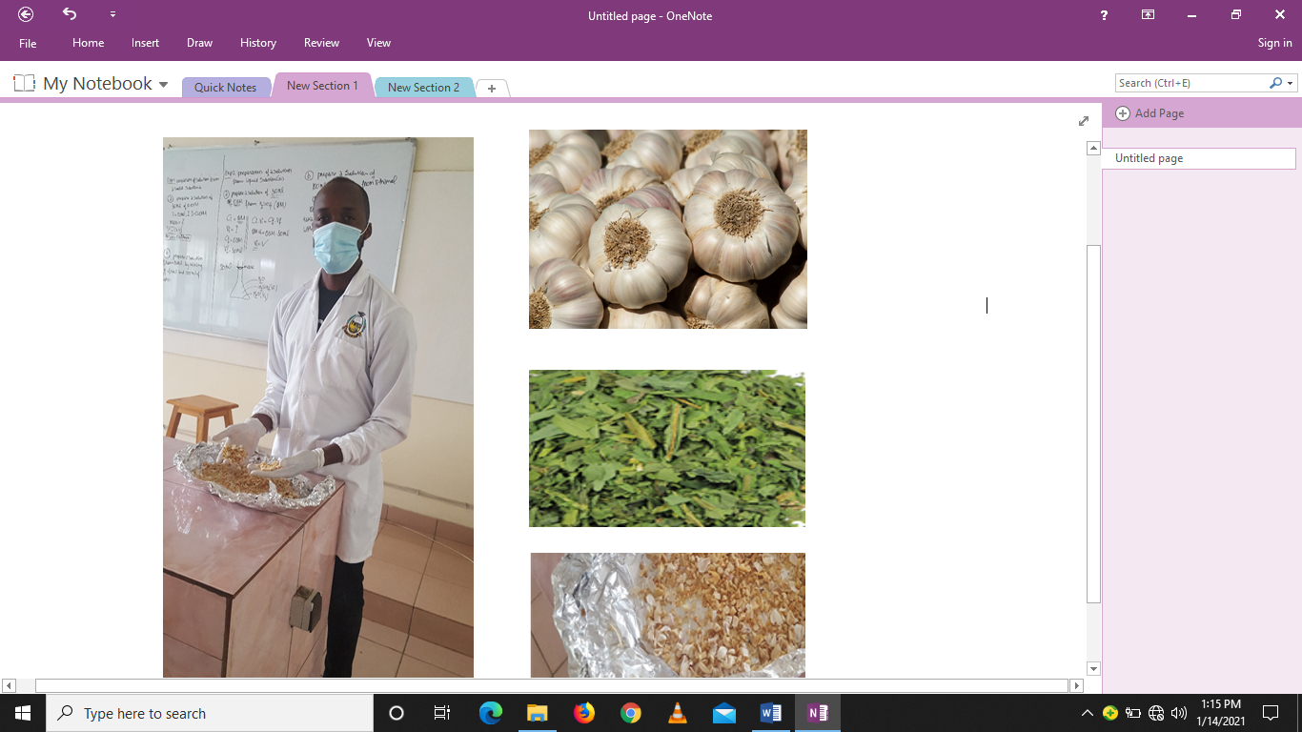

APPENDICES 2: Antibacterial susceptibility testing
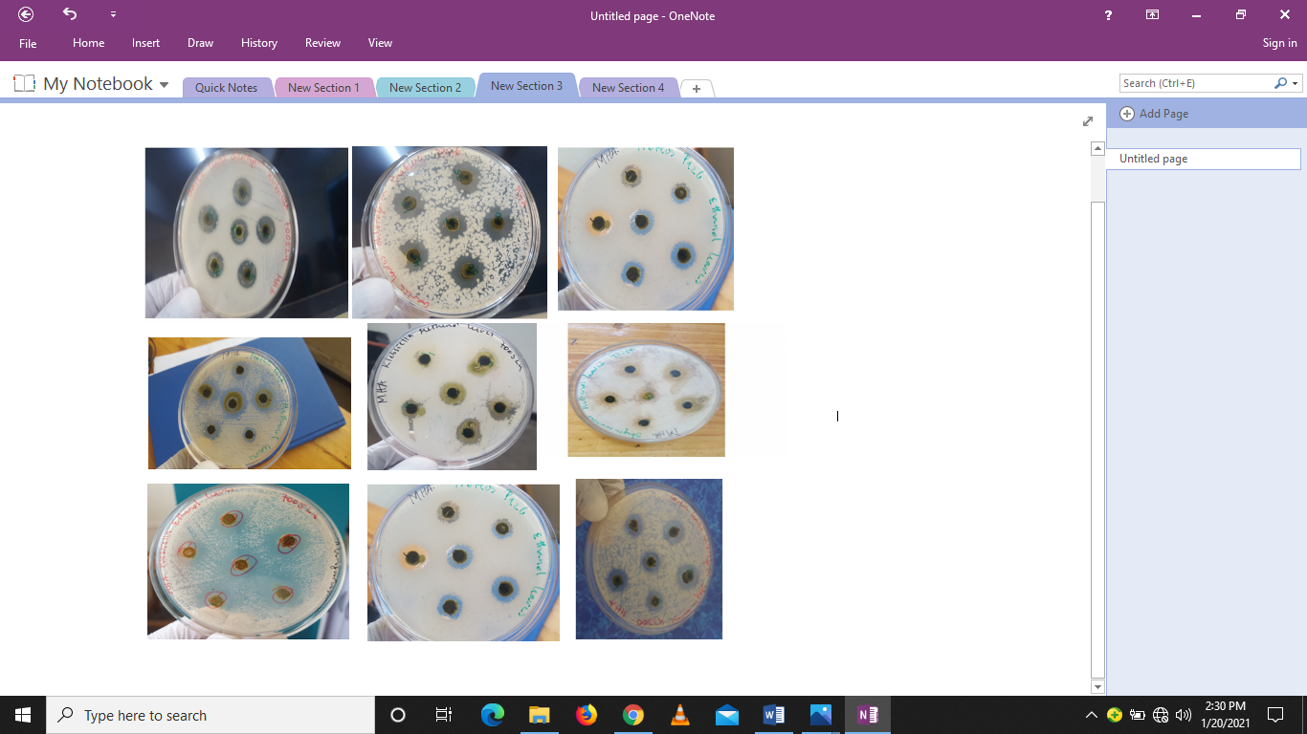

APPENDICES 3: Letter requesting data collection to CHUB
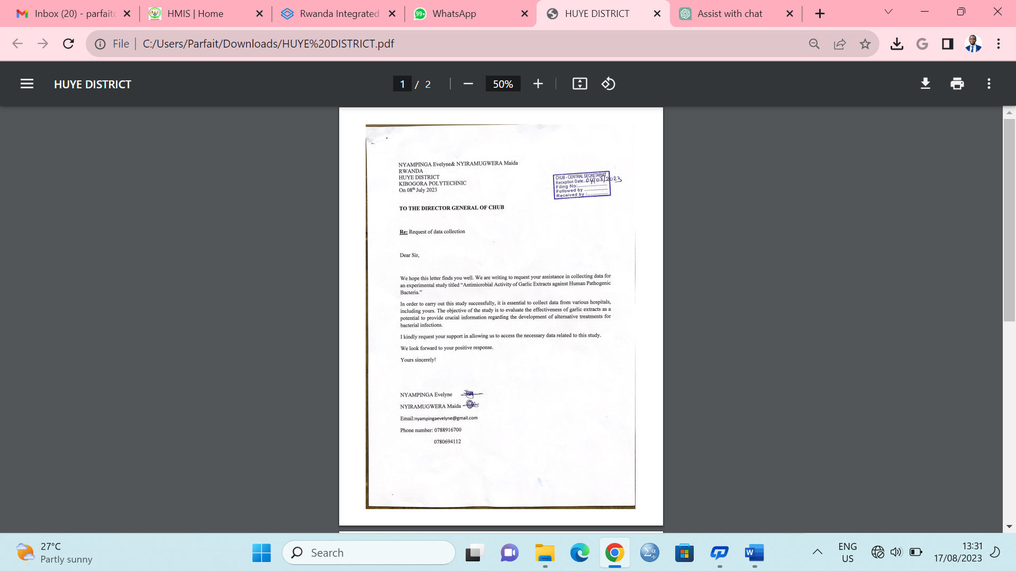

APPENDICES 4: Research Letter
