KIBOGORA POLYTECHNICS (KP)
FACULTY OF HEALTH SCIENCES

DEPARTMENT OF BIOMEDICAL LABORATORY SCIENCES

PREVALENCE OF TOXOPLASMA GONDII AMONG PREGNANT WOMEN ATTENDING KIBOGORA LEVEL TWO TEACHING HOSPITAL
Period: 2022 - 2023
Undergraduate Research thesis submitted in partial fulfillment of the requirements for the award of Bachelor’s Degree with honor in Biomedical Laboratory Sciences
PREPARED BY:
Name: ZAWADI Guevara
Reg. No: 1900558
And
Name: UWIZEYE Esther
Reg. No: 1900507
SUPERVISOR
HITAYEZU Elysee (Msc MBC)
Kibogora, August, 2023

DECLARATION
Declaration by the Candidates
We, ZAWADI Guevara and UWIZEYE Esther hereby declare that this is our own original research proposal and not a duplication of any similar academic work. It has therefore not been previously or concurrently submitted for any other degree, diploma or other qualification to Kibogora Polytechnic or any other institution. All materials cited in this paper which are not our own have been duly acknowledged.
1.ZAWADI Guevara
Signed……………..
Date……………….
2.UWIZEYE Esther
Signed…………………
Date…………………..

Declaration by the Supervisor

I declare that this work has been submitted for examination with my approval as KP Supervisor

Supervisor’s name: ……………………………………….
Signed………………………………………………………..
Date…………………………………………………………..

ABSTRACT

This reseach was conducted to found out the prevalence and associated risk factors of toxoplasma gondii among pregnant women attending Kibogora Level two teaching Hospital from 2022 up to 2023.Toxoplasma gondii is health ploblem wordwide with major consequence on human health. The purpose of this study was to determine the prevalence of toxoplasma gondii, its associated risk factors and preventive measures against it among pregnant women who attended Kibogora Level two teaching Hospital. A retrospective study design and both qualitative and quantitative study approach was used to determine the prevalence of toxoplasma gondii and , associated risk factors among pregnant women attending Kibogora Level two teaching Hospital, and the sample size was 190 pregnant women who attended Kibogora Level two teaching Hospital, medical records documentation were used for collecting data. According to our data analysis presentation, among 190 pregnant women who attended Kibogora Level two teaching Hospital from 2022 up to 2023 were tested, 8 of them were tested positive and 182 were not, this shows the prevalence of toxoplasma gondii among pregnant women attending Kibogora Level two teaching Hospital at 4.21%, The main risk factors of toxoplasma gondii were eating unwashed fruits and using contaminated water and vegetables.
As conclusion, this study concludeds that the prevalence of toxoplasma gondii among pregnant women in Kibogora Level two teaching Hospital, is 4%.This study recommends the Local authority leaders to do its best to help the population getting health food as it was proven that dirty food constitutes the principal causes of toxoplasma gondii in the pregnant women attending Kibogora Level two teaching Hospital.

DEDICATION
To:
The Almighty God,
Our beloved parents,
All our brothers and sisters
Our friends,
This study work is dedicated

ACKNOWLEDGMENTS
First and foremost, we would like to thank God for his care and protection during the writing of this project proposal.
Secondly we are heavily grateful to the staff of the Faculty of Health Sciences, particularly Biomedical Laboratory Sciences Department, in Kibogora Polytechnics for providing us with knowledge and skills for writing this academic study.

We wish to express our gratitude to our supervisor HITAYEZU Elysee for his guidance through the process of writing this research project.
We also gratefully thank Kibogora Level two teaching Hospital staff for having provided us with pertinent information for the realization of this study work.
Our appreciation also goes to our classmates for sharpening us and for their encouragement during the entire course.
We also thank our family and friends for their overwhelming support during the entire period.
May God bless you all!

TABLE OF CONTENTS
DECLARATION i
ABSTRACT ii
DEDICATION iii
ACKNOWLEDGMENTS iv
TABLE OF CONTENTS v
LIST OF TABLES viii
LIST OF FIGURES i
LIST OF APPENDICES ii
LIST OF ABBREVIATIONS AND ACRONYMS iii
CHAPTER ONE: GENERAL INTRODUCTION 1
1.0. INTRODUCTION 1
1.1. BACKGROUND OF THE STUDY 1
1.2 PROBLEM STATEMENT 2
1.3. PURPOSE OF THE STUDY 3
1.3.1.GENERAL OBJECTIVE 3
1.3. 2.SPECIFIC OBJECTIVES OF THE STUDY 3
1.4. RESEARCH QUESTIONS 3
1.5. SIGNIFICANCE OF THE STUDY 4
1.5.1. Personal interest 4
1.5.2. Scientific and academic interest 4
1.5.3. Community interest 4
1.6 LIMITATIONS OF THE STUDY 4
1.7 THE SCOPE OF THE STUDY 4
1.7.1. Time scope 4
1.7.2. Geographic scope 5
1.7.3. Content scope 5
CHAPTER TWO: LITERATURE REVIEW 6
2.0. INTRODUCTION 6
2.1. DEFINITION OF KEY CONCEPTS/TERMS 6
2.1.1. Prevalence 6
2.1.2. Toxoplasma gondii 6
2.4.3. Vaccination 11
2.4.4. Treatment 11
2.5. CONCEPTUAL FRAME WORK 11
2.6. RESEARCH GAP 12
CHAPTER THREE: RESEARCH METHODOLOGY 13
3.0. INTRODUCTION 13
3.1. RESEARCH APPROACHES AND DESIGN 13
3.1.1. Research approaches 13
3.1.2. Research design 13
3.2. TARGET POPULATION 13
3.3. SAMPLING PROCEDURES 14
3.4. SAMPLE SIZE 14
3.5. DATA COLLECTION PROCESS 14
3.5.1. Documentation 14
3.5.2. Interview guide 14
3.6. ETHICAL CONSIDERATION 14
3.7. VALIDITY AND RELIABILITY MEASURES 15
3.8. DATA ANALYSIS 15
CHAPTER FOUR: DATA PRESENTATION, ANALYSIS AND INTERPRETATION 16
4.0. INTRODUCTION 16
4.1. DATA PRESENTATION AND ANALYSIS 16
4.1.1.Social Demographic Prevalence of Toxoplasma Gondii among pregnant women in Kibogora hospital 16
4.1.2. Risk factors associated with Toxoplasma gondii in Kibogora hospital 19
4.1.3. Preventive measures Against Toxoplasma gondii in Kibogora hospital 20
4.2. DISCUSSION OF FINDINGS 21
4.3. SUMMARY OF FINDINGS 22
CHAPTER FIVE: CONCLUSION AND RECOMMENDATIONS 24
5.0. INTRODUCTION 24
5.1. CONCLUSION 24
5.2. RECOMMENDATIONS 24
5.2.2. Antenatal Screening 25
5.2.3To stakeholders 25
5.2.4 To a Researchers: 25
5.3. SUGGESTION FOR FURTHER RESEARCH 26
REFERENCES 27
APPENDICES a

LIST OF TABLES
Table 1: Prevalence of toxoplasma gondii by age 16
Table 2: Prevalence of toxoplasma gondii by marital status 17
Table 3: Prevalence of toxoplasma gondii by Education 18
Table 4: Prevalence of toxoplasma gondii by occupation 18
Table 5: Causes of toxoplasma among pregnant women 19
Table 6: Preventive measures against toxoplasma gondii 20

LIST OF FIGURES
Figure 1: Toxoplasma life cycle 8
Figure 2: Conceptual framework 12

LIST OF APPENDICES
Appendix 1: Introductory letter a
Appendix 2: Patient’s laboratory form b
Appendix 3: Interview guide for laboratory technicians c
Appendix4: Questionnaire for pregnant women ………………………………………………….d

LIST OF ABBREVIATIONS AND ACRONYMS
% : Percentage
C : Celsius
F : Fahrenheit
SOPs : Standard Operational Procedures.
T : Toxoplasma
SPSS : Statistical Package for the Social Sciences

CHAPTER ONE: GENERAL INTRODUCTION

1.0. INTRODUCTION
This chapter introduces the background of the study, problem statement, objective of the study, research questions, significance of the study, limitations and scope of the study.

BACKGROUND OF THE STUDY
Globally, Toxoplasma gondii causes most of the death word wide, two main routes of transmission have been described in humans is by oral ingestion of the parasite and trans placental transmission (from mother to child). and can be transmitted to human by accidental ingestion of water, food, or soil contaminated with T. gondii oocysts or by accidental ingestion of oocyst stage of the parasite after cleaning an infected cat's litter box. Other routes of transmission include accidental ingestion of the parasite in contaminated soil and drinking water, and consumption of infected raw meat. It can also be transmitted congenitally during pregnancy .Generally, it is estimated that about one third of the World’s population is infected with T. gondii. High prevalence of the infection have been reported among pregnant women and women of childbearing age from different foci in Latin America, parts of Eastern/Central Europe, the Middle East, parts of south-east Asia and Africa . (Liu Q et al, 2012)
Therefore, about 30% of the all population worldwide is seriously infected with T. gondii. The seroprevalence of toxoplasmosis ranged from 10 to 50% in developed countries and over 80% in developing tropical countries. Globally, there are 190,100 new cases of congenital toxoplasmosis; 26, 500 (2/1000 live births) being in the Africa region. In Ethiopia there was also high seroprevalence of T. gondii (74.73%) infection with higher odds of infection in pregnant women, (Bahia-Oliveira, 2003)
In Africa, overall seroprevalence rate as high as 92.5% has been reported. However, the prevalence of infection varies widely between countries (from 10% to 80%) and often within a given country or between different communities in the same region. The variations in socio-economic factors between communities and countries have been described to account for the observed difference in prevalence of toxoplasma gondii. (Rosso et al., 2008).
Furthermore, T. gondii infection causes severe and dangerous consequences in human beings and particularly it is a great health concern to pregnant women and the developing fetus or new-borns. 2 In East Africa, about 82% women of childbirth have immunity to T. gondii; the rest may be at risk of developing an acute infection if exposed to the T.gondii. Maternal infection of T. gondii is associated with birth defects or ploblem after the baby is born and pregnancy outcomes including abortion, stillbirth and psychomotor retardation. In women, infection was associated with anxiety, depression, swollen lympnodes and fatigue (Zapata M, 2005).
In Rwanda, the risk factors of T. gondii infection among pregnant women is largely unknown. Specific vectors for transmission may also differ based on geographic location. The water in different regions is thought to be contaminated by T. gondii oocysts that originate from the infected cat feces and wild felids, survive or bypass sewage treatment, and travel to the coast through river systems, (Murebwayire E., 2017). Furthermore, this study will have to assess the prevalence of toxoplasma gondii among pregnant women attending Kibogora level two teaching hospital.

1.2 PROBLEM STATEMENT
Worldwide gondii infection poses a significant health risk to pregnant women and can result in severe complications for both the mother and the fetus. However, there is a lack of data regarding the prevalence of T. gondii among pregnant women attending Kibogora Level two teaching Hospital, which hinders the development of targeted interventions and appropriate management strategies. Therefore, there is a need to determine the prevalence of T. gondii infection among pregnant women in this specific healthcare setting to inform preventive measures and enhance the quality of antenatal care.
Toxoplasma gondii infection during pregnancy poses a significant health risk to both the pregnant woman and the developing fetus. However, there is a lack of comprehensive data on the global prevalence of T. gondii among pregnant women, hindering the implementation of effective preventive strategies, optimal antenatal care, and targeted interventions. Therefore, there is a need to assess and understand the global prevalence of T. gondii infection among pregnant women to inform public health policies and improve the outcomes for affected mothers and infants.(Murebwayire E., 2017).Toxoplasma gondii infection during pregnancy significant health risks to both the pregnant woman and the developing fetus. However, there is limited information on the prevalence of T. gondii among pregnant women attending Kibogora Level two teaching Hospital, which hinders the development of targeted interventions, appropriate antenatal care, and management strategies. Therefore, it is crucial to determine the prevalence of T. gondii infection and associated risk factors among pregnant women attending Kibogora Level two teaching Hospital to improve preventive measures, antenatal care protocols, and overall maternal and fetal health outcomes. So the present study is to determine the prevalence of toxoplasma gondii among pregnant women attending Kibogora Level two teaching hospital.

1.3. PURPOSE OF THE STUDY

1.3.1.GENERAL OBJECTIVE
The general objective of the study was to assess the prevalence of Toxoplasma Gondii among pregnant women attending Kibogora Level two teaching hospital,

1.3. 2.SPECIFIC OBJECTIVES OF THE STUDY
The study seek to achieve the following objectives:
- To determine the overall prevalence of Toxoplasma gondii infection among pregnant women attending kibogora Level two teaching hospital .
- To identify the risk factors associated with Toxoplasma gondii infection among pregnant womenattending kibogora level two teaching hospital
- To assess the knowledge, attitudes, and practices regarding Toxoplasma gondii infection among pregnant women attending Kibogora Level two teaching Hospital.

1.4. RESEARCH QUESTIONS
The below research questions was based on the objectives of the study:
- What is the overall prevalence of Toxoplasma gondii infection among pregnant women attending Kibogora Level two teaching Hospital?
- What are the risks factors associated with toxoplasma gondii among pregnant women attending Kibogora Level two teaching Hospital?
- What are the knowledge, attitudes, and practices regarding Toxoplasma gondii infection among pregnant women attending Kibogora Level two teaching Hospital?

1.5. SIGNIFICANCE OF THE STUDY

1.5.1. Personal interest
This study will help researchers to improve knowledge and skills acquired in biomedical laboratory sciences. This research study will also allow the researchers to be rewarded Bachelor’s Degree with honour in Health Sciences.

1.5.2. Scientific and academic interest
This study have benefited by academicians as it may add new knowledge on existing literature, and may serve as a reference to other researchers who may be interested in the same area.

1.5.3. Community interest
This study will be of a great importance to both social and economic benefits because it will help the society in acquiring the basic knowledge on toxoplasma gondii parasite and its associated risk facts as a way of strengthening preventive measures.

1.6 LIMITATIONS OF THE STUDY
The finance of this study was the challenge during the course of the study. The respondents also were not able to complete or willing to submit the questionnaire given to them. Thus we were required translating the questionnaire into Kinyarwanda language so as to get on reliable information. The fact that we collected data in a given time, we were required to be courageous and to encourage all selected respondents to answer to our questionnaire, even the interviewees were with the Lab Technician. Despite these challenges, we constructed the confidence with the staff of the hospital by presenting the authorization letter for data collection.

1.7 THE SCOPE OF THE STUDY
Any scientific work was delimitated in content, geographic area and time and this research must apply this principle too.

1.7.1. Time scope
The time period for this study was summarized in 12 months starting from july, 2022 up to august, 2023.

1.7.2. Geographic scope
The present study was carried out in Kibogora Level two teaching hospital, operating in Kanjongo sector, Nyamasheke district of Western province.

1.7.3. Content scope
This study was to focus in medical domain, on the level of prevalence of toxoplasma gondii among pregnant women attending kibogora Level two teaching hospital

CHAPTER TWO: LITERATURE REVIEW

2.0. INTRODUCTION
This chapter defines and explains the key concepts which are used during this scientific work, and was to provide theoretical review about the related literature as developed from different authors as well.

2.1. DEFINITION OF KEY CONCEPTS/TERMS

2.1.1. Prevalence
The prevalence of something refers to the extent or degree to which it is widespread, particularly the percentage of a population affected by a specific disease at a given point in time (Nicolle, C. & Manceaux, L., 1908). Prevalence represents the proportion of a population that exhibits a particular characteristic within a specific timeframe. Specifically, it denotes the percentage of a population affected by a specific disease at a given time (Dardé, M. L et al, 2011). Prevalence is a metric used to measure the proportion of individuals in a population who have a certain disease or condition at a specific time, such as a particular date. It offers a snapshot of the disease's occurrence within a population (Dubey, J. P., 2010).

2.1.2. Toxoplasma gondii
Toxoplasmosis is an illness that arises from infection with the Toxoplasma gondii parasite, which is one of the most prevalent parasites worldwide. Infection commonly occurs through the consumption of undercooked contaminated meat, exposure to infected cat feces, or transmission from mother to child during pregnancy (Israili ZH, 2014).
Toxoplasma gondii is a protozoan parasite that infects a wide range of warm-blooded animals, including humans, and causes the disease known as toxoplasmosis (Vondrová M, 2011).
Toxoplasma gondii is an obligate intracellular parasitic protozoan, specifically belonging to the apicomplexan group, that is responsible for causing toxoplasmosis. This parasite is found worldwide and has the ability to infect almost all warm-blooded animals. However, felids, such as domestic cats, are the only known definitive hosts where the parasite can undergo sexual reproduction (Sullivan WJ, 2015).
2.1.3. Pregnant women
A pregnant woman refers to a woman of any age who has been medically confirmed to be expecting a child. The definition of a pregnant woman is applicable from the first day of the earliest month that a healthcare professional verifies as a month during which the woman was pregnant, until the last day of the month in which the 60th day occurs following the conclusion of her pregnancy, irrespective of the reason for pregnancy termination (Markoš A, 2014).
Pregnant woman denotes a woman throughout her pregnancy and the postpartum period, which commences on the day the pregnancy concludes, extends for 60 days, and concludes on the last day of the month in which the 60-day period ends (Smith, J., 2011).Being pregnant signifies the state of carrying a child or other offspring in the body; expecting or with child, as in the case of a woman or female mammal (Manceaux, L. 1908).
2.2. PREVALENCE OF TOXOPLASMA GONDII
The occurrence of T. gondii infection in the general populace of various countries, such as France, Belgium, and the United Kingdom, as well as the occurrence of congenital toxoplasmosis, has been reported to exhibit a decline over the past few decades. Similarly, the United States, with a lower overall seroprevalence compared to Western Europe, has also experienced a decrease in seroprevalence among the general population (Angel SO, 2012).
Numerous investigations have demonstrated a higher seroprevalence rate (>60%) in Central America and South America, particularly in countries like El Salvador, Costa Rica, and Brazil. However, most studies conducted in these regions have not explored seroprevalence trends over the last three decades, except for a study in Costa Rica that revealed a decrease in seroprevalence in the central valley region of the country (Knoll et al, 2019).
Despite suggestions that toxoplasmosis constitutes a public health concern in Colombia, it has received little attention or investigation. In 1980, the Ministry of Public Health and the National Institutes of Health of Colombia conducted a national seroprevalence study, employing an indirect immunofluorescence antibody test to detect IgG toxoplasma antibodies in a randomly selected sample of 9,139 individuals that represented the Colombian population. This nationwide survey revealed an overall age-adjusted prevalence rate of 47%, with an increasing prevalence of infection with age. Notably, variations in seroprevalence were observed among different geographical regions, with higher rates observed on the Atlantic coast (63%) and lower rates in the Pacific region (36%) (Sullivan WJ, 2015).
At present, in Cali (the largest city in the Pacific region of Colombia), local physicians, including specialists in infectious diseases, ophthalmologists, obstetricians, pediatricians, and general practitioners, hold the belief that toxoplasmosis appears to be both a common and significant cause of clinical illness.
Despite these perceptions, no epidemiological or clinical studies have been conducted in Cali or adjacent areas to determine whether toxoplasmosis is a significant cause of illness in high-risk individuals, including those who are immunocompromised or have ocular disease, and whether it poses a significant risk of infection during gestation, thereby endangering the fetus and newborn (Angel SO, 2012).
2.2.1. Causal agent
The primary hosts for Toxoplasma gondii are members of the Felidae family, including domestic cats and their relatives. Unsporulated oocysts are excreted in the cat's feces. While oocysts are typically shed for a period of 1-3 weeks, they can be shed in large numbers. Oocysts take 1-5 days to sporulate in the environment and become infectious. Intermediate hosts in nature, such as birds and rodents, become infected by ingesting soil, water, or plant material contaminated with oocysts (Macdonald DW, 2000).
Following ingestion, oocysts transform into tachyzoites. These tachyzoites localize in neural and muscle tissues and develop into tissue cyst bradyzoites. Cats become infected by consuming intermediate hosts that harbor tissue cysts. Cats can also become infected directly by ingesting sporulated oocysts. Animals raised for human consumption and wild game can also become infected with tissue cysts by ingesting sporulated oocysts present in the environment. Humans can become infected through various routes, including:
Consuming undercooked meat from animals that harbor tissue cysts.
Ingesting food or water contaminated with cat feces or through contact with contaminated environmental samples, such as fecal-contaminated soil or cleaning the litter box of a pet cat.
Blood transfusion or organ transplantation.
Transplacental transmission from mother to fetus (Macdonald DW, 2000).
In the human host, the parasites form tissue cysts, primarily in skeletal muscle, myocardium, brain, and eyes. These cysts can persist throughout the life of the host. Diagnosis is commonly achieved through serology, although tissue cysts can be observed in stained biopsy specimens
Figure 1: Toxoplasma life cycle
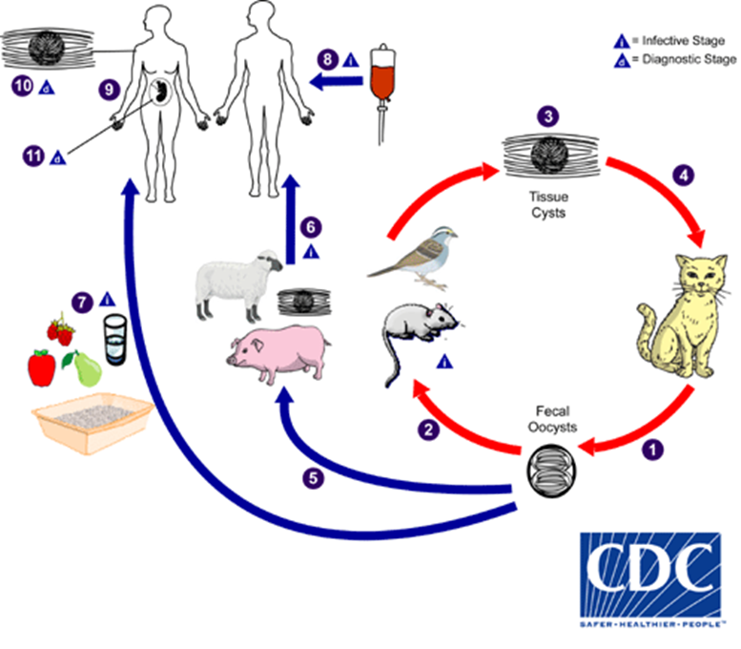
Source: (www. cdc/toxoplasmosis/biology)
2.3. RISK FACTORS ASSOCIATED WITH TOXOPLASMA GONDII
Risk factors for T. gondii infection in humans and warm-blooded animals have been identified as follows (Mc Conkey GA, 2013):
Consuming raw or undercooked meat that contains T. gondii tissue cysts. The primary concern in the United States is the consumption of raw or undercooked pork.
Ingesting water, soil, vegetables, or any other material contaminated with oocysts shed in the feces of an infected animal. Cat feces pose a particular risk, as even a single cyst consumed by a cat can result in thousands of oocysts. It is advised that pregnant or ill individuals avoid cleaning the cat's litter box at home. These oocysts are resilient and can survive in contaminated soil for over a year.
Acquiring the infection through blood transfusion or organ transplant.
Experiencing transplacental transmission from mother to fetus, particularly when T. gondii infection occurs during pregnancy.
Consuming unpasteurized goat milk.
Coming into contact with raw or treated sewage and bivalve shellfish contaminated by treated sewage (Mc Conkey GA, 2013).
A common topic in the discussion on the ethics of cat ownership involves the potential transmission of Toxoplasma gondii to humans. Although living in a household with a cat that uses a litter box is strongly associated with infection, and living with several kittens or a cat under one year of age has some significance, several other studies argue that living in a household with a cat is not a significant risk factor for T. gondii infection (Soldati-Favre D., 2020).
2.4. PREVENTIVE STRATEGIES AGAINST THE INFECTION
The following precautions are recommended to prevent or significantly reduce the risk of T. gondii infection. This information has been adapted from the websites of the United States Centers for Disease Control and Prevention and the Mayo Clinic (McCallum, H., 2013).
2.4.1. Food-related precautions:
Practicing basic food-handling safety measures, such as washing unwashed fruits and vegetables. Avoiding the consumption of raw or undercooked meat, poultry, and seafood. Refraining from drinking unpasteurized milk or untreated water. Recognizing that T. gondii can be transmitted through ingesting microscopic cysts in infected animal tissues, therefore ensuring proper cooking methods or freezing meat at subzero temperatures (-18 °C or 0 °F) for several days before cooking to destroy any cysts present (Dubey, J. P., 2010).
2.4.2. From Environmental precautions
Understanding that oocysts in cat feces take at least a day to sporulate and become infectious after being shed, thus emphasizing the importance of daily disposal of cat litter to minimize the development of infectious oocysts. Wearing gloves when gardening or working with soil and promptly washing hands after disposing of cat litter. Applying these precautions to outdoor sandboxes/play sand pits, which should be covered when not in use. Avoiding flushing cat feces down the toilet (McCallum, H., 2013).

2.4.3. Vaccination
Currently, no approved human vaccine exists against Toxoplasma gondii, but research on human vaccines is ongoing.However, for sheep, there is an approved live vaccine called Toxovax (from MSD Animal Health) that provides lifelong protection (McCallum, H., 2013).

2.4.4. Treatment
Active toxoplasmosis in humans can be treated using a combination of drugs, such as pyrimethamine and sulfadiazine, along with folinic acid.Immune-compromised patients may require continuous treatment until their immune system is restored (Dubey, J. P., 2010).

2.5. CONCEPTUAL FRAME WORK
A conceptual framework serves as an analytical instrument employed to gain a holistic comprehension of a particular phenomenon. It finds application in various professional domains and is frequently utilized to visually elucidate the essential concepts or variables and their interrelationships that necessitate investigation. Moreover, the risk factors associated with toxoplasma gondii, regarded as independent variables, are expected to indirectly contribute to various underlying causes leading to anemia symptoms, as depicted in the diagram below.

Figure 2: Conceptual framework
Independent variables of Toxoplasma Gondi:
- Avian wildlife
- Marshes and swamps
- Marine environment
- Pathological examination
- African penguins
- Mustelids and otters

Dependent variables of Toxoplasma gondii:

- Vertical transmission (from mother to child)
- Consumption of unwashed fruits
- Consumption of infected raw or undercooked meat
- Ingestion of contaminated water, soil, or vegetables
- Transmission through blood transfusion or organ transplant

0
Inter-variables of Toxoplasma gondii:

- Muscular pain and headaches
- Enlarged lymph nodes
- Impaired vision and blurred vision
- Fever and exhaustion
- Enlargement of the liver

Source: Researcher compilation, july, 2023

2.6. RESEARCH GAP
Based on the information to the literature review we can say that there is a gap where there is no current information regarding to our study in the developed countries, area of study and even to other specific area in our country. Even many studies have been conducted in urban areas in Rwanda and rural areas remain scanty.

CHAPTER THREE: RESEARCH METHODOLOGY

3.0. INTRODUCTION
This chapter was to provide a detailed overview of the methodological approach and techniques that was employed in the study. It was to encompass the geographical area under investigation and the targeted study population. Additionally, it was to elucidate the methods and techniques used for sample selection and data collection. Furthermore, it was to outline the procedures for data collection, processing, and subsequent analysis, ultimately leading to the interpretation and implications of the findings.

3.1. RESEARCH APPROACHES AND DESIGN

3.1.1. Research approaches
This study was to employ both quantitative and qualitative methodologies. Therefore, a combination of quantitative and qualitative data collection methods was utilized. This research work was considered a quantitative study as it involves the use, collection, and analysis of numerical data. Additionally, qualitative data collection techniques was employed to gather non-numerical data.

3.1.2. Research design
The nature of this study is retrospective Cross section study . It aims to detect and identify health problems or events related to a specific disease or condition. This type of research helps determine the frequency and population parameters. It is retrospective as it includes case reports, case series, and cross-sectional studies. Moreover, it is descriptive as it involves data collection through interviews and Questionnaires for in-depth analysis. This research design is suitable for assessing the prevalence of toxoplasma gondii among pregnant women attending Kibogora Level two teaching Hospital.

3.2. TARGET POPULATION
The target population for this study was to comprise only pregnant women who have attended Kibogora Level two teaching Hospital, specifically the laboratory department and Maternity service, from july 2022 to august 2023. The number of patients in this population is 190, in addition to 7 laboratory techinicians.

3.3. SAMPLING PROCEDURES
According to Grinnell and William (1990), a sample size refers to the number of objects or individuals included in the sample. In this study, the researchers was to use systematic random sampling procedure . This is because the target population is relatively small, and each patient and laboratory technician needs to be considered.

3.4. SAMPLE SIZE
To ensure accurate results, the entire target population under study was considered as the sample size for the study in the specified area and time period. Therefore, the sample size was to consist of 190 pregnant women who underwent serology testing to measure immunoglobulin G (IgG) at Kibogora Level two teaching Hospital's medical laboratory, in addition to 7 laboratory techinicians.

3.5. DATA COLLECTION PROCESS
Research instruments was utilized to gather relevant information regarding the relevance of toxoplasma gondii among pregnant women.

3.5.1. Documentation
Upon obtaining permission to conduct the research from Kibogora Level two teaching Hospital, data from laboratory record books on serology tests measuring immunoglobulin G (IgG) was collected. The inclusion criteria specified in the study was used, and patients' request forms was considered to obtain data on the prevalence of Toxoplasma gondii among pregnant women.

3.5.2. Interview guide
face-to-face interviews was conducted with purposively selected laboratory technicians to collect data on associated factors and preventive strategies related to toxoplasma gondii. interviews are chosen as an effective research instrument due to their flexibility and ability to generate quick responses.

3.6. ETHICAL CONSIDERATION
An official approval request letter was submitted to both Kibogora Polytechnic and Kibogora Level two teaching hospital to obtain permission for conducting this research. The data collected from the laboratory services at Kibogora Level two teaching Hospital was used exclusively for research purposes, ensuring strict confidentiality.

3.7. VALIDITY AND RELIABILITY MEASURES
Data collection conducted , The aim of the study explained to the patients. Participants who consent to participate in the study asked to sign a consent form. Questionnaire used to determine prevalence of toxoplasma gondii among pregnant women (The full questionnaire on APPENDIX 4).

3.8. DATA ANALYSIS
This study was to employ descriptive data analysis, utilizing both quantitative and qualitative methods. The statistical package for the social.
The study was to use descriptive data analysis which combines both quantitative and qualitative data methods of analysis. The analysis was made by means of the statistical package for the social sciences (SPSS)Version and the data analysis was conducted using Microsoft office excel 2010 software. Given the descriptive nature of the study, the analysis was to encompass descriptive statistics such as frequency distributions and percentages. The findings was visually presented through the utilization of tables.

CHAPTER FOUR: DATA PRESENTATION, ANALYSIS AND INTERPRETATION

4.0. INTRODUCTION
This chapter is entitled data presentation, analysis, interpretation and summary. It presents various categories of respondents, presentation of data, analysis and data interpretation about two variables, simple statistical percentages were tabulated during data analysis and interpretation were used to make easy findings, and some statistical tests were used to test significance of findings and variables

4.1. DATA PRESENTATION AND ANALYSIS

4.1.1.Social Demographic Prevalence of Toxoplasma Gondii among pregnant women in Kibogora hospital
The prevalence of Toxoplasma Gondi among pregnant women was determined by analyzing the age, marital status, education and occupation.

4.1.1.1. Prevalence of Toxoplasma Gondii by age
The researchers assessed the prevalence of Toxoplasma Gondii among patients examined for serologic test in study area referring to the category of their ages.

Table 1: Prevalence of toxoplasma gondii by age
Age |  | Frequency | Not contaminated | Contaminated | Not contaminated (%) | Contaminated (%) | Total (%}
 | Under 18 | 7 | 7 | 0 | 3.7 | 0.00 | 3.68
 | 18 – 27 | 22 | 19 | 3 | 10.0 | 1.58 | 10.58
 | 28 – 37 | 56 | 54 | 2 | 28.4 | 1.05 | 29.48
 | 38 - 47 | 105 | 102 | 3 | 53.7 | 1.58 | 55.26
 | Total | 190 | 182 | 8 | 95.8 | 4.21 | 100
Source: Kibogora Hospital, 2022 - 2023
Table 1 illustrates that within the cohort of 190 Pregnant women in the study are. with reference to their ages, none of the pregnant women under 18 years displayed toxoplasma gondii contamination. among those aged 18-27,0.00% exhibited contamination, while 1.05% of participants aged 28-37 years and 1.58% within the age range of 38-47 years tested positive for the parasite. This highlights the age group of 38-47 years as being the most significantly affected. This also substantiates that, considering the age distribution of pregnant women, the prevalence of toxoplasma gondii stood at 55.26%. This indicates a substantial proportion of pregnant women seeking care at Kibogora Hospital, particularly those above 18 years old, were afflicted by toxoplasma gondii.

4.1.1.2. Prevalence of toxoplasma gondii by marital status
It was of great importance to evaluate the prevalence of toxoplasma gondiiregarding the marital status as one of the factors of pregnancy.

Table 2: Prevalence of toxoplasma gondii by marital status
Marital status |  | Frequency | Not contaminated | Contaminated | Not contaminated (%) | Contaminated (%) | Total (%)
 | Single | 12 | 12 | 3 | 6.3 | 1.58 | 11.49
 | Married | 176 | 176 | 0 | 92.6 | 0.00 | 83.83
 | Widows | 4 | 2 | 2 | 1.1 | 1.05 | 3.4
 | Separated | 3 | 0 | 3 | 0.0 | 1.58 | 1.28
 | Total | 195 | 190 | 8 | 100.0 | 4.21 | 100
Source: Kibogora Hospital, 2022- 2023
Table 2 reveals that within the cohort of 190 individuals, 8 (4.21%) individuals exhibited the presence of toxoplasma gondii. Among those affected, 1.58% were categorized as single, which emerged as the most vulnerable group. 0.00% belonged to the married demographic. Widows constituted 1.05%, while those who were separated accounted for 1.58% of the patients. This underscores the prevalence of toxoplasma gondii primarily among single and separatedpregnant women. This suggests that single and separated individuals were the most susceptible to contamination by this parasite.

4.1.1.3. Prevalence of toxoplasma gondiiby Education
The researchers assessed the prevalence of patients with toxoplasma gondii basing on the level of education as the educated people could have knowledge about preventive measures against any disease.

Table 3: Prevalence of toxoplasma gondii by Education
Education |  | Frequency | Not contaminated | Contaminated | Not contaminated (%) | Contaminated (%) | Total (%)
 | Primary | 10 | 9 | 1 | 4.74 | 0.53 | 5.26
 | Secondary | 76 | 72 | 4 | 37.89 | 2.11 | 40.00
 | University | 104 | 101 | 3 | 53.16 | 1.58 | 54.74
 | Total | 190 | 67 | 8 | 95.7894737 | 4.21 | 100.00
Source: Kibogora Hospital, 2022 - 2023
Table 3 illustrates that among 190 pregnant women, Toxoplasma Gondi had affected 8(4.21%) patients of whom 0.53% had primary level and 2.11% had completed secondary school whereas 1.58% had academic level. It is clear that, patients with secondary education are the most infected group as they are exposed to different conditions which could be sources of contamination. This means that the prevalence of toxoplasma gondii, among pregnant women having attended Kibogora Hospital, was in the women with low education level.

4.1.1.4. Prevalence of Toxoplasma gondii by occupation
Occupation of respondents was another criterion to assess the prevalence of Toxoplasma gondii as due to occupation people could get financial means to avoid the contamination of Toxoplasma gondii.

Table 4: Prevalence of Toxoplasma gondii by occupation
Occupation |  | Frequency | Not contaminated | Contaminated | Not contaminated (%) | Contaminated (%) | Total (%)
 | Agriculture and farming | 105 | 101 | 4 | 53.2 | 2.11 | 55.32
 | Business | 69 | 68 | 1 | 35.8 | 0.53 | 31.92
 | Governmental occupation | 16 | 13 | 3 | 6.8 | 1.58 | 12.76
 | Total | 190 | 182 | 8 | 95.8 | 4.21 | 100.0
Source: Kibogora Hospital, 2022 - 2023
Table 4 illustrates that within the subset of 8 (4.21%) infected individuals out of the total 190 patients, 2.11% were engaged in agricultural and farming pursuits, while 0.53% were involved in business activities. Additionally, 1.58% were employed within governmental organizations. This indicates a higher prevalence among those practicing agricultural and farming activities. Consequently, toxoplasma gondii exhibited its prominence among individuals facing challenging living conditions.

4.1.2. Risk factors associated with Toxoplasma gondii in Kibogora hospital

The investigators were required to evaluate the determinants linked with toxoplasma gondii among expectant women seeking care at Kibogora Hospital. This was accomplished by conducting interviews with a subset of the patients at the hospital.

4.1.2.1. Risk factors associated with toxoplasma gondii
By this, the researchers had to find out the risk factors that are associated with toxoplasma gondii, in Kibogora hospital, since these factors increased the chance of developing the disease on the side of the patients.

Table 5: Causes of toxoplasma among pregnant women
Causes |  | Frequency | Percent | Value | Df | Asymptotic Significance (2-sided)
 | Oral exposure to infected cat faeces | 3/7 | 42.86 | 12.791ª | 23 | .001
 | Transmission from mother to child | 6/7 | 85.71 | 12.898 | 23 | .055
 | Eating unwashed fruit | 7/7 | 100.0 | 0.988 | 1 | .266
 | Consuming undercooked meat | 2/7 | 28.57 | 0.788 | 12 | .386
 | Contaminated water, soil or vegetables | 7/7 | 100.0 | 0.688 | 13 | .506
 | Blood transfusion or organ transplant | 5/7 | 71.43 | 0.988 | 32 | .245
Source: Primary data, July, 2023
Table 6 portrays that, among the 7 patients interviewed, 42.86% affirmed that pregnant women could contract toxoplasma gondii through oral exposure to infected cat faeces , Oral exposure to infected cat faeces Equal 0.001 is risk factor associated with Toxoplasma gondii because asymptotic significance is less than P value <0.05 . Moreover, 85.71% emphasized the transmission from mother to child, and the entirety of the espondents, i.e., 100%, indicated the risk associated with consuming unwashed fruit and contaminated water, soil, or vegetables. Additionally, 28.57% of those interviewed acknowledged the risk associated with consuming undercooked meat, while 71.43% of all interviewees recognized the potential for pregnant women to contract Toxoplasma gondii through blood transfusion or organ transplant. Transmission from mother to child, Eating unwashed fruit, Consuming undercooked meat, Contaminated water, soil or vegetables and Blood transfusion or organ transplant are not significant because asymptotic significance is high than P value 0.05 This underscores that a considerable proportion of pregnant women attending Kibogora Hospital were affected by Toxoplasma due to diverse factors. Among these factors, the consumption of unwashed fruits and contaminated water and vegetables emerged as key contributors affecting a significant number of pregnant women.

4.1.3. Preventive measures Against Toxoplasma gondii in Kibogora hospital
Through an interview with some of the patients at Kibogora hospital, the researchers had to analyse the preventive measures taken to fight against Toxoplasma gondii among pregnant women attending hospital.

4.1.3.2. Preventive measures against Toxoplasma gondii
Having collected risk factors associated with toxoplasma gondii among pregnant women attending Kibogora hospital, the researchers also had to know more about what was taken as preventive measures against the disease.

Table 6: Preventive measures against Toxoplasma gondii
Causes |  | Frequency | Percent
 | Disposing of cat | 0 | 0
 | Washing hands after soil work | 1 | 14.29
 | Washing fruits and vegetable before use | 4 | 57.14
 | Use of drinkable water | 2 | 28.57
 | Freezing meet before cooking | 0 | 0
 | Total | 7 | 100.0
Source: Primary data, July, 2023
The table 6 shows that the majority of the interviewees equal to 57.14% suggested washing fruits and vegetables before use, and 2 interviewees corresponding to 28.57% recommended for use of drinkable water, then one interviewee equating to 14.29% proposed for washing hands after each soil work while none of them mentioned neither freezing meat before cooking nor disposing of cat.

4.2. DISCUSSION OF FINDINGS
Referring to analysed data as documented from laboratory results of pregnant women having attended Kibogora Hospital for serological test in order to determine the prevalence of toxoplasma gondii, its associated risk factors and preventive measures against toxoplasma gondiifrom 2022 up to 2023, it was revealed as follows:
The study revealed that, respectively referring to the table 1, 2, 3 and 4, there was prevalence of toxoplasma gondii among pregnant women attending Kibogora Hospital since 4.21% of all patients tested positive of toxoplasma gondii where the study proved that it highly infected women of between 38-47 years old at the level of 1.58% and single and separeted women at the level of 1.58% then women having secondary academic level at the level of 2.11% while the pregnant women who are farmers had been infected by toxoplasma gondii at the level of 2.11%. This proved the prevalence of toxoplasma gondii among pregnant women through taking into consideration their age, marital status, education and profession, from which it should be deduced that the most affected are the women with either little awareness of toxoplasma gondii or little financial means, referring to the analyzed data as proven above.
In reference with the table 5, 42.86% affirmed that pregnant women could contract toxoplasma gondii through oral exposure to infected cat faeces , Oral exposure to infected cat faeces Equal 0.001 is risk factor associated with Toxoplasma gondii because asymptotic significance is less than P value <0.05 . Moreover, 85.71% emphasized the transmission from mother to child, and the entirety of the respondents, i.e., 100%, indicated the risk associated with consuming unwashed fruit and contaminated water, soil, or vegetables. Additionally, 28.57% of those interviewed acknowledged the risk associated with consuming undercooked meat, while 71.43% of all interviewees recognized the potential for pregnant women to contract Toxoplasma gondii through blood transfusion or organ transplant. Transmission from mother to child, Eating unwashed fruit, Consuming undercooked meat, Contaminated water, soil or vegetables and Blood transfusion or organ transplant are not significant because asymptotic significance is high than P value 0.05 This underscores that a considerable proportion of pregnant women attending Kibogora Hospital were affected by Toxoplasma due to diverse factors. Among these factors, the consumption of unwashed fruits and contaminated water and vegetables emerged as key contributors affecting a significant number of pregnant women. This proved how much these factors were associated with the prevalence of toxoplasma gondii among pregnant women in Kibogora Hospital. risk factor of all those find are the same with the other finded in the Existing literature review funded on the study conducted at Nigeria say that Oral exposure to infected cat faeces Equal 0.001 is risk factor associated on the Toxoplasma gongii.
Referring to the table six, it was proven that different measures to fight toxoplasma gondii in Kibogora Hospital have been put into places where 57.14% suggested that people should be washing fruits before they eat them or vegetables before getting them cooked, and 28.57% recommended that people should not be drinking any water except the drinkable one even while cooking, to 14.29% proposed that they could take care of cleanliness by washing their hand ant time they got contact with soil.

4.3. SUMMARY OF FINDINGS
As regarded the analysis was based on the data collected from the laboratory results of pregnant women, in Kibogora Hospital, consisting of 190 specimens of which 4.21% tested positive of toxoplasma gondii.
Therefore, the table 1 showed that 0.00% were between 18-27 then 1.05% were between 28-37 years old while 1.58% were between 38-47years old. Moreover. 1.58% represented single and 0.00% represented married then 1.05% represented widows and the separated one was 1.58% as shown in the table 2. In addition, basing on the table 0.53% had primary level and 2.11% had completed secondary school whereas 1.58% had academic level. Therefore, 2.11% were practicing agricultural and farming activities and 0.53% werein businesswhile 1.58% were public employees, referring to the table 4.
The table 5, about the associated factors with toxoplasma gondii, showed that 100% of interviewees advanced for eating unwashed fruits and use of contaminated water and vegetables, 42.86% for oral exposure to infected cat faeces,85.71% for transmission from mother to child, and 28.57% for Consumption undercooked meat while 71.43% of all interviewees acknowledged for blood transfusion or organ transplant.
The table 6, about preventive measures against toxoplasma gondii, displayed that 57.14% suggested for washing fruits and vegetables before use, and 28.57% recommended for use of drinkable water, while 14.29% proposed for washing hands after each soil work.

CHAPTER FIVE: CONCLUSION AND RECOMMENDATIONS

5.0. INTRODUCTION
This chapter composed the conclusions basing on the findings in order to achieve the research work’s objectives. In addition, some recommendations and suggestion for future researches had to be forwarded.

5.1. CONCLUSION
The current study centered on the compilation of the prevalence of toxoplasma gondii and its associated risk factors. Through both qualitative and quantitative analysis of the findings, employing the SPSS computer package, the investigators determined the prevalence of toxoplasma gondii among expectant women attending Kibogora Hospital, along with its correlated risk factors, spanning from 2022 to 2023. In summation, it can be concluded that one of the risk factors, namely oral exposure to infected cat feces, transmission from mother to child, consumption of unwashed fruit, intake of infected raw or undercooked meat, use of contaminated water, contributed to the prevalence of toxoplasma gondii among pregnant women, reaching 4.21% at Kibogora Hospital. The demographic most affected by this prevalence consisted of single and separated women between the ages of 38 and 47, particularly those with secondary school education, engaged in agricultural and farming activities. To reiterate, it is essential to underscore that the prevalence of toxoplasma gondii among pregnant women in Kibogora Hospital is 4%, in comparison with a survey conducted by Anet,B. (2019) in the Southern province, which established a toxoplasma prevalence of 73% among pregnant women.

5.2. RECOMMENDATIONS
Having conducted this research, it is obviously clear that there are some recommendations made for local authorities forward eradicating
5.2.1.Health Education and Awareness: Implement comprehensive health education programs targeting pregnant women, emphasizing the risk factors associated with toxoplasma gondii. Focus on educating them about proper hygiene practices, including handwashing, safe food handling, and avoiding contact with cat faeces. Collaborate with local health authorities to initiate public health campaigns targeting the community at large. Promote awareness about toxoplasma gondii, its transmission, and prevention strategies through various media channels and community events.

5.2.2. Antenatal Screening
Introduce routine antenatal screening for toxoplasma gondii infection. This will help in identifying infected pregnant women early and providing appropriate medical interventions to prevent transmission to the fetus. Offer counseling sessions for pregnant women, particularly those at higher risk, to discuss preventive measures against toxoplasma gondii infection. Provide guidance on safe food choices, water consumption, and avoiding risky behaviors. Ensure regular medical follow-up for pregnant women diagnosed with toxoplasma gondii infection. Monitor their health and provide necessary treatments to manage the infection and reduce the risk of complications.

5.2.3To stakeholders
Improve access to clean and safe drinking water in the community. Addressing contaminated water sources can contribute significantly to reducing the risk of toxoplasma gondii infection. Educate pregnant women and their families on proper food preparation and cooking techniques to eliminate the risk of consuming undercooked or contaminated meat. Encourage the washing of fruits and vegetables before consumption. Educate individuals who own cats about the importance of maintaining proper hygiene when handling cat litter and feces. Promote responsible pet ownership practices to minimize the risk of transmission.

5.2.4 To a Researchers:
Conduct further research to explore the genetic diversity of toxoplasma gondii strains in the region and their correlation with disease severity. This can help in understanding the local epidemiology better.Collaborate with healthcare professionals, educators, and community leaders to develop training programs that can empower pregnant women and the community to adopt safer practices and reduce the risk of toxoplasma gondii infection.
5.2.4 To Kibogora Hospital
By implementing these recommendations, Kibogora Level two teaching Hospital and relevant stakeholders can contribute to continue the reduction of toxoplasma gondii infection among pregnant women and improve maternal and fetal health outcomes.

5.3. SUGGESTION FOR FURTHER RESEARCH
Due to resources and time constraints the researcher was not able to extract everything about different diseases prevalence among patients in Kibogora Hospital operating in Nyamasheke district. This is why the researchers suggest that further research should be carried out on:
1. Prevalence of Toxoplasma gondii among pregnant women attending at Nyamasheke district.
2. To assess the causative agent Toxoplasma gondii among women attending at Western Province.
3. A countrywide study should be done to have real the status of this problem because this study used limited number of samples

REFERENCES
A. Books
Angel SO (2012). "Toxoplasma histone acetylation remodelers as novel drug targets". Expert Review of Anti-Infective Therapy.
Bahia-Oliveira LM, Jones JL, Azevedo-Silva J, Alves CC, Orefice F, Addiss DG, (2003). Highly endemic, waterborne toxoplasmosis in north Rio de Janeiro state, Brazil. Emerg Infect
Dubey, J. P. (2010). "General Biology". Toxoplasmosis of Animals and Humans (Second ed.). Boca Raton, London, New York: Taylor and Francis Group.
Esperance Murebwayire, (2017), Seroprevalence and risk factors of Toxoplasma gondii infection among pregnant women attending antenatal care in Kigali, University of Rwanda, Kigali, Rwanda
Israili ZH (2014). "Toxoplasmosis – a global threat. Correlation of latent toxoplasmosis with specific disease burden in a set of 88 countries"
Knoll, Laura J.; Dubey, J. P.; Wilson, Sarah K.; Genova, Bruno Martorelli Di (2019). "Intestinal delta-6-desaturase activity determines host range for Toxoplasma sexual reproduction". bioRxiv.
Liu Q, Singla LD. H. Z (2012), Vaccines against toxoplasma gondii: status, challenges and future directions. Hum VaccImmunoth
Macdonald DW (2000). "Fatal attraction in rats infected with Toxoplasma gondii". Proceedings of the Royal Society of London B: Biological Sciences.
Manceaux, L. (1908). "Sur une infection à corps de Leishman (ou organismes voisins) du Gondi". Comptes Rendus Hebdomadaires des Séances de l'Académie des Sciences.
Markoš A, 2014). "Masterpiece of epigenetic engineering – how Toxoplasma gondii reprogrammes host brains to change fear to sexual attraction". Molecular Ecology.
Mc Conkey GA (2013). "Toxoplasma gondii infection, from predation to schizophrenia: can animal behaviour help us understand human behaviour?". The Journal of Experimental Biology.
McCallum, H. (2013). Wildlife disease ecology in changing landscapes: Mesopredator release and toxoplasmosis. International Journal for Parasitology: Parasites and Wildlife,
Rosso F, Montoya JG. (2008), Perception of pregnant women towards threat of congenital toxoplasmosis. International Conference on Women and Infectious Diseases: progress in science and action.
Smith, J. (2011). "Population structure and epidemiology of Toxoplasma gondii". In Weiss, L. M.; Kim, K. (eds.). Toxoplasma Gondii: The Model Apicomplexan. Perspectives and Methods. Amsterdam, Boston, Heidelberg, London, New York: Elsevie.
Soldati-Favre D. (2020). Neuroinflammation-Associated Aspecific Manipulation of Mouse Predator Fear by Toxoplasma gondii. Cell reports,
Sullivan WJ (2015). "Proteome-wide lysine acetylation in cortical astrocytes and alterations that occur during infection with brain parasite Toxoplasma gondii". PLOS ONE.
Vondrová M (2011). "Fatal attraction phenomenon in humans: cat odour attractiveness increased for toxoplasma-infected men, but decreased for infected women". PLOS Neglected Tropical Diseases.
Zapata M, Reyes L, Holst I, (2005), Risk factors for Toxoplasma gondii infection in pregnant women in Armenia, Colombia. Rev SaludPublica
Jones, J. L., Kruszon-Moran, D., Sanders-Lewis, K., Wilson, M., McQuillan, G., & Navin, T. (2001). Toxoplasma gondii infection in the United States: seroprevalence and risk factors. American Journal of Epidemiology, 154(4), 357-365.
Alvarado-Esquivel, C., Torres-Castorena, A., Liesenfeld, O., Estrada-Martínez, S., Urbina-Álvarez, J. D., López-Hurtado, M., ... & Martínez-García, S. A. (2019). Seroepidemiology of Toxoplasma gondii infection in pregnant women in a public hospital in northern Mexico. Journal of Medical Microbiology, 68(3), 382-388.

B. Electronicsource :
Htpp://www.cdc/toxoplasmosis/biology, Retrieved 14th April, 2022

APPENDICES

Appendix 1: Introductory letter

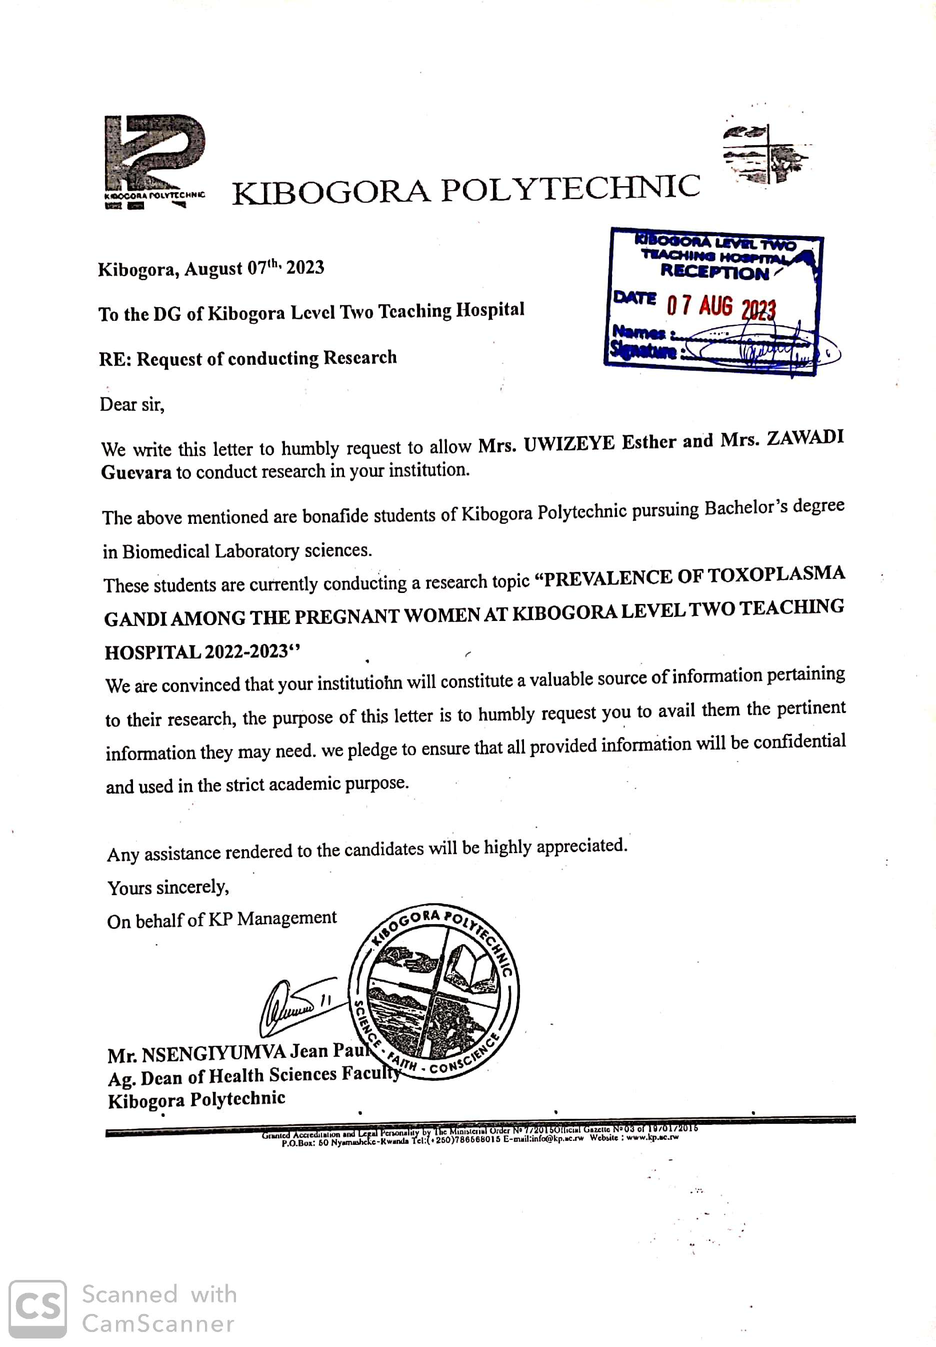
Appendix 2: Patient’s laboratory form
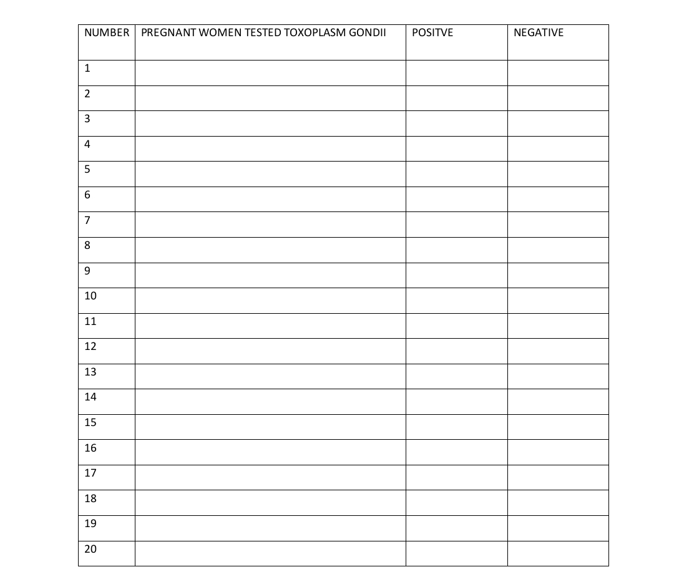

Appendix 3: Interview guide for laboratory technicians
- Do you think that the toxoplasma gondii is prevailing among pregnant women attended this hospital?
- If yes, at which level?
- 25%
- 50%
- 75%
- 1005
- What do you think could be causing pregnant women be infected by toxoplasma gondii infection?
- What do you think could be done as preventive measures to fight against toxoplasma gondii infection?

Appendix 4: Questionnaire for Pregnant women
questionnaire for a study on the prevalence of Toxoplasma gondii among pregnant women. Please note that you may need to adapt and expand upon these questions based on the specific objectives and requirements of your study. Additionally, consider seeking ethical approval and consulting with experts in the field to ensure the questionnaire's validity and reliability.
Section 1: Demographic Information
1.1. Participant ID (for tracking purposes): (Auto-generated)
1.2. Age: (Open-ended)
1.3. Ethnicity: (Open-ended)
1.4. Education Level:
- High School or less
- Some college or technical training
- Bachelor's degree
- Postgraduate degree
1.5. Marital Status:
- Single
- Married
- Divorced
- Widowed
- Other (please specify): _______
1.6. Employment Status:
- Employed full-time
- Employed part-time
- Unemployed
- Student
- Homemaker
- Retired
Section 2: Pregnancy Information
2.1. Gestational Age (weeks): (Open-ended)
2.2. Number of Pregnancies (including current): (Open-ended)
2.3. Current Pregnancy Type:
- Singleton
- Twins
- Triplets or more
2.4. Number of Children Already Born: (Open-ended)

Section 3: Lifestyle and Habits
3.1. Do you own any pets (cats, dogs, birds, etc.)?
Yes
No

3.2. If you have cats, do they go outdoors?
Yes
No
I don't have cats

3.3. Have you ever been exposed to soil or participated in gardening or farming activities during this pregnancy?
Yes
No
3.4. Do you consume raw or undercooked meat?
Yes
No
3.5. Have you had any contact with soil or sand (e.g., gardening or playing in sandboxes)?
Yes
No
Section 4: Medical History
4.1. Have you been previously diagnosed with Toxoplasmosis?
Yes
No
4.2. Have you experienced any symptoms of Toxoplasmosis during this pregnancy (fever, muscle aches, swollen lymph nodes, etc.)?
Yes
No
Not sure

4.3. Have you had a Toxoplasma gondii screening during this pregnancy?
Yes
No
Not sure

Section 5: Knowledge and Awareness

5.1. How familiar are you with Toxoplasmosis and its risks during pregnancy?
Very familiar
Somewhat familiar
Not familiar at all

THANKS !

