
FACULTY OF HEALTH SCIENCES

DEPARTMENT OF BIOMEDICAL LABORATORY SCIENCES

PREVALENCE OF TRICHOMONIASIS AMONG ADULT WOMEN ATTENDING GITWE HOSPITAL, RUHANGO DISTRICT, RWANDA
Case study: Gitwe District Hospital
Period: May up to July 2019

Undergraduate this is presented in partial fulfillment of the Requirements for the Bachelor, degree with honor in Biomedical Laboratory Sciences at KIBOGORA POLYTECHNIC (KP)

PREPARED BY:

Olive BAYISENGE REG No 1800424
&
Felicie UWINEZA REG No 1800351

Supervisor:
Mr. MUNYANDAMUTSA Fulgence

Kibogora, August,2019

DECLARATION

Declaration by the Candidates

We, BAYISENGE Olive and UWINEZA Felicie hereby declare that this is my own original work and not a duplication of any similar academic work. It has therefore not been previously or concurrently submitted for any other degree, diploma or other qualification to Kibogora Polytechnic or any other institution. All materials cited in this paper, which are not my own have been duly acknowledged.

BAYISENGE Olive UWINEZA Felicie
Signature………………………. Signature ……………………
Date ……. /........ / 2019 Date ……. /........ / 2019

Declaration by the Supervisor

I declare that this work has been submitted for examination with my approval as KP Supervisor.

Supervisor’s name: …………………………………
Signed………………………………………………
Date…………………………………………………

ABSTRACT

Trichomoniasis is a sexually transmitted disease (STD) caused by a parasite called Trichomonasvaginalis. Women are most often affected by this disease, although men can become infected and pass the infection to their partners through sexual contact. (Marcin, 2016).
The problem of this study can cause health problem such as infertility, abortion in pregnant women, give birth to premature baby etc.
Objective of this study is to assess possible cause of Trichomoniasis among adult women attended Gitwe Hospital.
The aim of this retrospective study is to determine the prevalence of Trichomoniasis among adult women attending Gitwe Hospital, from May to July 2019.
The target population of this study were adult women suspect trichomoniasis attended Gitwe Hospital.
From 160 of participants 28 were positive which is equal to 17.5% and 132 negative whichis equal to 82.5%. This study shows that Trichomoniasis has high prevalence rate according to result found after conducting this study.
we recommended Gitwe hospital to emphasize and make follow up on adult women with trichomoniasis by improving the laboratory diagnosis and better treatment to prevent the consequence of Trichomoniasis.
To Ministry of health should set and provide measures for educating people how to preventtrichomoniasis.
To local population have to focus on self-hygiene, abstinence, avoid unprotected sexual intercourse, and following advice from health care providers.

DEDICATION
We dedicate this research project report to the Almighty God who protects us in our study, to our families, our parents for their support and advice that has helped us in our daily life and, our educations, to our brothers and sisters for their untiring prayers during our presence at school.
To all relatives, classmates and acquaintances whoever has contributed to the success of our
Studies and all who helped to complete this work.

ACKNOWLEDGEMENTS

We extend sincere gratitude to our God for his existence in our life; Jesus who is crucified to save us and Holly Spirit who continues to guide us in our studies. Special thanks go to our extraordinary supervisor Mr. MUNYANDAMUTSA Fulgence. He has sacrificed most of his precious time for allowing us to work under his guidance and for having provided the necessary resources to complete this work. Our special thanks are due to the Government of Rwanda for its considerable policy of promoting education at all levels. Again our sincere acknowledgements go to entire administration of Kibogora polytechnic and the whole academic staff. Lastly but not least, we are grateful to all our colleagues, friends and relatives who have contributed their time, energy, ideas, experience and encouragement to help us to complete these studies.

TABLE OF CONTENTS

DECLARATION ii
ABSTRACT iii
DEDICATION iv
ACKNOWLEDGEMENTS v
TABLE OF CONTENTS vi
LIST OF TABLES ix
LIST OF FIGURES x
LIST OF APPENDICES xi
1. Data collection sheet …… ………………………………………………............. xi
LIST OF ABREVIATIONS xii
CHAPTER ONE: GENERAL INTRODUCTION 1
1.0. Introduction 1
1.1Background of the study 1
1.2.STATEMENT OF THE PROBLEM 2
1.3. The objective of the study 3
1.4. Research question 3
1.5. Significance of the study 3
1.6. Limitations of the study 3
1.7. Scope of the study 4
1.7.1. Content scope 4
1.7.2 Geographical scope 4
CHAPTER TWO: LITERATURE REVIEW 5
2.0 Introduction 5
2.1 Theoretical Review 5
2.2 Morphology 6
2.3. Epidemiology 7
2.4.Pathogenesis 8
2.5. Mode of transmission 8
2.6 Laboratory diagnosis 9
2.6.1. Microscopy 9
2.6.2.Clinical Presentation 9
2.6.4 Signs and symptom 10
2.6.5.Treatment of Trichomoniasis 10
2.6.6. Prevention and control 11
2.7. Empirical literature 11
CHAPTER 3: RESEARCH METHODOLOGY 13
3.0. Introduction 13
3.1. Study area 13
3.2. Study design 13
3.2.0 Target population 13
3.2.1 sample size 13
3.3 Data collection method 13
3.4. Data analysis and presentation of results 13
CHAPTER FOUR: DATA PRESENTATION, ANALYSIS, AND INTERPRETATION 14
4.0. INTRODUCTION 14
4.2. SUMMARY OF FINDINGS 17
CHAPTER FIVE: CONCLUSION AND RECOMMENDATIONS 19
5.0. INTRODUCTION 19
5.1. CONCLUSION 19
5.2. RECOMMENDATIONS. 19
REFERENCES 20
APPENDICES 24

LIST OF TABLES
Table1: Distribution of Trichomoniasis based on age of participants attended Gitwe Hospital Error! Bookmark not defined.
Table2:Laboratory result of Trichomonas vaginalis Error! Bookmark not defined.
Table3:Prevalence of Trichomoniasis based on age. Error! Bookmark not defined.

LIST OF FIGURES

Figure 1:One Trophozoite of Trichomonas vaginalis from in vitro culture. (Melissa D. Conrad, 2013) 7
Figure 3:show adult women attended Gitwe hospital according 15
Figure 4:Laboratory result of Trichomonas vaginalis 16
Figure 5:Prevalence of Trichomoniasis based on age. 17

LIST OF APPENDICES

1. Data collection sheet …… ………………………………………………............. I
2. Recommendationletter………………………………………………………........ II

LIST OF ABREVIATIONS

DNA: Deoxyribonucleic Acid
TV: Trichomonasvaginalis
RBC: Red Blood Cells
HIV: Human Immunodeficiency virus
BTN: between
STI: sexually transmitted infection
HOD: Head of the department
UG: University of GITWE
WBC: white blood cells
RBC: Red blood cells

CHAPTER ONE: GENERAL INTRODUCTION

1.0. Introduction
This chapter constitutes the background of the study, problem statement andobjective of study, research question, and significance of the study, limitation of study, and scope of the study.

1.1Background of the study
Trichomonasvaginalis is a sexually transmitted parasitic protozoan known to cause trichomoniasis. An estimated 174million new infection each year (WHO, 2015), making it the most prevalent sexually transmitted non-viral pathogen worldwide(Camila Braz Menezes, 2016).The World Health Organization ( WHO) reported that amongst the set of curable sexually transmitted infection (STIs) ,there was an estimated 340 million new cases annually amongst which , trichomonasvaginalis was recognized as the most common , with an overwhelming incidence of approximately 174million reported case .WHO describes that T.Vaginalis in African region occurs 10times as often in women than in menVaginalis infection in the entire African region are estimated to be 42.8million.in women describes that T.vaginalis infection can persist for months, and if left untreated, it can increase the risk for HIV acquisition. If exposed T. Vaginalis could lead to an increase in the vaginal HIV load and thus potentially increase the risk of HIV transmission to a sexual partner. In addition, an association between T. Vaginalis and Chlamydia trachoma is infection has been found. Having a concurrent Chlamydia infection was a predict of both prevalent and incident T. Vaginalis despite the estimated large burden of T. Vaginalis infection in the African region, data on clinical presentation,demographic and behavioral factors associated with infection, and microbiological factors are relatively limited. However, in other continents, multiple studies have been done in the context of T.Vaginalis infection.(sethowa, 2017).An additional cause behind the increased rate of STSs, specifically within South Africa,in the common phenomenon of migration by men from rural to urban areas for employment.Male migrant workers have been shown to have high levels of contact with sex workers, as well as a greater number of casual sexual partners(Dewi J de Waaij, 2017).
Trichomoniasis is a major problem in developing countries, where parental testing and antibiotics use are not adequately available. According to the African HumanItalian Action (AHA)report of July2008, high rates of the common encountered sexual transmitted infections.
Trichomoniasis causes a common genitourinary infection which is frequently asymptotic; about 10-50% of infection in women are asymptomatic, in women trichomoniasis is characterized by a yellow-green frothy vaginal discharge, vagina odor, and pain with sexual intercourse and during urination, andvulvovaginal soreness and itching(Elissa Meites, MD, MPH, 2013).
Complications in pregnant women include post-abortion infection, post-cesarean infection, preterm birth, low birth weight infant, and preterm labor, causing premature rupture of membrane. Trichomoniasis was suggested as a risk factor for developing neoplasia other complication caused by trichomoniasis includes pelvic inflammatory diseases and tubular infertility, vaginitis and arthritis (parasies77, 2019).

1.2. STATEMENT OF THE PROBLEM
According to the World Health Organization (WHO) reported that amongst the set of curable sexually transmitted infections ((STIs), there were an estimated 340 million new cases annually amongst which, Trichomonasvaginalis was recognized as the most common with an overwhelming incidence of 176 million.(Purnima Madhivanan, 2013).
The infection with TrichomonasVaginalis is one of the most common sexually transmitted diseases (STDs) in human, Only 12 of the 42 patients who were clinically diagnosed as having the T. vaginalis infection were confirmed by the culture method(Elissa Meites, MD, MPH, 2013).
The World Health Organization (WHO) has estimated that more than 170 million people are infected annually with T. vaginalis throughout the world. Several studies have determined the prevalence of trichomoniasis be between 2-8% that according to the cultural and social status, can also reach over 30%(Dharma Vijaya MN, 2013).
T. Vaginalis was encountered STI, as it was positively responded by 16% of the interviewed group of the Kiziba Refugee Camps population. Samples were collected from STIs patients presenting genital discharge daily visiting KizibaRefugee Camp and CHUK (Jean Pierre Rutanga, 2011). The T. Vaginalis prevalence in KizibaRefugee Camps was calculated and found to be equal to 28.2% in 78samples examined Samples were collected from STIs patients presenting genital discharge daily visiting KizibaRefugee Camps and CHUK.As some people
FromGitwe share the same hygienic problems with people from Kiziba Refugee Camps which may be the cause of Trichomoniasis.
From this case, we preferred to do prevalence of trichomoniasis among adult women attending Gitwe hospital, and limit the consequences ofTrichomoniasis against women.

1.3. The objective of the study

1.3.0. The main objective
To evaluate the prevalence of Trichomoniasis among adult women attending Gitwe hospital in parasitology service, RuhangoDistrict, Rwanda.
1.3.1. The specific objective of study
I. To assess the prevalence of trichomoniasis among adult women at GitweHospital.
ii. To moderate the prevalence of Trichomoniasis based on age.
iii. To assess the possible cause of trichomoniasis among adult women attending Gitwe Hospital

1.4. Research question
i.What is the prevalence of Trichomoniasis among adult women at Gitwe Hospital?
ii.What are the causes of trichomoniasis among people?
iii. What is the prevalence of trichomoniasis based on age?

1.5. Significance of the study
This study was generated data to be used by health policy makers, and clinicians on the diagnosis, prevention and treatment mechanisms to be adopted from carrying this:
Research will improve skills and gain experience for clinical agent of the etiological agent of trichomoniasis in hands with critical strategy prevention methods required Researchers will improve skills and gain experience for clinical field work. The finding from this study will help women to get knowledge of etiological agent of trichomoniasis in hands with critical strategy preventionmethod (Menezes, 2016).

1.6. Limitations of the study
1. This study was limited only on testing TV among women at Gitwe Hospital due to their high risk of exposure on it.
2.The time used in collecting that information about our study is three months from May to July 2019

1.7. Scope of the study

1.7.1. Content scope
The study was focused on the prevalence of Trichomoniasis among adult women at Gitwe Hospital, and the prevalence of Trichomoniasis based on age

1.7.2 Geographical scope
The study was carried out at Gitwe Hospital, which is located in the southern province, Ruhango District, Bweramana sector.
1.7.3 Time scope
The study wasstarted from May to July 2019

CHAPTER TWO: LITERATURE REVIEW

2.0 Introduction
This chapter contains the theoretical review, the empirical review, and thecritical review.

2.1 Theoretical Review
Trichomoniasis was typically found in sexually active patients. Transmission occurs predominantly via sexual intercourse. The organism was most commonly isolated from vaginal secretions in women and urethral secretions in men. It was not isolated from oral sites, and rectal prevalence appears to be low in men who have sex with men(Eileen M. Duffy, 2000). While it is possible to contract Trichomoniasis without engaging in sexual intercourse, it is less common. In the NHANES 2001-2004 study conducted among females aged 14-49 years, 1% of women with Trichomoniasis had no history of sexual intercourse. Nearly half of infected females and nearly all infected males are asymptomatic. One-third of asymptomatic women become symptomatic within six months.

Trichomoniasis in women
Trichomoniasis symptoms in women range from none to severe pelvic inflammatory disease (PID). Women with Trichomoniasis frequently report an abnormal vaginal discharge, which may be purulent, frothy, or bloody. Frothy vaginal discharge, which is thought to be the classic presentation of Trichomoniasis, may be observed in only 12% of patients with this infection.(Darvin Scott Smith, 2018). Cervicitis due to Trichomoniasis was characterized by two major signs: purulent discharge in the endocervical canal and easily induced endocervicalbleeding. However, it may also be asymptomatic (Rosenberger, 2017).
T vaginalis infection is one of the top three causes of vaginitis. Vaginitis is usually characterized by vaginal discharge, which may be accompanied by vulvar itching, irritation, and odor. The two other most common causes of vaginal discharge are anaerobic bacteria overgrowth of normal flora and candidiasis (infection with Candida albicans).(Joseph E. Pizzorno ND, 2016).
Men withTrichomoniasis
Men with Trichomoniasis may was divided into the following 3 groups based on their symptoms: Asymptomatic carrier state (comprising the majority of patients), Mild symptomatic disease and Acute Trichomoniasis (Jessica A. Schumann, 2019).

History
Alfred Francois Donné (1801–1878) was the first to describe a procedure to diagnose trichomoniasis through "the microscopic observation of motile protozoa in vaginal or cervical secretions" in 1836. He publishedthis in the article entitled, "Animalcules observés dans les matières purulentes et le produit des sécrétions des organes génitaux de l'homme et de la femme" in the journal, comptes rendus de l’académie des sciences s. As a result, the official binomial name of the parasite is Trichomonasvaginalis.

Complications
Some of the complications of T. vaginalis in women include: preterm delivery, low birth weight, and increased mortality as well as predisposing to HIV infection, AIDS, and cervical cancer.(Hsin-Chung Lin, 2019)T.vaginalis has also been reported in the urinary tract, fallopian tubes, and pelvis and can cause pneumonia, bronchitis, and oral lesions.

2.2 Morphology
Trichomonasvaginalis exists in only one morphological stage, a Trophozoite, and cannot encyst. T. vaginals is a single-celled, teardrop-shaped protist that can grow between five and 20 micrometers wide. Four anterior and one posterior flagella allow T. vaginals to move. The posterior flagellum is part of the center ax style, and has a barbwire-like structure. This structure allows the protist to attach to and tear the urethra or vaginal walls, which causes inflammation and aids in speeding and intensifying infection and may also cause the tissue damage seen in trichomoniasis infections while T. vaginalis does not have a cyst form, organisms can survive for up to 24 hours in urine, semen, or even water samples. T. vaginalis has a cell membrane, but lacks a cell wall. Half of the cell body also has an undulating membrane, which helps sweep nutrients into the protist's mouth-like structure, called the cytosome. A visible nucleus was located at the organism's center(Petrin D, 1998).
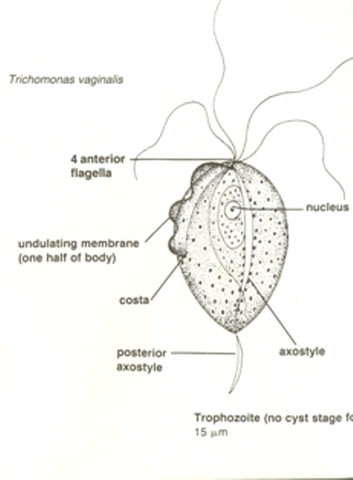

Figure 1:OneTrophozoite of Trichomonasvaginalis from in vitro culture. (Melissa D. Conrad, 2013)

2.3. Epidemiology
Trichomonasvaginalis, which affects at least 170 million individuals globally, may was increasedthe risk of transmission of HIV, and predispose pregnant women to premature rupture of membranes, and early labor. (Bowden FJ, 2017)The epidemiology of the disease was still poorly understood, and some practitioners continue to question its importance. However, there was grow evidence that T. vaginalis was an important pathogen, both in its own right due to the “immediate” morbidity associated with the infection for its role in the promotion of premature rupture of membranes, premature labor, and low birth weight, and because of the likely facilitation of HIV transmission(Bowden FJ, 2017).
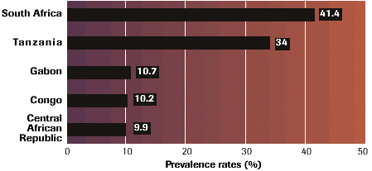

2.4.Pathogenesis
T. vaginalis is approximately the size of a white blood cell (WBC)—about 10-20 μm long and 2-14 μm wide—though its size may vary with physical conditions (see the image below). It was four flagella projecting from the anterior portion of the cell and one flagellum extended backward to the middle of the organism, formed an undulating membrane. An ax style, a rigid structure, extends from the posterior aspect of the organism (Rosenberger, 2017).
In women, T. vaginalis was isolated from the vagina, cervix, urethra, bladder, and Bartholdi and Skene glands. In men, the organism was found in the anterior urethra; external genitalia, prostate, epididymis, and semen (see the image below). It resides both in the lumen and on the mucosal surfaces of the urogenital tract. The flagella allow the Trophozoite to move around vaginal and urethral tissue (Pagano, 2019).

2.5. Mode of transmission
Trichomonasvaginalis was typically transmitted through vaginal, oral, or anal sex with an infected individual. It was also passed from a mother to her baby at birth, as evidenced by the discovery of the parasite in the newborn's lungs.TrichomonasVaginalis reproduces asexually through longitudinal fission. The Trophozoite (adults) then lives in the urinary or reproductive tracts, until they are passed into their next human host via unprotected sexual contact, where the whole process starts over again. Unlike many other protists, T. vaginalis was not a cyst stage as part of reproduction (hadi_fayyadh, 2019).

2.6 Laboratory diagnosis

2.6.1. Microscopy
Clinical diagnosis was appropriate for women presenting with symptoms of an infection; discharge, itching, and vaginal odor. The most commonly used diagnostic test is wet preparation microscopy. A swab is used to collect material from the vaginal fornix and placed into a small amount, 0.5 to 1.0 ml, of normal saline. The diagnosis of Trichomoniasis was traditionally depended on the microscopic observation of motile protozoa from vaginal or cervical samples, and from urethral or prostatic secretions(B, 2016).
This technique was first described in 1836 by Donne. T. vaginalis was differentiated based on its characteristic jerky movements. On occasion, the flagella movement was also noted. The sensitivity of this test varies from 38% to 82% and was depended on the inoculums size because fewer than 10⁴ organisms/ml was not seen. As well, the need for the specimen to remain moist and the experience of the observer was important variables. The size of the Trichomonas was approximately the same as that of a lymphocyte (10 µm to 20 µm) or a small neutrophil; when not motile, a Trichomonas was difficult to differentiate from the nucleus of a vaginal epithelial cell.(Karki, 2018) Motility was very dependent on the temperature of the specimen. At room temperature in phosphate-buffered saline, the organism will remain alive for more than six hours; however, the motility of the organisms becomes significantly attenuated. This wet mount examination was the most cost-effective diagnostic test, but the lack of sensitivity was contributed to the under diagnoses of the disease. Because viable organisms was required, delay in transport and evaporation of moisture from the specimen was reduced motility and, consequently, diagnostic sensitivity(Noriyuki Inoue, 2018).

2.6.2.Clinical Presentation
The appropriate use of diagnostic testing was dependent on appropriate specimen collection. However, specimens are only taken when a diagnosis was considered. The classic presentation of T vaginalis is that of a purulent, foul-smelling vaginal discharge which was associated with pruritus, dysuria and dyspareunia. The discharge usually exceeds pH 6.0, and a 'strawberry' cervix, which is characterized by punctuate hemorrhagic lesions was described. These classic symptoms was only seen 20% of the time, which often leads to women with these vaginal symptoms was empirically treated for yeast infections or bacterial vaginosis(Smith, 2018).
The majority of men who was sexual contact with a woman with T vaginalis was completely asymptomatic or only had mild dysuria even though the organism was found on culture(Christian Bories, 2017).
2.6.3. Diagnosis and Culture
The diagnosis of trichomoniasis can be confirmed by looking at a sample of vaginal fluid for women or urine for men under a microscope. Growing a culture used to be the way to diagnose trichomoniasis, but newer, faster tests, such as rapid antigen tests and nucleic acid amplification, are more common now. Broth culture technique was the gold standard for T. vaginalis for the past 40 years. The inoculums size required was only in the range of 102 organisms/mL and the growth of the organism was easy to interpret. Incubation periods ranging from two to seven days are required to identify T. vaginalisin culture (Marcia M Hobbs, 2013).

2.6.4 Signs and symptom
- A greenish-yellow, frothy vaginal discharge with a pronounced odor.
- Vaginal itching or irritation
- Painful during sexual intercourse
- Discomfort during urination
- Vaginal bleeding
- Pain in the lower abdomen

2.6.5.Treatment of Trichomoniasis
Trichomoniasis was cured with a single dose of prescription antibiotic medication (either metronidazole or tinidazole), pills which can be taken by mouth. It was okay for pregnant women to take this medication. Some people who drink alcohol within 24 hours after taking this kind of antibiotic can have uncomfortable side effects (Bernard, 2019).
People was treated for trichomoniasis can get it again. About one in five people get infected again within three months after treatment. To avoid getting reinfected, make sure that all of your sex partners get treated too, and wait to have sex again until all of your symptoms go away (about a week). Get checked again if your symptoms come back(suzanne66, 2016).
It is the only drug that should be used to treat Trichomoniasis if there is any chance that you could be pregnant (Kawthar Bouchemal, 2016).
Your partner should also be treated at the same time to prevent reinfection and further spread of the disease. Also, persons was treated for Trichomoniasis should avoid sex until they and their sex partners complete treatment and have no symptoms. It was important to take all of your antibiotics, even if you feel better. You should get retested after three months to be certain the infection was gone, even if your partner was treated (Telfer, 2018).

2.6.6. Prevention and control

2.6.6.1. Practice safer sex
Preventing an STI is easier than treating an infection after it occurs.
- Be responsible.
- Talk with your partner about STIs before beginning a sexual relationship. Find out if he or she was at risk for an STI. Remember that it was quite possible to be infected with an STI without knowing it. It can take up to 6 months before some STIs, such as HIV, was detected in the blood(Bell, 2018).
- Avoid sexual contact if you were symptoms of an STI or was treated for an STI.
- Avoid all intimate sexual contact with anyone who has symptoms of an STI.
- Don't have more than one sex partner at a time. Your risk of getting an STI increases if you were several sex partners at the same time.
- Malaise condom (Lazenby, 2011).
Using the condom may have reduced the risk of becoming infected with anSTI.Condom must be put before beginning any sexual contact.

2.7. Empirical literature
Trichomonasvaginalis infection was a common sexually transmitted protozoa infection, with an estimated 180 million prevalent cases worldwide, the annual incidence in the United States was estimated to be 3–5 million cases, of which two million involve young people (age, 15–24 years). One recent study estimated that the prevalence of Trichomoniasis among the general population of young adult women (age, 18–25 years and above) was 2.8%.However, the prevalence of Trichomoniasis among all reproductive-age women wasunknown (Dino Petrin, 2015).
In this nationally representative sample, the prevalence of Trichomoniasis among 14–49-year-old women in the United States was 3.1%, corresponding to 2.3 million women with Trichomoniasis (95% CI, 1.7–3.2 million women with Trichomoniasis). Within the same years of the NHANES national survey data sets, the prevalence of two other sexually transmitted diseases, Neisseria gonorrhea and Chlamydia trachoma is infection, were 0.33% and 2.5%, respectively, among female persons aged 14–39 years. Our data show that T. vaginalis infection is a highly prevalent sexually transmitted infection among reproductive-age girls and women aged 14–49 years, also our data provide new information on a wider age group of nationally representative women, was compared with the previously reported estimated prevalence of Trichomoniasis of 2.8% among 18–25-year-old and above women(Yako A. B, 2014).
In the present study, the prevalence of T. vaginalis infection was found lower than the previous studies in Iran (2.1%), such as in Shiraz the Trichomoniasis prevalence of 11.2% in vulnerable household women who was covered by the Imam Khomeini Relief Foundation insurance scheme was reported, while the prevalence in non-pregnant women referred to health centers were as follows: 9.2% in Tabriz, 4.8% in Zanjan and in Tehran 3.2%(Naser Nazari, 2015).
The prevalence of Trichomoniasis in a rural area of Southern Mozambique, Palestine, Argentina and USA were reported 31%, 28.1%, 4%, and 13%, respectively. Therefore, it was concluded that the Trichomonas prevalence varies in different societies, which might be due to different factors, such as hygiene behaviors and socio-demographic characteristics and diagnostic tests used. Also, one possible explanation of the lower prevalence of Trichomoniasis among Iranian population is due to Islamic quotes that prohibit nonmarital sex and homosexuality. Moreover, stated that the lower incidence of infection may was related to universal male circumcision in Iran. In this study, the women aged 21 to 35 years had the highest infection rate. This finding was consistent with the results from several previous studies. This might be due to biologic changes in older women as one of the predisposing factors for the parasite growth or longer duration of infectiousness and resistance to treatment. Although the prevalence of Trichomoniasis in the urban dwellers was higher than the rural dwellers (11/13), the percentage of urban and rural participation was 78% and 22%, respectively. This difference was difficult to interpret, indeed whether the prevalence of the disease was more in urban or rural areas(Akram AZAMBAKHTIAR, 2018).

CHAPTER 3: RESEARCH METHODOLOGY

3.0. Introduction
This chapter contains the study population, study area, design of the study, sample size, data collection instrument, data analysis, ethical consideration, and limitation of the study.

3.1. Study area
Our study area was Gitwe hospital where we were collected data for prevalence of Trichomoniasis among adult women attending Gitwe Hospital located in the southern province in Ruhango district in Bweramana sector. We have collected data in the laboratory of Gitwe Hospital.

3.2. Study design
The retrospective was conducted in our research of prevalence ofTrichomoniasis among adult women attendedGitwe Hospital.

3.2.0 Target population
All adult women attendedGitwe Hospital laboratory in the department of parasitology who are suspected of havingTrichomoniasisfrom May up to July.

3.2.1Sample size
The sample size of this study was 160Client suspect women attending Gitwe Hospital from May up to July.

3.3 Data collection method
Datawas collected using a retrospective, thedata collection worksheet was composed of different information relating to clinical data such age, sex, code number and laboratory testing results, data werecollected within a period of three months from May 2019 up to July 2019 for all adult women who was suspectedtrichomonasvaginalis attendedGitwe Hospital, and then the determination of prevalence was set by using the results obtained.

3.4. Data analysis and presentation of results
In this study, the retrospectives method was used. Therefore, statistical analysis was performed with statistical software like:
- Microsoft office word used in treating texts.
- Microsoft office excels for the study of the table.
- The frequency was done with a statistical package of social sciences (SPSS).

CHAPTER FOUR: DATAPRESENTATION, ANALYSIS, AND INTERPRETATION

4.0. INTRODUCTION
This chapter includes an introduction, population characteristic, prevalence of Trichomoniasis
4.1.0 Laboratory result of Trichomonasvaginalis
Table 1: the distribution of Trichomoniasis based on the age of participants attended Gitwe Hospital
 | Result according to age |  |  | Frequency |  | Percent |  | Cumulative Percent
 |  | 20-29 with Positive |  | 8 |  | 5.0 |  | 5.0
 |  | 20-29 with Negative |  | 37 |  | 23.1 |  | 28.1
 |  | 30-39 with positive |  | 4 |  | 2.5 |  | 30.6
 |  | 30-39 with Negative |  | 11 |  | 6.9 |  | 37.5
 |  | 40-49 with Positive |  | 6 |  | 3.8 |  | 41.3
 |  | 40-49 with Negative |  | 8 |  | 5.0 |  | 46.3
 |  | 50-59 with Positive |  | 4 |  | 2.5 |  | 48.8
 |  | 50-59 with Negative |  | 7 |  | 4.4 |  | 53.1
 |  | 60-69 with Positive |  | 3 |  | 1.9 |  | 55.0
 |  | 60-69 with Negative |  | 7 |  | 4.4 |  | 59.4
 |  | 70-79 with Positive |  | 3 |  | 1.9 |  | 61.3
 |  | 70-79 with Negative |  | 11 |  | 6.9 |  | 68.1
 |  | 80-89 with Negative |  | 51 |  | 31.9 |  | 100.0
 |  | Total |  | 160 |  | 100.0
This table shows all adult women attending Gitwe hospital ranged between 20-89 years old where each age has negative and positive results.
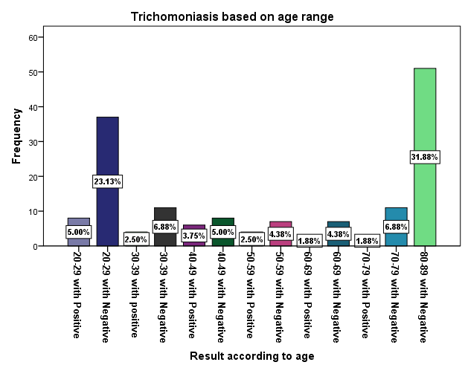Figure 2:show adult women attended Gitwe hospital according
The table 2 present laboratory finding

Result |  | Frequency | Percent | Cumulative Percent
 | Positive | 28 | 17.5 | 17.5
 | Negative | 132 | 82.5 | 100.0
 | Total | 160 | 100.0
We have found that in 160 of adult women who attended lab test 28 were positive that means they have Trichomoniasis which was equal to 17.5% and 132 were negative result that means they don’t have Trichomoniasis which was equal to 82.5%.

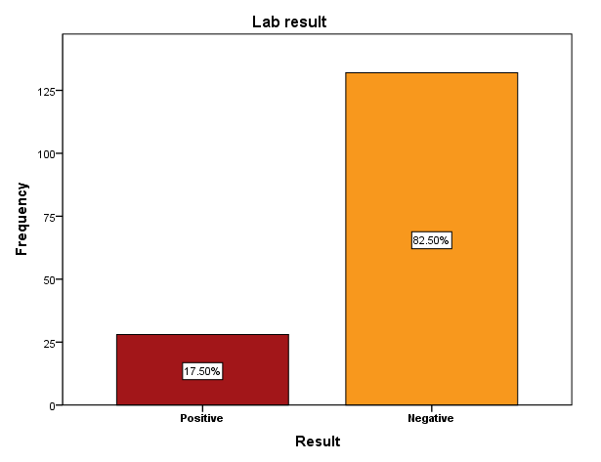
Figure 3:Laboratory result of Trichomonasvaginalis
Table 2:Prevalence of Trichomoniasis based on age.
Age range |  | Frequency | Percent | Cumulative Percent
 | 20-29 | 8 | 28.6 | 28.6
 | 30-39 | 4 | 14.3 | 42.9
 | 40-49 | 6 | 21.4 | 64.3
 | 50-59 | 4 | 14.3 | 78.6
 | 60-69 | 3 | 10.7 | 89.3
 | 70-79 | 3 | 10.7 | 100.0
 | Total | 28 | 100.0
This table shows that the prevalence of Trichomoniasis based on the age between 20 to 89 years old the prevalence of (20-29) is equal 28.6%, (30-39) is equal to 14.3%, (40-49) is equal to 21.4%, (50-59) is equal to 14.3%, (60-69), is equal to 10.7%, (70-79), is equal to 10.7%, (80-89), is equal to 0%.
Figure 4:Prevalence of Trichomoniasis based on age.

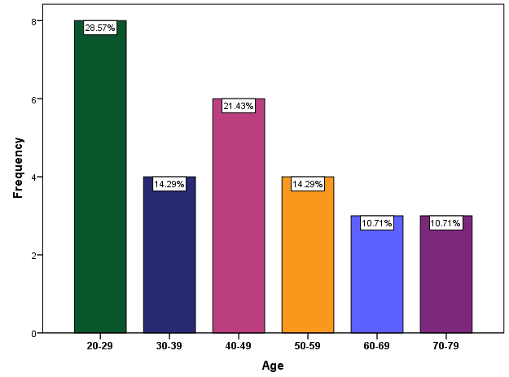

4.2. SUMMARY OF FINDINGS
This compromises three objectives: To assess the prevalence of Trichomoniasis among adult women at Gitwe Hospital, to obtain a general view of the group of individual affected by Trichomoniasis among adult women at Gitwe Hospital, and to assess the possible causes of trichomoniasis among adult women attending Gitwe Hospital.
4.2.0. Objectify/1. to assess the prevalence of Trichomoniasis among adult women attending Gitwe Hospital.
The prevalence of Trichomoniasis among adult women attending Gitwe Hospital from May to July 2019 is equal to 28.6%.
4.2.1. Objectify 2. Determine prevalence of Trichomoniasis based on ages range between 20 to 89 years.
the prevalence of Trichomoniasis based on ages range between 20 to 89 years old the prevalence of (20-29) is equal 28.6%, (30-39) is equal to 14.3%, (40-49) is equal to 21.4%, (50-59) is equal to 14.3 %, (60-69), is equal to 10.7%, (60-79), is equal to 10.7%, (80-89), is equal to 0%.
Objectify3.To assess the possible causes of trichomoniasis among adult women attending Gitwe Hospital.
First we can need a test to find out if you have trichomonas,trichomonas is usually offered if you have signs and symptoms of trichomonas especially women where the signs and symptoms haven’t caused by other infections such as chlamydia and gonorrhea, and a sexual partner has trichomonas. You may also be advised to have a test if you’ve recently had unprotected sex with a new partner (Kristena Ducre, 2015).
It is estimated that only 2% of Ruhango residents had access to clean water in 1994. The trend
Improved to 52% in 2012. Various water supply pipelines were installed to supply water to
Households, commercial units and social services institutions the schools, and hospitals.
The AIDER Water supply that used was served Mayaga region was renovated and now supplies water in the Sector of Mbuye and other parts of the district as well as Kamonyi and Nyanza districts.
The district has boreholes and piped water lines. A new pipeline of 20km from Ruhango to
Nyarurama has been constructed in Mayaga sector and another of 18km from Gahama to Gitwe
Hospital in Kabagari area but Gitwe still having the problem of enough water that causes the
Problem of hygiene practices and this lead to cause trichomoniasis and also sexual behavior increase the number of new cases (mudingu, 2017).

CHAPTER FIVE: CONCLUSION AND RECOMMENDATIONS

5.0. INTRODUCTION
This chapter contains the conclusion and recommendations

5.1. CONCLUSION
The aim of this study was to determine the prevalence of Trichomoniasis among adult women attended Gitwe Hospital from May to July 2019. From 160 of participants 28 were positive which is equal to 17.5% and 132 negative which is equal to 82.5%. This study shows that Trichomoniasis has high prevalence rate according to result found after conducting this study.
Based on age: the majority with 28.6% was ranged in age group 20 years to 29 years and the minority with 0% was ranged in age group 80-89, and all are adult women aged between 20 to 89 years’ old who attend Gitwe Hospital.
Generally, trichomoniasis was an extremely common infection worldwide and their causes search as poor hygiene which was associated with important public health problems. Current treatment with metronidazole was reliable and inexpensive; however, the number of strains resistant to metronidazole may be increasing. The results of this study provide a comprehensive data though further studies need to be conducted(Melanie L. Yarbrough, 2016; Purnima Madhivanan, 2013)

5.2. RECOMMENDATIONS.
To Ministry of health
The findings from this study show that prevalence of Trichomoniasis is a high. Which will lead to high number of Trichomoniasis in Rwanda; hence, the ministry of health in Rwanda should set and provide measures to further to prevent Trichomoniasis.
To Gitwe Hospital
The management of Gitwe Hospital must emphasize strong follow up on adult women with Trichomoniasis for improving diagnosis and better treatment to prevent the consequence, and educate people how to avoid trichomoniasis.
To local population
People have to focus on self-hygiene, abstinence, protected sexual intercourse, and in case of uncomfortable he\she has to attend health facilities for being treated, and following advice from health care providers.

REFERENCES

parasies77. ( 2019).
World Health Organization DoRhaR. Global incidence and prevalence of selected curabe sexually transmitted infections-2008. Geneva: WHO, 2012:1–20. (accessed 28 sep 2015). (n.d.).
Akram AZAMBAKHTIAR, B. N. (2018). The Prevalence of Trichomoniasis in Women . The Prevalence of Trichomoniasis in Women , 108–113.
B, V. D. (2016). Clinical and Laboratory Testing for Trichomonas vaginalis Infection. Clinical and Laboratory Testing for Trichomonas vaginalis Infection, 7–12.
Bell, J. ( 2018). How to tell your partner you have a sexually transmitted infection (STI). How to tell your partner you have a sexually transmitted infection (STI.
Bernard, A. R. (2019). what's the Treatment for Trichomoniasis? what's the Treatment for Trichomoniasis?
Bowden FJ, G. G. (2017). Trichomonas vaginalis epidemiology. Trichomonas vaginalis epidemiology: parameterising and analysing a model of treatment interventions., 248-56.
Camila Braz Menezes, A. P. (2016, 09). the journal of unicellular biology and human disease. Trichomoniasis – are we giving the deserved attention to the most common non-viral sexually transmitted disease worldwide?, 3(9), pp. 404 - 419.
Christian Bories, P. M. (2017). Strategies for Prevention and Treatment of Trichomonas vaginalis Infections. Strategies for Prevention and Treatment of Trichomonas vaginalis Infections, 109-16.
Darvin Scott Smith, M. M. (2018). the signs and symptoms of trichomoniasis in women? What are the signs and symptoms of trichomoniasis in women?
Dewi J de Waaij, J. H. (2017). Prevalence of Trichomonas vaginalis infection and protozoan load in South African women. Prevalence of Trichomonas vaginalis infection and protozoan load in South African women: a cross-sectional study.
Dharma Vijaya MN, K. U. (2013, Jul). Journal of clinical& Diagnostic research. Prevalence of the Trichomonas Vaginalis Infection in A Tertiary Care Hospital in Rural Bangalore, Southern India, 7(7), 1401–1403.
Dino Petrin, K. D. (2015). Clinical and Microbiological Aspects ofTrichomonas vaginalis. Clinical and Microbiological Aspects ofTrichomonas vaginalis.
DoRhaR, W. H. (2015). Global incidence and prevalence of selected curabe sexually transmitted infections-2008. Geneva: WHO.
Eileen M. Duffy, M. F. (2000). Sexually Transmitted Diseases in Adolescents. Sexually Transmitted Diseases in Adolescent.
Elissa Meites, MD, MPH. (2013). The “Neglected” Sexually Transmitted Disease. Trichomoniasis, 755-764.
Francis J Bowden, G. P. (2017). Trichomonas vaginalis epidemiology. Trichomonas vaginalis epidemiology, 248.
hadi_fayyadh, m. (2019). trichomonas Medias. trichomonas Medias.
Hsin-Chung Lin, K.-Y. H.-A. (2019, mar). Infection with Trichomonas vaginalis increases the risk of psychiatric disorders in women. parasites&vector, 12, 88.
Jean Pierre Rutanga, A. N. (2011). Prevalence of Trichomonas vaginalis infections among patients at Kiziba refugee Camp and Centre Hospitalier Universitaire de Kigali (CHUK). nfections among patients at Kiziba refugee Camp and Centre Hospitalier Universitaire de Kigali (CHUK).
Jessica A. Schumann, S. P. (2019). Trichomoniasis. Trichomoniasis.
Joseph E. Pizzorno ND, H. J.-B. (2016). Vaginitis. Vaginitis.
Karki, G. (2018). Trichomonas vaginalis. Trichomonas vaginalis.
Kawthar Bouchemal, C. B. (2016). Strategies for Prevention and Treatment of Trichomonas vaginalis Infections. Strategies for Prevention and Treatment of Trichomonas vaginalis Infections.
Lazenby, G. B. ( 2011). trichomonas vaginalis screening and prevention in order to impact the HIV pandemic. trichomonas vaginalis screening and prevention in order to impact the HIV pandemic.
Leitsch, D. (2016, Feb 11). F1000 Research. Recent Advances in the Trichomonas vaginalis Field, 5, 162.
Marcia M Hobbs, A. C. (2013). Modern diagnosis of Trichomonas vaginalis infection. Modern diagnosis of Trichomonas vaginalis infection.
Marcin, J. (2016). Trichomoniasis. Trichomoniasis.
Melanie L. Yarbrough, C.-A. D. (2016). sexually transmitted disease. clinical microbiology, 794–803.
Melissa D. Conrad, M. B. (2013). Getting trichy: tools and approaches tools and approaches to interrogating trichomonas vaginalis in a post of genome world. tools and approaches to interrogating tricho.vaginalis in a post of genome world.
Menezes, C. B. (2016). Trichomoniasis - are we giving the deserved attention to the most common non-viral sexually transmitted disease worldwide? trichomoniasis, 404–419.
Noriyuki Inoue, Y. T. (2018). Observation of wet specimens sensitive to evaporation using scanning electron microscopy. oservation of wet specimens sensitive to evaporation using scanning electron microscopy, 356–366.
Pagano, T. (2019). Understanding Trichomoniasis -- the Basics. Understanding Trichomoniasis -- the Basics.
Petrin D, D. K. (1998, apr). clinical and Microbiological Aspects of Trichomonas vaginalis. Aspects of Trichomonas vaginalis, 300–317.
Purnima Madhivanan, l. P. (2013). Prevalence of Trichomonas vaginalis infection among young reproductive age women in India. hhp public access, 339_344.
Rosenberger, K. D.-B. (2017). A missed diagnosis of trichomoniasis. A missed diagnosis of trichomoniasis, 1-4.
sethowa, j. t. (2017). trichomonas vaginalis and bacterial coinfections identified in reproductive age women. richomonas vaginalis and bacterial coinfections identified in reproductive age women.
Smith, D. S. (2018). CLINICAL PRESENTATION OF TRICHOMONIASIS. CLINICAL PRESENTATION OF TRICHOMONIASIS, 400.
Telfer, N. (2018). What is trichomoniasis? Trichomoniasis 101.
WHO. (2015). Global incidence and prevalence of selected curabe sexually transmitted infections. WHO, 1–20.
Zhenchao Zhang, L. K. (2018, Mar). Parasite& Vectors. Prevalence and genetic diversity of Trichomonas vaginalis clinical isolates in a targeted population in Xinxiang City, Henan Province, China, 11, 124.

APPENDICES

APPENDIX1:DATA SHEET FORM

Lab No | ID | Sex | Age | Result

APPENDIX2:STUDENTS PROJECT LETTER
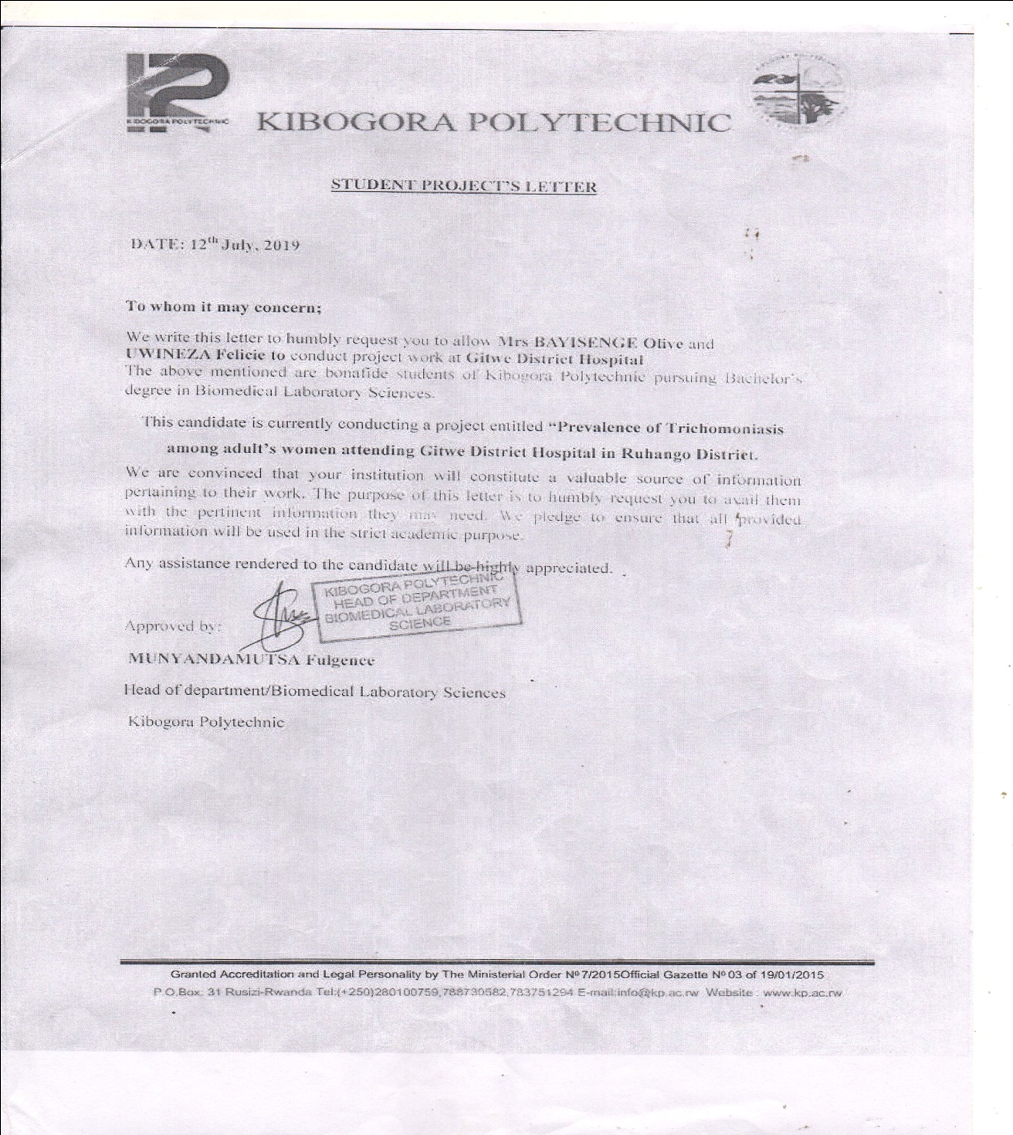

APPENDIX 3: APPROVAL FOR DATA COLLECTION REQUEST
